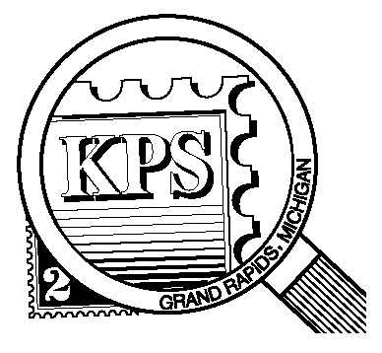

NEWSLETTER OF THE KENT PHILATELIC SOCIETY
P.O. Box 1156, Grand Rapids, Michigan 49501-1156
Jerry Frye, President 616-538-6069
Louis Morel, Editor 269-420-3128
KentPhilatelicSociety.com

K.P.S. Philatelist
Volume 69 - No. 11 November 2025

KPS Club News
We welcome a new member to our Club. Robert Phillips exhibited Lions Clubs International stamps from around the world at Kentpex and took the opportunity to join us. We look forward to meeting him at our monthly gatherings and learning more about his philatelic interests.  Eighty-three collectors attended Kentpex 2025, each eager to browse the inventory of the dealers and view the exhibits.  Did you share your enthusiasm with anyone unfamiliar about the hobby during National Stamp Collecting Month? Here is another opportunity for you to benefit our Club. Seriously consider serving on the KPS Board. Fresh eyes and thoughts are always welcome. Let a current Board member know that you are interested in contributing to the Club’s success or contact Jerry Frye for more details (616-538-6069). Elections will be held at the December meeting.  The November meeting will feature a presentation by Club member David Luke. In a natural tie-in with Veteran’s Day, he will focus on soldiers and the military on stamps. There also will be an opportunity to trade postal items with fellow members. | Our traditional annual pot luck Holiday dinner will take place on December 9 in our usual meeting place. Bring a dish to share. Participate in the table auction. See more details below.  It is time to renew your KPS membership for 2026. The dues remain unchanged for the upcoming year at $15. Many members dropped off their payment at Kentpex. You can drop off your payment at the next Club meeting. You can also send a check to the address found above in the masthead. Please do not delay.  KPS Archives: The Club’s Apil 1964 issue of The Philatelist included the last of several articles written by member Frances Wood on stamps issued by the Confederate States of America (CSA). She mentioned the decree by the Postmaster-General of the CSA in 1861 authorizing new postage stamps. She went on to caution collectors about some forgeries that were in circulation. A one-cent stamp showed a fort with the words “Charleston, P. O.” prominently displayed. She cited another purported to have been issued by The Buck Express of Richmond. The latter had a fifteen-cent face value. It emphasized that it was valid in “CONFEDERATE STATES ONLY”.

The KPS Board will enhance our monthly auctions by holding a drawing for a FREE $10 certificate toward the winning purchases of one lucky member. You need to be present to participate in the drawing.

MONTHLY PROGRAM SCHEDULE
The Kent Philatelic Society meets on the 4th Tuesday of the month at the Byron Center Baptist Church, 7343 Byron Center Ave SW, Byron Center.
November 25, 2025: KPS CLUB MEETING  5:30 PM Board Meeting  6:30 PM Lot Viewing  7:00 PM Presentation and Trade Night | December 9, 2025: KPS MEMBERS POT LUCK  6:00 PM Doors open  6:30 PM Bring a dish  7:00 PM Table Auction

Members are invited to share their philatelic experiences in this space. Perhaps you made a special acquisition, or thrive on an uncommon collecting topic, or saw a remarkable exhibit. Share it with your fellow collectors. Contact the Editor with your stories.
An Indian Cultural Site
Legend has it that early in the 8th century Narasimhavarman II, king of the Pallavas, had a group of seven temples built along the shore of the Bay of Bengal. The temples, with their bas-reliefs, pagodas, and statuary were so beautiful that it made the god Indra jealous of the earthly city. Indra conjured up a great storm and sank the city leaving only the Shore Temple remaining above sea level.

The Shore Temple, shown below (India, 1983, Scott 1013), is the sole remaining pagoda, It is a complex consisting of 40 religious monuments and temples including one of the largest open-air rock reliefs in the world known as Arjuna's Penance (Descent of the Ganges).
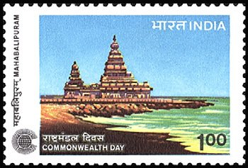
The Shore Temple, is considered to be one of the gems of the architectural heritage. The majestic Shore Temple bears this name as it faces the shore of the Bay of Bengal, one of the largest bays in the world. The Shore Temple was sculpted in place using a single, large, freestanding granite boulder.

The temple contains three hallowed places mainly devoted to Lord Shiva and Lord Vishnu. Shrines are dedicated to both deities. The one dedicated to Vishnu is the oldest and smallest among them. The shrine walls have carvings depicting the life stories of Vishnu and Shiva.

The temple’s architecture belongs to a style known as Dravidian which is common in the southern states of India. Characteristics of Dravidian architecture often include covered porches on temples, tall entry gate towers on two or more sides, many-pillared halls, and a water tank or reservoir for ritual bathing. Dravidian temples are typically enclosed within an outer wall with a large gateway tower. Some of these traits can be seen in the image above.

The development of early Indian architecture demonstrates a progression from structures of wood and timber to cave shrines, rock cut structures, and eventually freestanding temples constructed out of mortar and stone. As an architectural form, the Shore Temple is of immense importance. It demonstrates progression from rock cut structures to free standing structural temples. It signifies religious harmony with sacred spaces dedicated to both Shiva and Vishnu, and was also an important symbol of political and economic strength.

Mamallapuram, where the Temple was built, was an important port town during India’s early history and developed as a key center for artistic activity under the patronage of the Pallava rulers. The Pallavas played a crucial role in shaping southern Indian history and heritage. The Pallavas became a major power and dominated the region for about 600 years until the ninth century. During the seventh century a large number of rock-cut monuments were built including cave shrines, monolithic temples, and large sculptures carved out of boulders.

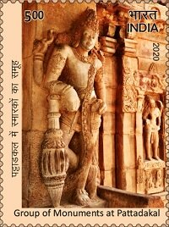
There are multiple categories of monuments found at Mamallapuram. Most were built in the early 7th to early 8th centuries. The one depicted on the stamp at left (India, 2020, Scott 3233) is found at the temples at Pattadakal. Like the Shore Temple, it is a UNESCO World Heritage Site.

The stunning open-air rock reliefs and stone cut temples were built between 695 and 722 CE. Some archeological excavations have revealed material dating to the 6th century or earlier.

Marco Polo landed in southern India in 1292. He made mention of the "Seven Pagodas" on his way back to Venice but never visited the site. Polo stated that the fauna and flora were superior to those found in Italy, both in size and beauty having seen lions, leopards, peacocks, and other “exotic” animals and plants. European sailors and merchants first made mention of the site in the 16th century. The site was brought to the attention of European scholars in William Chambers' 1788 literary survey of Mamallapuram linking art and Hindi texts.

Restoration on the Shore Temple site began in 1960 and the Indian government continues to actively participate in ensuring the protection, preservation and excavation of the historic site.

Louis Morel

