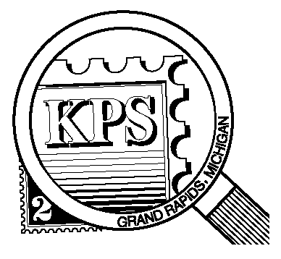

## 



NEWSLETTER OF THE KENT PHILATELIC SOCIETY

P.O. Box 1156, Grand Rapids, Michigan 49501-1156

Jerry Frye, President 616-538-6069

Louis Morel, Editor 269-420-3128

KentPhilatelicSociety.com

K.P.S. Philatelist

Volume 69 - No. 9 September 2025

KPS Club News

|  |  |
| --- | --- |
| Another collector has joined the Club. Jeff Joyce follows in the footsteps of his father, long-time member, Don Joyce. Jeff was a KPS member many years ago. Life kept him away from the hobby as is the case for many collectors. We hope to learn about his philatelic journey at our Club meetings.  🟋🟋🟋  The August Club meeting was more successful than the previous one based on attendance. Thirty members were present. Member Bob Toland shared his knowledge of coil stamps. Businesses’ requests for such stamps were granted in 1908. The large number of easily accessible stamps eased the burden on businesses and organizations that relied on mass mailings. The USPS began producing coil stamps with plate numbers in 1981. Collectors have been seeking the numbered stamps since then.  🟋🟋🟋  The USPS is celebrating the 250th anniversary of Benjamin Franklin’s appointment as the first American Postmaster General. So is Kentpex! Benjamin Franklin will be theme of the Kentpex 2025 Stamp Show. We are looking for exhibitors at the Show. This is an opportunity for you to share your passion for a theme. Contact Ron Rich ([kcrichfamily@gmail.com](mailto:kcrichfamily@gmail.com)) to obtain a registration form if you wish to exhibit at Kentpex in October. | 🟋🟋🟋  This month’s Club meeting will feature an auction by KPS member and dealer, Chris Daly. One quarter of the lots was issued by postal authorities based on islands. These islands are found in Canadian waters, in the Caribbean, and in the South Pacific. Also at the meeting, Carol Ligda-Wong, will put her Canadian collection up for auction. Her collection consists of more than 1500 stamps. Acquiring such a trove is an ideal way to jump start a new country collection or to fill gaps in an existing one. Interested? It’s not too late to request a partial list of the available stamps by writing to [kps.stampclub@gmail.com](mailto:kps.stampclub@gmail.com).  🟋🟋🟋  There is a vacancy on the KPS Board. Are you interested in contributing in a meaningful way to the Club? Contact Jerry Frye for more details (616-538-6069).  🟋🟋🟋  **KPS Archives**: Roger Cook joined KPS in 1988. An active member, he wrote about precancels in the June 2007 issue of the KPS Philatelist. He stated that few collectors or dealers understand the relative value or scarcity of precancels. He recalled how some dealers showed precancels claiming they were valuable when they were actually quite common. And others who placed little value on some precancels and sold them at a low price. Could a scarce one be in that mixture? |

The KPS Board will enhance our monthly auctions by holding a drawing for a **FREE** $10 certificate toward the winning purchases of one lucky member. You need to be present to participate in the drawing.

**MONTHLY PROGRAM SCHEDULE**

The Kent Philatelic Society meets on the 4th **Tuesday** of the month at the Byron Center Baptist Church, 7343 Byron Center Ave SW, Byron Center.

|  |  |
| --- | --- |
| September 23, 2025: **KPS CLUB MEETING**  5:30 PM Board Meeting  6:30 PM Lot Viewing  7:00 PM Chris Daly Auction | October 28, 2025: **KPS CLUB MEETING**  5:30 PM Board Meeting  6:30 PM Lot Viewing  7:00 PM Donation Auction |
|  |  |

*Members are invited to share their philatelic experiences in this space. Perhaps you made a special acquisition, or thrive on an uncommon collecting topic, or saw a remarkable exhibit. Share it with your fellow collectors. Contact the Editor with your stories.*

**Sandford Fleming: Engineer and Artist**

Born in Scotland in 1827, he studied science and engineering in his homeland and served a professional apprenticeship in surveying at age 14. When he turned 18, he joined his older brother on a massive adventure, immigrating to colonial British North America. He eventually settled in Peterborough (in present day Ontario) in 1847 and became a surveyor in 1849. He joined the engineering staff of the Ontario, Simcoe and Huron Railway. In 1863, the Canadian government appointed him chief surveyor of the first portion of a proposed railway from Quebec City to Halifax and Saint John (in present day New Brunswick).

Fleming was an ardent advocate of an all-British railway from the Atlantic to the Pacific coasts. In 1863 he presented a petition from the settlers at the Red River Colony to the Imperial authorities in England. The Colony was a settlement on the Red and Assiniboine rivers whose boundaries crossed parts of what are now Manitoba and North Dakota. Founded in 1812, the colony grew through times of extreme hardship into a multiracial society. The petition urged construction of a railway that would link that community with the British North America colonies further east.

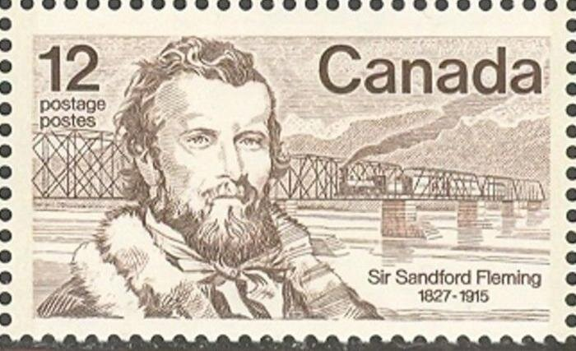In 1865, he was promoted to Chief Engineer of the Northern Railway of Canada. A civil engineer and draughtsman, he was an early advocate of using iron for bridges instead of wood for safety reasons. The stamp above (Scott 739), showing an iron railway bridge, was issued in 1977 to commemorate the sesquicentennial of his birth. The design of this stamp included two fluorescent bands. An error is known to exist. Stamps were printed without the tagging bands.

In 1867, he was named engineer-in-chief of the transcontinental railway and served in that post until 1876. The plan directly led to British Columbia joining the Canadian federation. He later joined the Canadian Pacific Railway and was awarded the right to drive the last spike into the completed railway.

Town clocks in the early nineteenth century showed local time. Thus, you could never know what time it would be when you traveled to another destination. When Fleming personally missed a train because of these variations in time, he devised the idea of standardized time zones. He suggested a 24-hour clock for the whole world with a central time and every other place changing an hour later or earlier based on 15 degrees of longitude. It took ten years for his plan to be accepted worldwide, but in 1884 twenty-four time zones were established with the observatory in Greenwich, England as the base line and an International Date Line drawn in the Pacific Ocean. By 1929, every country in the world had adopted the time zones.

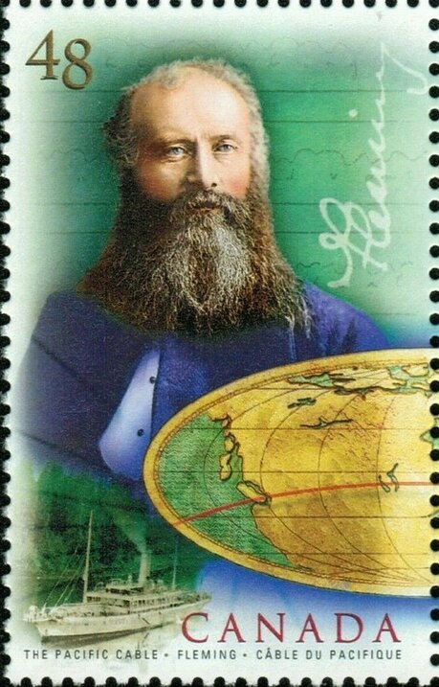He became a strong advocate of a telegraph cable from Canada to Australia, which he believed would become a vital communications link of the British Empire. The Pacific Cable was successfully laid in 1902. His contribution was recognized on the stamp at left (Scott 1963) issued in 2002 celebrating the centennial of the submarine cable.

Fleming also designed Canada’s first postage stamp, the1851 red-toned “threepenny beaver”. He drew it on a napkin during lunch in downtown Toronto with a senior postal official. That napkin is now in Canada’s archives. Canada reprinted the beaver several times between 1851 and 1859 (Scott 1, 4, 8, 12, 15), Unknowingly, perhaps, Fleming designed the world’s first stamp depicting an animal.

The design “was symbolic of the people in the young country of Canada building their towns, cities, and communities,” Douglas and Mary Patrick wrote in their 1964 book, ‘Canada’s Postage Stamps’. “The secondary purpose of choosing the beaver centered in the original meaning of the beaver skin; it represented a medium of exchange in trade.”

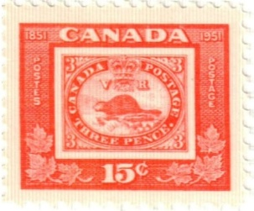The design was also used on several twentieth century stamp-on-stamp issues. The first, issued in 1951 (Scott 314) for the 100th anniversary of the “threepenny beaver”, reproduced it in miniature on a 15-cent commemorative.

The second was a 30-cent (Scott 913) stamp issued for the 1982 International Philatelic Youth Exhibition in Toronto. The latest was released in 2001. The 47-cent stamp (Scott 1900) commemorated, “One Hundred and Fifty Years of Canadian Post” as an official government agency responsible for processing and carrying mail. Others would follow.

Louis Morel