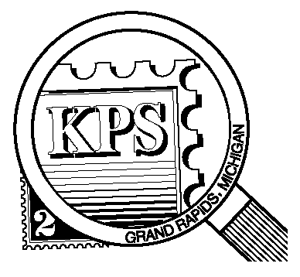

## 



NEWSLETTER OF THE KENT PHILATELIC SOCIETY

P.O. Box 1156, Grand Rapids, Michigan 49501-1156

Jerry Frye, President 616-538-6069

Louis Morel, Editor 269-420-3128

KentPhilatelicSociety.com

K.P.S. Philatelist

Volume 69 - No. 6 June 2025

KPS Club News

|  |  |
| --- | --- |
| On June 14, 1775, the Continental Congress authorized the enlistment of expert riflemen to serve the United Colonies for one year. This was the birth of the U. S. Army more than one year before the Declaration of Independence. The Continental Navy and Marine Corps were formed in October and November, respectively, of the same year. They all celebrate their 250th anniversary this year!  The Second Continental Congress adopted the first flag on June 14, 1777. The first national observance of the flag occurred on its one hundredth anniversary. Amid these patriotic celebrations, KPS member, David Luke, will offer his presentation titled “What Makes a Good Flag Stamp a Great Flag Stamp?” at this month’s meeting.  🟋🟋🟋  The second annual KPS Stamp Social will take place at the Byron Center Baptist Church (address below) on **Saturday, June 21** from 10 AM to 3 PM. Have you signed up to attend yet? If not, please call Bill Sobotka (616.531.3295) and let him know that you plan to do so. Food and beverages will be served. We would appreciate knowing ahead of time how many people to expect. If you would like to help with the preparation of the event on Friday afternoon or tear down on Saturday, please contact Bill. Worldwide dealer Chris Daly and US dealer David Alex, will be present. Many lots of stamps will be available for collectors to inspect. | 🟋🟋🟋  The auction at the July meeting will feature the collection of member Richard Walquist. Richard has been a member of KPS since 1962! Richard collected primarily canceled stamps.  🟋🟋🟋  **KPS Archives**: The December 2005 issue of The KPS Philatelist announced that the Club’s Constitution & By-laws did not spell out the Society’s dues structure. The Club had been in existence since 1949. Dues for membership, very modest in the early years, continued to rise but a structure had not been codified.  The following change was proposed for discussion by the Board of Directors. Comments from members were welcome. The proposal was such that:   1. Youth (16 years and under) would be free to join. 2. Youth 17 and 18 years of age would pay $5 per year. 3. Associate membership would cost $10 per year to those wishing to attend and participate in membership meetings without having voting rights on Club matters. The dues apply to all family members in the household. 4. Full benefits of the Club could be achieved for $15 per year. Full membership entailed “the right and necessity to work on various projects and programs”. Members were encouraged to work or exhibit at the Show. |

The KPS Board will enhance our monthly auctions by holding a drawing for a **FREE** $10 certificate toward the winning purchases of one lucky member. You need to be present to participate in the drawing.

**MONTHLY PROGRAM SCHEDULE**

The Kent Philatelic Society meets on the 4th **Tuesday** of the month at the Byron Center Baptist Church, 7343 Byron Center Ave SW, Byron Center.

|  |  |
| --- | --- |
| June 24, 2025: **KPS CLUB MEETING**  5:30 PM Board Meeting  6:30 PM Lot Viewing  7:00 PM Presentation and Floor Auction | July 22, 2025: **KPS CLUB MEETING**  5:30 PM Board Meeting  6:30 PM Lot Viewing  7:00 PM Richard Walquist Auction |
|  |  |

*Members are invited to share their philatelic experiences in this space. Perhaps you made a special acquisition, or thrive on an uncommon collecting topic, or saw a remarkable exhibit. Share it with your fellow collectors. Contact the Editor with your stories.*

**Maria Sibylla Merian’s Nature Studies**

Phil Jordan was a USPS contractual art director and designer. He was an aviation expert. Accordingly, he supervised the design work, or actually designed, most of the stamps with aviation or space themes for many years. He was responsible for the 1997 stamps issued to commemorate the 50th anniversaries of the United States Air Force (Scott 3167) and Chuck Yeager’s first supersonic flight (Scott 3173). But Jordan was fascinated by botany. He had aspired to become a landscape architect. His ambition was fulfilled somewhat when he was assigned to produce self-adhesive stamps honoring artist and scientist Maria Sibylla Merian.

The USPS wanted these issues to be “generic type pretty stamps”, the kind that the mailing public like. The National Museum of Women in the Arts owns more than 70 hand-colored, engraved plates by Merian. Jordan chose two of her illustrations. One features a citron (a yellow, thick-skinned fruit resembling a lime or lemon but larger and less acid) festooned with a moth, larva, pupa and a beetle (lower left, Scott 3126). The other shows a flowering pineapple under investigation by two varieties of cockroaches (lower right, Scott 3127).

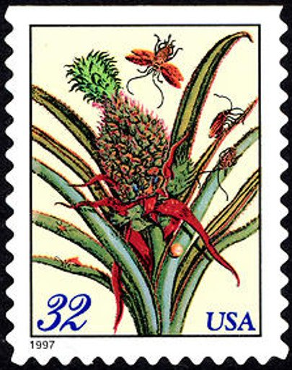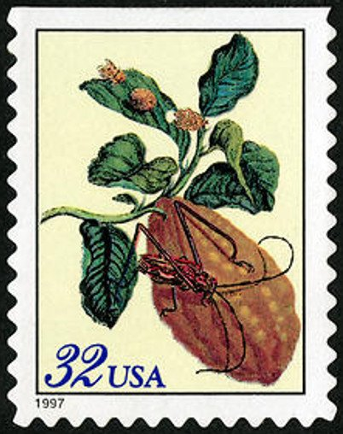

Maria Merian drew these plants while on a five-year expedition to Suriname in 1699. Nearly 52 years old, in a breakthrough accomplishment, she traveled from the Netherlands with her daughter, also an artist, to study the insect and plant life of the tropical Dutch possession. After two years, she contracted yellow fever. She was forced to return to Europe where she recovered. The publication in book form of her engravings of the wildlife she encountered in Suriname became her greatest work. She died in poverty in Amsterdam in 1717 at age 70.

Her artwork was always in the service of her scientific research into the transitions of insects during their life cycles. At that time, little was known about these processes. The metamorphosis of the caterpillar, for example, was still a mystery. Her research refuted that butterflies and other insects were born spontaneously. She went on to explore the life cycles of 186 insects.

These botanical illustrations should be of particular interest to collectors. They were issued in two formats in 1997: flat panes of 20 (as shown above) and folded booklets of 15. The two formats required stamps of different sizes resulting in four varieties rather than two. The latter, shown below (left, Scott 3128; right Scott 3129), are smaller in both dimensions measuring 22 mm by 27 mm. This was a new size for U. S. stamps.

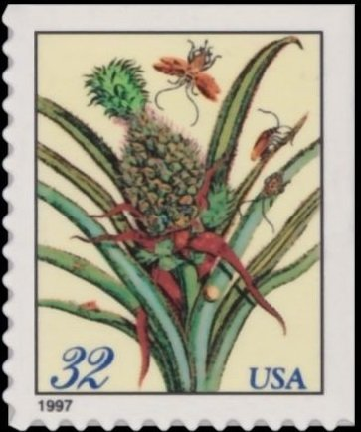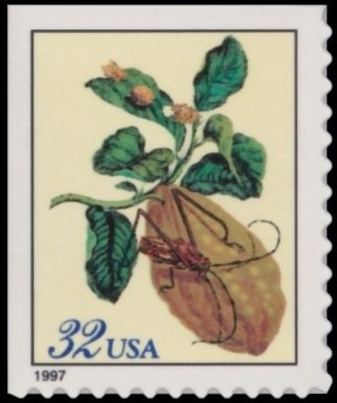The booklet stamps were also oriented differently. They were configured in three sections of five stamps. Four stamps were oriented vertically while the fifth stamp was rotated 90 degrees. No other US booklet had been arranged this way before. The turning of the stamps allowed the pane to fold to the dimensions appropriate for vending machines.

The simulated perforations on the large and small Merian stamps are die cut to different gauges. The larger ones measure about 10.8 by 10.3 while the small stamps measure about 11.3 by 10.7. As is the case with most self-adhesive panes and booklets that have die-cut simulated perforations, the individual stamps can be found in several different combinations of perforations and straight edges.

Look closely at the four images reproduced here. No need to resort to rulers or perforation gauges to distinguish the two formats. The position of the numerals in the denomination is unique to each. On the larger stamp printed for the 20-stamp panes, the “3” is close to the left line of the frame. On those printed for the 15-stamp booklets, there is a space between the frame and the numeral.

Phil Jordan had included Merian’s name in early designs of the stamps. The USPS told him to remove it as this was not a specific honor for her. The USPS yielded to museum officials such that Merian’s name and a short biography appear on the booklet cover and liner of the pane.

Louis Morel