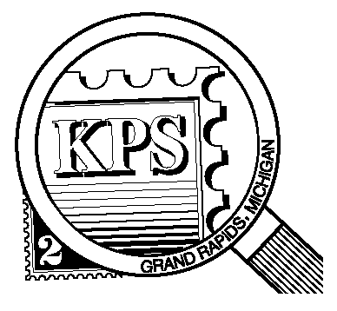

**2023**

**75 YEARS**

**1948**

## 



NEWSLETTER OF THE KENT PHILATELIC SOCIETY

P.O. Box 1156, Grand Rapids, Michigan 49501-1156

Gerry Frye, President 616-538-6069

Louis Morel, Editor 269-420-3128

KentPhilatelicSociety.com

K.P.S. Philatelist

Volume 68 - No. 9 September 2024

KPS Club News

|  |  |
| --- | --- |
| The annual Stamp Exhibition & Dealer Bourse (Kentpex) of the Kent Philatelic Society is coming up on Saturday, October 26 (10 AM to 4 PM) and on Sunday, October 27 (10 AM to 3 PM) at the Neal Fonger American Legion Post #179 in Walker. A stamp show is an excellent opportunity to acquire philatelic materials. It is also a unique opportunity to present your stories through the lens of postal history in an exhibit.  Whether your interest is in revenue stamps, Brazilian issues or classic paintings on stamps, consider fashioning an exhibit for the Stamp Show. Contact Ron Rich ([kcrichfamily@gmail.com](mailto:kcrichfamily@gmail.com)) if you wish to exhibit in October. He will provide you with a registration form and instructions. This year’s theme is “Going for the Gold”. The exhibit considered “Best of Show” will be awarded the “Gold” prize: a plaque, a medal, a certificate and a $25 voucher offered by Chris Daly. The “Silver” and “Bronze” exhibits will each receive a medal, a certificate and a voucher offered by Chris Daly.  We are looking for volunteers to help out with various tasks in preparation for the Show. We also need people at the registration desk to greet members and other collectors. Can you offer an hour or two of your time to help the Club? Let Bill Sobotka (616.531.3295) know that you are interested.  🟋🟋🟋  The Club has welcomed four new members so far this year. All | four were present at the August meeting. Among them, Maria Kiutule, who won the monthly drawing for a $10 certificate redeemable at the auctions.  🟋🟋🟋  Darrin Lettinga introduced us to a Japanese stamp with a unique postmark associated with the ship “Persia-Maru”. Darrin also explained the connection of this ship to Thomas Edison and the Titanic! Another example of the power of postal history.  🟋🟋🟋  **KPS Archives:** A 1935 graduate of Union High School, Reeves Simms, Jr. began his working career as a greenskeeper and a clerk in O’Reilly’s Hardware store. He joined the Navy and served until 1946. He spent two years as an aviation ordnance instructor and ended his service stationed in the Marshall Islands. His dedication and exemplary work carried through all his endeavors. He spent 39 years working for an auto parts store. He joined KPS in the early 1950s. He held about every available position in the Club including president (he served six terms). His exhibits focused on Mexican postal issues and early US air mail covers. A KPS award bearing his name is meant for a novice collector who demonstrates enthusiasm in stamp collecting by attending KPS meetings, promoting the hobby, and exhibiting at the annual Show. |

The KPS Board will enhance our monthly auctions by holding a drawing for a **FREE** $10 certificate toward the winning purchases of one lucky member. You need to be present to participate in the drawing.

**MONTHLY PROGRAM SCHEDULE**

The Kent Philatelic Society meets on the 4th **Tuesday** of the month at the Byron Center Baptist Church, 7343 Byron Center Ave SW, Byron Center.

|  |  |
| --- | --- |
| September 24, 2024: **KPS CLUB MEETING**  5:30 PM Board Meeting  6:30 PM Lot Viewing  7:00 PM Chris Daly Dealer Auction | October 22, 2024: **KPS CLUB MEETING**  5:30 PM Board Meeting  6:30 PM Lot Viewing  7:00 PM Donation Auction |
|  |  |

*Members are invited to share their philatelic experiences in this space. Perhaps you made a special acquisition, or thrive on an uncommon collecting topic, or saw a remarkable exhibit. Share it with your fellow collectors. Contact the Editor with your stories.*

**The Stamp That Never Was**

Last month’s tall tale, “Reaching for the Sky”, gave us a survey of the tallest man-made structures that were celebrated on postage stamps. The story introduced us to the medieval Lincoln Cathedral which surpassed the height of the Giza pyramid. To understand the philatelic outcome of that particular church, some context is required.

In the USA, the Citizens’ Stamp Advisory Committee uses its collective expertise in topics such as science and history to recommend subjects for postage stamps. In Great Britain, the Royal Mail itself selects the subjects of upcoming stamp issues. It appoints designers to draw up various possibilities for each issue. They are submitted to the Stamp Advisory Committee (SAC). It advises Royal Mail which they think are the best. Typically, special proofs known as essays are prepared. They reveal what the completed stamps will look like. Each stamp is presented to the ruling Monarch for review. Once the stamp has received royal approval, it can be printed and sold.

In 1968, the SAC advised Royal Mail to proceed with a proposed series of medieval English cathedrals as they were among the greatest architectural monuments of Europe. Four cathedrals would be chosen, each representing a different style and a different region of England.

The series would consist of a block of four stamps each denominated five-pence, a single stamp (nine pence) showing St. Paul’s in London, and a single stamp (one shilling, six pence) showing a modern cathedral. The set would illustrate English cathedrals throughout the ages.

Royal Mail invited artists to submit designs and conveyed instructions defining the scope of the project. The designs should include churches from different parts of England and, if possible, of different styles (Norman, Early English, Decorated, Perpendicular). The artists submitted many designs. The SAC reviewed the submissions and preferred the work of Peter Gauld. He submitted the churches of Durham, Lincoln, York and Canterbury for the five-pence issues, St Paul’s for the nine-pence, and Liverpool for the high denomination stamp.

The Committee suggested that Gauld produce another design showing St Giles Cathedral (Edinburgh) as an alternative for one of the four five-pence stamps. Gauld submitted the design. The Postmaster General (PMG) agreed that Gauld’s submissions were the best. He stated that St. Paul’s should be adopted for the nine-pence value and Liverpool for the one shilling, six pence stamp. For the four five-pence stamps he chose York, Canterbury and St Giles. The latter would provide a stamp for Scotland. In addition, he asked Gauld to design a five-pence stamp showing Salisbury Cathedral.

Gauld reasoned that Salisbury, with its tall spire, would not be shown to advantage on a horizontal stamp while a vertical design is impossible in a block of four where the others are horizontal: Nevertheless, a Salisbury design was produced.

The printer provided essays of these designs. They were presented to the SAC. After considerable discussion, the Committee opted even more strongly than before in favor of its original choice for the four medieval cathedrals: Durham, Lincoln, York and Canterbury. St Giles was a relatively minor building and had been poorly restored in recent times. There could be no justification for choosing it other than geographical.

The matter of including St Giles Cathedral was still a matter of debate. A member of the SAC argued that the Scottish church has no Bishop in its hierarchical structure and therefore has no cathedral in the Anglican sense of the word. The four cathedrals recommended by the SAC illustrated the four classic periods of architecture: Norman, Early English, Decorated and Perpendicular. In this context St Giles is architecturally the odd building out, the weakest choice in the set.

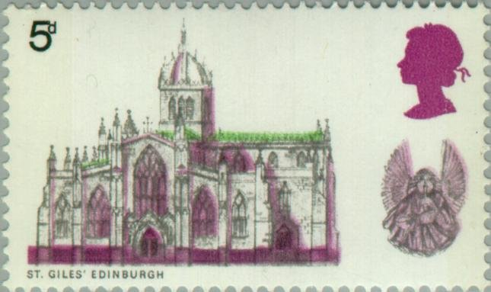The PMG wavered, first saying that St Giles should be included in place of Lincoln. A short while later he asked if Lincoln could be brought back into the block of four. It was too late. Any change would be costly and cause a delay in the delivery of the stamps. St. Giles was in (1969, Scott 591). Lincoln Cathedral was out. Our loss.

It took three centuries to build the Lincoln church. After its central spire was raised, the cathedral ruled the skies from its hilltop perch in Lincolnshire. Watching over the church’s famous choir, complete with carvings of angels, is the locally-beloved “Lincoln imp”, a horned grotesque carved into the top of a pillar. The story goes that the imp, sent by the devil to cause mischief, was turned to stone by an avenging angel, never to leave the church. With the completion of the Lincoln Cathedral (1311), the title of “world’s tallest building” entered an era of Christian churches competing to be at the top.

Louis Morel