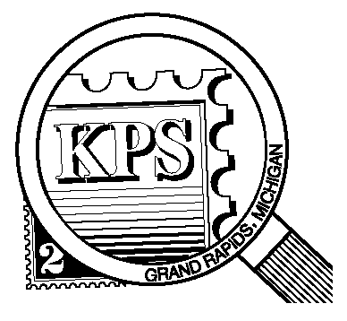

**2023**

**75 YEARS**

**1948**

## 



NEWSLETTER OF THE KENT PHILATELIC SOCIETY

P.O. Box 1156, Grand Rapids, Michigan 49501-1156

Gerry Frye, President 616-538-6069

Louis Morel, Editor 269-420-3128

KentPhilatelicSociety.com

K.P.S. Philatelist

Volume 68 - No. 10 October 2024

KPS Club News

|  |  |
| --- | --- |
| This year’s Stamp Exhibition & Dealer Bourse (Kentpex 2024) will be held on Saturday, October 26 (10 AM to 4 PM) and on Sunday, October 27 (10 AM to 3 PM) at the Neal Fonger American Legion Post #179 in Walker. There will be six dealers in the hall.  This is your last opportunity to register as an exhibitor for Kentpex. This year’s theme is “KPS Olympics: Going for the Gold”. The top three exhibitors will earn gold, silver and bronze prizes. Each prize includes a voucher that can be redeemed with member dealer Chris Daly. Contact Ron Rich ([kcrichfamily@gmail.com](mailto:kcrichfamily@gmail.com)) if you wish to exhibit this month. He will provide you with a registration form and instructions.  We are looking for volunteers to help out at the registration desk to greet members and other collectors. Can you offer an hour or two of your time to help the Club? Let Bill Sobotka (616.531.3295) know that you are interested.  🟋🟋🟋  The October meeting will feature a donation auction. All proceeds of the sales will go to the Club.  🟋🟋🟋  The annual awards dinner will be held on Tuesday, November 12 at Brann’s Steakhouse & Grille on Division Street in Wyoming. Mingling will start at 6 PM. The meal will be served | at 6:30 followed by the distribution of the awards and prizes.  🟋🟋🟋  Dr. Bradley Fisher (Missouri State University) interviewed people ages 60 to 93. He explored their understanding of successful aging and creativity and the requirements to achieve both. His study confirmed six features of successful aging: a sense of purpose, interactions with others, personal growth, self-acceptance, autonomy, and health. The findings indicate that creative activity contributes to successful aging by fostering a sense of competence, purpose, and growth. Philately as a hobby is definitely one of those creative activities that meets the requirements for successful aging as outlined in the study. Our hobby keeps us young!  🟋🟋🟋  **KPS Archives:** Mr. Milton Greenbaum of Saginaw, nationally known for his outstanding collection of Masonic covers, was the speaker at the July 1968 Club meeting. Years ago, each Postmaster could make his own cancelling devices in any way he wished. He could cut the insignia of an organization that he belonged to into cork or wood and cancel franked envelopes with it. Greenbaum showed 75 photographs of the 600 or so covers with Masonic cancellations that he owned. They were cancelled between 1851 and 1870. The various cancellations included the square and compass emblem, the double eagle and more. |

The KPS Board will enhance our monthly auctions by holding a drawing for a **FREE** $10 certificate toward the winning purchases of one lucky member. You need to be present to participate in the drawing.

**MONTHLY PROGRAM SCHEDULE**

The Kent Philatelic Society meets on the 4th **Tuesday** of the month at the Byron Center Baptist Church, 7343 Byron Center Ave SW, Byron Center.

|  |  |
| --- | --- |
| October 22, 2024: **KPS CLUB MEETING**  5:30 PM Board Meeting  6:30 PM Lot Viewing  7:00 PM Donation Auction | November 26, 2024: **KPS CLUB MEETING**  5:30 PM Board Meeting  6:30 PM Lot Viewing  7:00 PM Presentation and Table Auction |
|  |  |

*Members are invited to share their philatelic experiences in this space. Perhaps you made a special acquisition, or thrive on an uncommon collecting topic, or saw a remarkable exhibit. Share it with your fellow collectors. Contact the Editor with your stories.*

**National Stamp Collecting Month**

British schoolteacher, Roland Hill (1795-1879), tried to make the postal service more efficient. Early postal methods delivered mail to the recipient without any sort of payment until the delivery was complete. As such, there was never any guarantee of payment which created a lot of risk and losses for the postal service. Hill recommended using a form of prepayment described as, “A bit of paper just large enough to bear the stamps showing that tax had been paid, and covered at the back with a glutinous wash which the bringer of the letter might, by applying a little moisture, attach to the back.” His ingenious idea did not receive universal acceptance at first. By 1840, postage stamps as we know them were a reality in Great Britain.

It did not take long for some cities, city-states, kingdoms, and countries to follow suit. Within a decade, New York City, Zurich, Geneva, Bavaria, Brazil, the United States, Mauritius, Belgium, and France had issued their first postage stamps. And people began collecting them!

A French collector, Georges Herpin, noticed that collecting had been popular for about six years. The activity needed a suitable name. In 1864, he took the Greek root words *phil(o)-*, meaning "an attraction or affinity for something", and *ateleia*, meaning "exempt from duties or taxes", to form "philatélie". The introduction of official, paid stamps meant that the reception of letters was now free of charge.

By the time Herpin had given the hobby a new name, there was already a stamp catalogue available. The world’s first catalogue was published three years earlier in France by Oscar Berger-Levrault. It was the basis for the first illustrated catalogue, by Alfred Potiquet, published in December of 1861. Great Britain’s first catalogues were published in 1862 by Frederick Booty, Mount Brown and Dr. John Edward Gray. The first in the U.S., also that year, was ‘The Stamp Collectors Manual’, by A.C. Kline.

By the mid-1860s, every pair of countries that exchanged mail had to negotiate a postal treaty with each other. In the absence of a treaty providing for direct delivery of letters, mail had to be forwarded through an intermediate country. Postal arrangements were complex to say the least. On October 9, 1874, 22 countries gathered to sign the Treaty of Bern, creating the General Postal Union, which would later become known as the Universal Postal Union. A century and a half later, the UPU now unites the postal networks of 192 member countries, having realized its founders’ vision of establishing a single postal territory to serve people everywhere. The UPU’s theme for this, its 150th year – “150 years of enabling communication and empowering peoples across nations”.

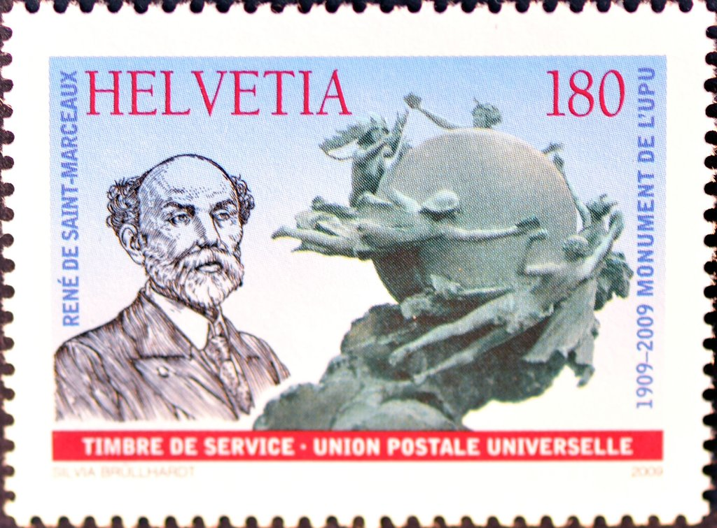The Swiss issue (Scott 9O22, 2009) honors the UPU Monument *Around the World* whichwas created by the French sculptor René de Saint-Marceaux. It was inaugurated on October 4, 1909, after de Saint-Marceaux won an international competition in which more than 120 artists participated. The central image of the monument – the five women passing letters around a globe – was adopted as the UPU emblem several decades ago and symbolizes international postal communication.

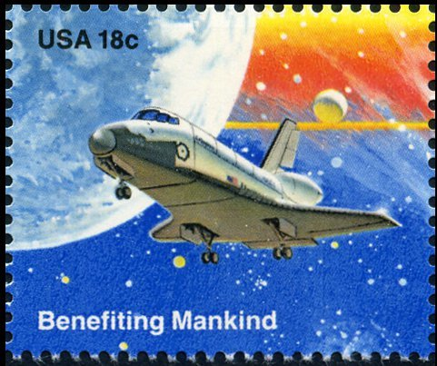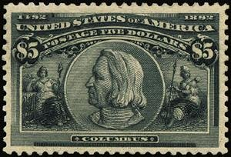On October 1, 1981, the USPS began its very first National Stamp Collecting Month in collaboration with the extinct Council of Philatelic Organizations.

That first year, the USPS produced a souvenir card picturing two stamps (shown above) – Scott 245, the $5 issue showing Christopher Columbus (1893), and Scott 1918, the 1981 “Benefiting Mankind” stamp from that year’s Space Achievement issue. The theme that first year was “Discover Stamp Collecting – the Hobby of a Lifetime.”

The 1985 issue of the block of four horses (Scott 2155-2158), has been associated, perhaps erroneously, as the first stamps issued by the USPS specifically for National Stamp Collecting Month. This stems from the first-day program which was hosted by Deputy Postmaster General Jackie Strange. She used the American Horses block as a platform to promote October as National Stamp Collecting Month. Ever since, the USPS has issued a set of stamps most years in late September or early October to celebrate National Stamp Collecting Month. Often, these stamps are geared toward children, to help increase interest in a new generation of collectors.

Louis Morel