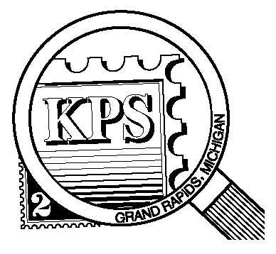

NEWSLETTER OF THE KENT PHILATELIC SOCIETY
P.O. Box 1156, Grand Rapids, Michigan 49501-1156
Gerry Frye, President 616-538-6069
Louis Morel, Editor 269-420-3128
KentPhilatelicSociety.com

K.P.S. Philatelist
Volume 70- No. 1 January 2026

KPS Club News
Happy “National Hobby Month”  Dan Ondersma and Louis Morel were re-elected to the board at the December meeting. The Officers of the Club will be chosen at this month’s board meeting on January 27. There are two remaining positions on the board that need to be filled. Are you going to join the Board to contribute to the advancement of our Club? Please contact Jerry Frye (616.538.6069) if you would like to volunteer or have questions about the role.  Twenty-five people attended the December potluck dinner. David Luke moderated a philatelic quiz which taxed a certain number of gray cells. Some members went home with prizes. A good time was had by all.  The Toledo Stamp Expo will take place in Perrysburg, Ohio, on February 27 and 28. The organizing committee has reached out to Clubs and extended an invitation to exhibit at the Show. Contact Charlie Schafstall for more information if you wish to participate. His email address is cschafstall82@gmail.com.  The program calendar for this year accompanies the newsletter. It lists the various auctions that will take place at our monthly | meetings. Also, we can look forward to a number of presentations by Club members on a variety of topics.  Most members have renewed their KPS membership for 2025. The cost remains unchanged at $15 for the year. Please make your payment as soon as possible if you have not done so already. You can drop it off at the next Club meeting. You can also send a check made out to Kent Philatelic Society to the address found above in the masthead.  The Archives: The editorial published in the February 1959 issue of the KPS Philatelist was titled “This Is Your Club – You Make It or Break It!”. Marjorie Nind and Sarah Nicholson, co-editors, exhorted members to take an active part in the Club. They provided a three-prong approach to contributing. First, attend as many meetings as possible. Take an active part in discussions, auctions, and social hours. Second, prepare a talk on your collection or philatelic interest. There is a diversity of collecting interests and different ways of collecting. Let’s share our knowledge. Finally, they encouraged members to contribute to the newsletter. Its purpose exceeded announcing the next speaker or commenting on the previous meeting. It was an opportunity to contribute something about one’s philatelic journey. That remains true today.

The KPS Board will enhance our monthly auctions by holding a drawing for a FREE $10 certificate toward the winning purchases of one lucky member. You need to be present to participate in the drawing.

MONTHLY PROGRAM SCHEDULE
The Kent Philatelic Society meets on the 4th Tuesday of the month at the Byron Center Baptist Church, 7343 Byron Center Ave SW, Byron Center.
January 27, 2026: KPS CLUB MEETING  5:30 PM Board Meeting  6:30 PM Lot Viewing  7:00 PM Floor Auction | February 24, 2026: KPS CLUB MEETING  5:30 PM Board Meeting  6:30 PM Lot Viewing  7:00 PM Dealer Auction: Chris Daly

Members are invited to share their philatelic experiences in this space. Perhaps you made a special acquisition, or thrive on an uncommon collecting topic, or saw a remarkable exhibit. Share it with your fellow collectors. Contact the Editor with your stories.
Cuneiform Writing
One-summer day in 1856, a letter carrier stepped from a mail coach in front of a three-story townhouse in central London. The courier handed a wax-sealed envelope to a clerk. The missive was addressed to the secretary of one of Europe’s leading research institutions. The postman had no way of knowing that the envelope would help rewrite the story of civilization’s origins and ignite a contest for international renown. At stake: the immortality conferred on those who make a once-in-a-century intellectual breakthrough. Three men, driven by boundless curiosity, a love of risk, and the distinctive demons of aspiration and ambition, were most responsible for making the contest possible.

The first was Austen Layard. At age 22, he had fled the drudgery of a law office for a life of adventure on the backroads of the Ottoman Empire. He joined a rebellious mountain tribe in Persia (now Iran) and spied in the Balkans for the British ambassador in Constantinople. He reached the mounds of Mesopotamia, where he transformed himself into one of the most celebrated archaeologists of the age.
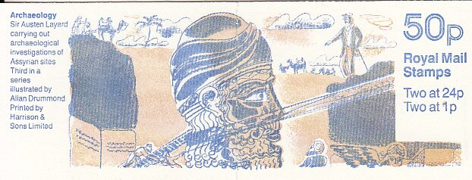
The Royal Mail commissioned Allan Drummond to illustrate the covers of four booklets honoring famous British archaeologists. The one shown above (Stanley Gibbons FB61) was released in 1992 and was the third in a series. The text reads “Sir Austen Layard carrying out archaeological investigations of Assyrian sites.” Assyria was a kingdom of northern Mesopotamia. It became the center of one of the great empires of the ancient Middle East. It was located in what is now northern Iraq and southeastern Turkey. Its history spanned fourteen centuries starting in the twenty-first century BCE.

Another contestant was Henry Rawlinson who decided early on that he would carve his own identity in exile. As a 23-year-old military officer of the East India Company, he found himself in Persia. There, he demonstrated a flair for languages and a skill at scaling heights in search of millennia-old inscriptions. In his early 30s, he deciphered the writing of the ancient Persian Empire which brought him fame.

Finally, there was Irishman Edward Hincks, a country parson. Hincks was hungry for peer recognition of his linguistic gifts. He had translated obscure texts written in Egyptian hieroglyphs and ancient Hebrew.

Until the 1840s, few Europeans knew anything about the great civilizations that began their rise along the Tigris and Euphrates Rivers around 2000 BCE. Researchers began investigating antiquity by digging objects out of the earth. And Layard was one of its most spectacularly successful practitioners. He made a series of discoveries including 2,500-year-old Assyrian palaces. Unreadable inscriptions swirled around the carvings. The characters were dubbed cuneiform. Rawlinson and Hincks were recognized for their significant contributions to the deciphering of Assyrian cuneiform.

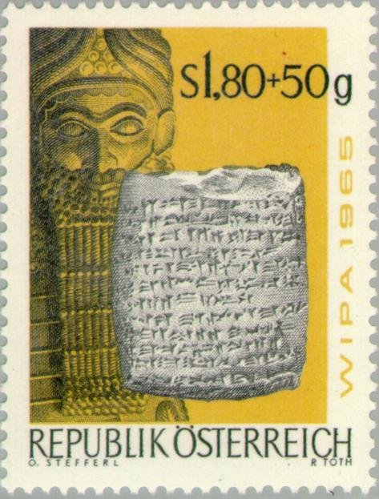
Cuneiform means "wedge-shaped," a term the Greeks, and later, the Romans, used to describe the look of the signs. Cuneiform was invented some 6,000 years ago in Mesopotamia and it was most often written on clay tablets a few inches square and an inch high. Deciding to use clay for a writing surface was ingenious because clay has proven to be the most durable, and perhaps most sustainable, writing surface humanity has used.

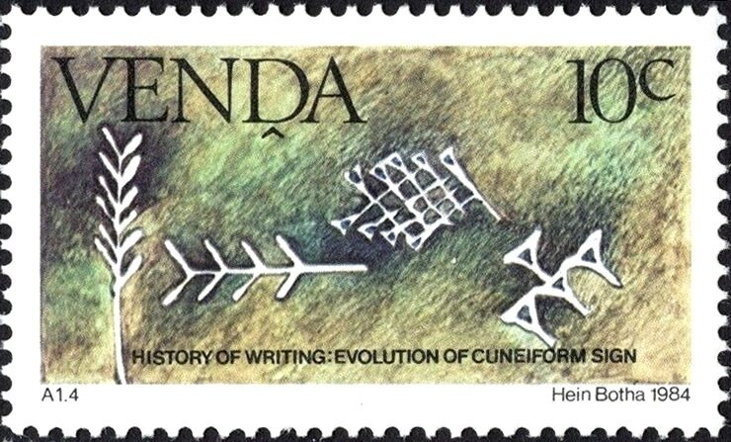
Examples of cuneiform are shown nearby. Above is an Austian stamp (Scott B316) issued in 1965. It shows cuneiform script on a clay tablet excavated in Assyria. Below is a stamp issued in 1983 (Scott 65) by the Republic of Venda. In 1962, the South African Government created Venda as a Homeland for the Venda-speaking people. It was granted independence in 1979. Venda was not recognized as an independent country by the rest of the world. Venda issued stamps from 1979 until all the Homelands in the country were absorbed into South Africa in 1994.

The origins of writing lie in the need to keep better records such as keeping track of sheep sales, for example, not, as many might assume, to express oneself or pray. Most agree that cuneiform evolved into the first full-fledged writing system with signs corresponding to speech.
Louis Morel

