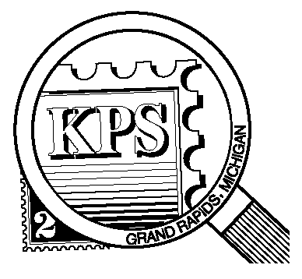

**2023**

**75 YEARS**

**1948**

## 



NEWSLETTER OF THE KENT PHILATELIC SOCIETY

P.O. Box 1156, Grand Rapids, Michigan 49501-1156

Gerry Frye, President 616-538-6069

Louis Morel, Editor 269-420-3128

KentPhilatelicSociety.com

K.P.S. Philatelist

Volume 68 - No. 8 August 2024

KPS Club News

|  |  |
| --- | --- |
| It is with regret that we share the passing of long-time KPS member Russell Povenz, Sr. He joined the Club in 1990. He was an avid collector of US stamps until recently. The Club has sold much of his collection in recent months at his request. Russell passed away on July 16 at age 92.  🟋🟋🟋  The Club needs volunteers to step forward and help with numerous activities that are coming up. The Program Committee Chairman is seeking assistance in identifying and scheduling the presentations and auctions for the coming calendar year. Will you give an hour or two of your time to help put together the calendar of events for next year? The task will be conducted most likely by phone or email. Contact Louis at the number found above in the masthead.  As the famous adage goes, “The Show must go on!” With your help we can ensure that the Kentpex Stamp Show will continue to meet collectors’ needs. The Club needs volunteers to make the Show a success. Please call Bill Sobotka (616.531.3295) to volunteer one or two hours of your time. We need people to help with all aspects of the Show such as setting up the exhibits and welcoming visitors at the registration desk. Above all, we need a chairperson to oversee all the activity that the Show entails. Will that be you?  🟋🟋🟋 | Darrin Lettinga has done much research into Japanese postal history. He will offer us “Postmark Stories — Number 1” at the August meeting. It is the tale of an unusual postmark he found on a Japanese cover.  🟋🟋🟋  **Erratum:** The July issue of The Philatelist published the wrong day of the week for the upcoming August meeting. The meetings are still held on the fourth Tuesday of the month. See the schedule below.  🟋🟋🟋  **KPS Archives:** The May 1989 issue of The Philatelist profiled member Fred Langland. He graduated from Union High School in 1936. Jobs were very difficult to find. He took one selling household products door-to-door. It did not pay much. The arrival of a gas supply in Grand Rapids was a boon for him. Theat same year he joined Grand Rapids Gas Company and sold appliances. That came to an end in 1940 as production of war materiel took precedence. A boyhood injury kept him out of the military. Fred took to selling books such as the classics and encyclopedias. The advent of television changed the public’s taste for reading and Fred switched fields: he began to sell cemetery plots and services. Fred, a worldwide collector, had the distinction of being KPS member #5. He was the Club’s first Treasurer (1951), and President twice (1953 and 1967). |

The KPS Board will enhance our monthly auctions by holding a drawing for a **FREE** $10 certificate toward the winning purchases of one lucky member. You need to be present to participate in the drawing.

**MONTHLY PROGRAM SCHEDULE**

The Kent Philatelic Society meets on the 4th **Tuesday** of the month at the Byron Center Baptist Church, 7343 Byron Center Ave SW, Byron Center.

|  |  |
| --- | --- |
| August 27, 2024: **KPS CLUB MEETING**  5:30 PM Board Meeting  6:30 PM Lot Viewing  7:00 PM Presentation and Floor Auction | September 24, 2024: **KPS CLUB MEETING**  5:30 PM Board Meeting  6:30 PM Lot Viewing  7:00 PM Chris Daly Dealer Auction |
|  |  |

*Members are invited to share their philatelic experiences in this space. Perhaps you made a special acquisition, or thrive on an uncommon collecting topic, or saw a remarkable exhibit. Share it with your fellow collectors. Contact the Editor with your stories.*

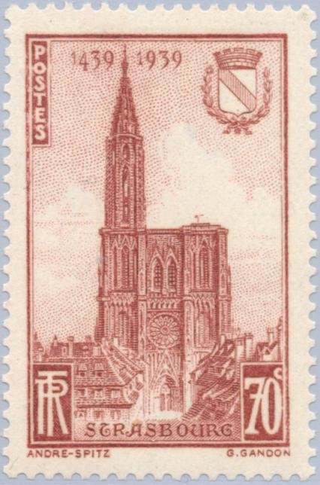**Reaching for the Sky**

Architect William Van Alen watched as a 185-foot steel needle rose from his unfinished masterpiece, the Chrysler Building. Now the city’s tallest building with its 27-ton spire, the Chrysler’s height reached 1,046 feet. But there was hardly any time for celebration. Plans had already been announced for the Empire State Building which would shatter the Chrysler’s record just over a year later. More important, the morning after Van Alen’s coup, a calamitous stock market crash plunged the United States into the deepest economic crisis the country had known. The Chrysler Building resonated as an Art Deco exclamation point to mark the end of the Gay 20s.

While the Chrysler Building was the tallest man-made structure for only one year, other buildings held that title for much longer periods.

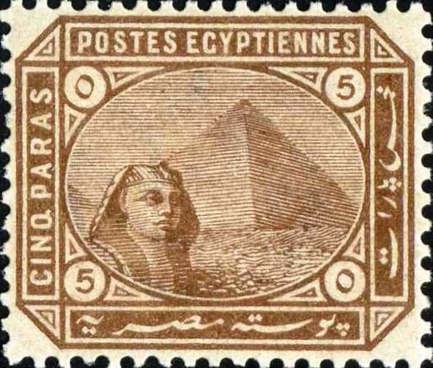The Great Pyramid—also known as Khufu, after the Egyptian pharaoh it was built to entomb—is the largest of Giza’s pyramids (at left, Egypt, 1889, Scott 29). It was built around 2600 BCE, over a period of about 27 years. Initially standing at 481 feet, the Great Pyramid was the world's [tallest human-made structure](https://en.wikipedia.org/wiki/List_of_tallest_buildings_and_structures#History) for more than 3,800 years. Over time, most of the smooth white [limestone](https://en.wikipedia.org/wiki/Limestone) casing eroded away which lowered the pyramid's height to the current 454 feet. Khufu enjoyed three reigns as the world’s tallest building. Rivals rose, took over the top spot for tallest structure but collapsed during the medieval period and the Renaissance. During its unmatched first stint at the top, totaling almost four millennia, the only competitor that came close in height was the Lighthouse of Alexandria, which stood about 350 feet tall before it fell.

It was a Gothic church in Lincolnshire, England that dethroned the Great Pyramid as the tallest man-made structure. It took three centuries to complete this church. The top of its spire reached 525 feet above the ground. It would not be challenged until 1548 after Lincoln’s spire fell in a horrible storm. St. Mary's Church in Stralsund, Germany, then took the title at 495 feet tall. When, its spire collapsed, the Beauvais Cathedral in France moved into the top spot. The Lincoln Cathedral will be in the thick of next month’s philatelic tale.

From the Middle Ages until the advent of the skyscraper, Christian church buildings were often the world's tallest buildings. From 1311, when the spire of Lincoln Cathedral surpassed the height of the Great Pyramid of Giza, until the Washington Monument was completed in 1884, a succession of church buildings held this title. Among them was the Cathedral of Strasbourg (shown at left, France, 1939, Scott 391, issued to commemorate the 500th anniversary of the church) which held the title the longest. The Nazi army stole its stained-glass windows. In 1945, they were discovered in a German salt mine by the U.S. Army’s Monuments Men, a group of deployed art preservationists.

The Washington Monument, at a height of 555 feet, put an end to the long string of tallest buildings dedicated to religious rites. Funding difficulties caused the construction to occur in two phases and with three different marbles. The stones weathered differently causing contrast in their colors. No mortar was used in the construction of the Monument. It stands supported only by the weight of its stones and the friction between them. The Monument was completed in 1884.

Five years later, Alexandre Eiffel unveiled his striking Tower at the Paris World’s Fair. It stretched 1024 feet. Most of the time. As its iron expands or contracts with changes in temperature, the Tower grows a few inches each summer and shrinks in the winter. A succession of American buildings brought the title of tallest man-made structure to the United States throughout the twentieth century. The Chrysler Building, the Empire State Building, the World Trade Center and the Willis (originally Sears) Tower held the title.

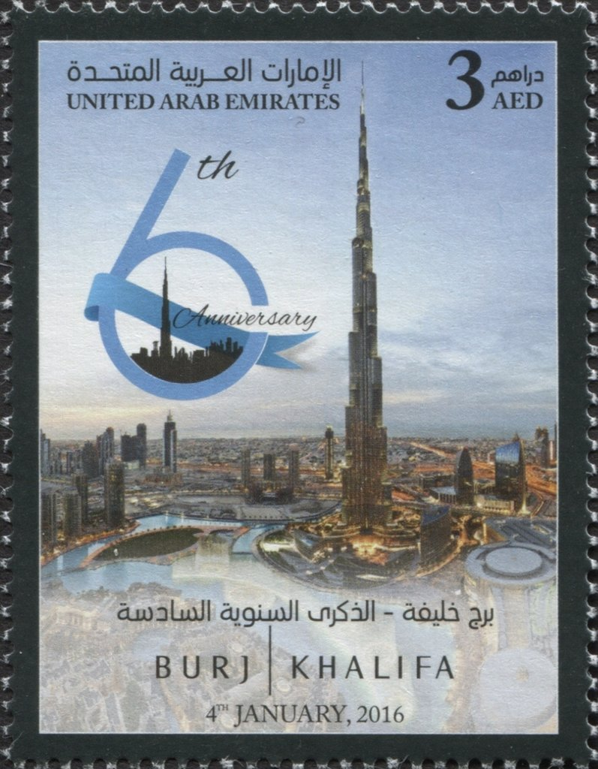A “megatall” skyscraper—a classification for buildings over 600 meters (1,968 feet) tall—was raised in just six years, with construction costing $1.5 billion. Currently the world’s tallest building (shown at right, United Emirates, 2016, Scott 1229), the Burj Khalifa, located in Dubai, also holds records for the highest observation deck, longest elevator shaft and more. The gleaming tower is 200 stories tall, but only 160 are habitable. The top 29 percent of the structure consists of floors filled with structural support built to increase the height of the building. The building’s accessible floors host a five-star hotel, offices, restaurants and residences designed by Giorgio Armani.

Louis Morel