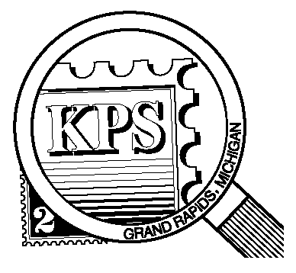

**2023**

**75 YEARS**

**1948**

## 



NEWSLETTER OF THE KENT PHILATELIC SOCIETY

P.O. Box 1156, Grand Rapids, Michigan 49501-1156

Gerry Frye, President 616-538-6069

Louis Morel, Editor 269-420-3128

KentPhilatelicSociety.com

K.P.S. Philatelist

Volume 68 - No. 7 July 2024

KPS Club News

|  |  |
| --- | --- |
| The KPS celebrated 75 years of continuous operation by hosting a **Summer Social and Mini-Bourse** on Saturday, June 29. More than 60 collectors attended the event. Three of them joined our ranks. Dealers Chris Daly, a KPS member, and David Alex were on hand to cater to collectors’ needs. Many took the opportunity to browse through boxes from Bernie Jager’s extensive collection. Bernie passed away earlier this year. He served the Club with great dedication for many years.  Dan Ondersma and Bob Toland cooked hamburgers, hot dogs, and bratwurst for those in attendance. Thirty people won a door prize. Mike Baranoski of the Kalamazoo Stamp Club held the winning 50/50 ticket and went home $79 richer.  Among those in attendance were collectors who have been Club members for more than a quarter century. None can hold a candle to Richard Walquist. He was present as he has been for the past 62 years!  The event was a success by all accounts.  🟋🟋🟋  Darrin Lettinga introduced many members to the field of social philately at the June meeting. This is an obscure area of interest for many collectors. Its purpose is to give context to a franked cover in a broader non-philatelic sense. Starting only with the | names of the sender and the recipient, a signed note as well as the cancellation information, Darrin described the research he conducted to bring to light the details of a letter a woman sent from Japan to her father in England. Using government and genealogical documents as primary sources, he was able to paint a portrait of this family. He will share another example of his research at the August meeting.  🟋🟋🟋  **KPS Archives:** The June 4, 1984 issue of the Grand Rapids Press reported the opening of a philatelic service at the main post office. This special station was designed to cater to philatelists. It was open from 11 AM to 1 PM on weekdays and from 10 AM to 12 PM on Saturdays. There were two other such stations in Michigan at the time. One was located in Detroit while the other was in Saginaw.  The newspaper article quoted the USPS Director of Customer Services, Donald Buzalski. He described the area as follows. “The oaken paneling and windows came from three small post offices that were renovated in the Detroit area. There is a large oaken case displaying commemorative stamps and souvenir cards.”  Mr. Buzalski said he found the case at a local salvage company and restored it from its “disheveled” condition.  What became of this philatelic service? |

The KPS Board will enhance our monthly auctions by holding a drawing for a **FREE** $10 certificate toward the winning purchases of one lucky member. You need to be present to participate in the drawing.

**MONTHLY PROGRAM SCHEDULE**

The Kent Philatelic Society meets on the 4th **Tuesday** of the month at the Byron Center Baptist Church, 7343 Byron Center Ave SW, Byron Center.

|  |  |
| --- | --- |
| July 23, 2024: **KPS CLUB MEETING**  5:30 PM Board Meeting  6:30 PM Lot Viewing  7:00 PM Gordon Freeman Auction | August 26, 2024: **KPS CLUB MEETING**  5:30 PM Board Meeting  6:30 PM Lot Viewing  7:00 PM Presentation and Floor Auction |
|  |  |

*Members are invited to share their philatelic experiences in this space. Perhaps you made a special acquisition, or thrive on an uncommon collecting topic, or saw a remarkable exhibit. Share it with your fellow collectors. Contact the Editor with your stories.*

**All the Roads Lead to Paris**

The world will convene in France this month to hold the Games of the XXXIII Olympiad. Paris will host the event for the third time. It hosted in 1900 and 1924.

Olympic philately is a category of collecting in which the images or subjects on the postal products are related to the Olympic Games or the Olympic movement. The theme or topic may recount a moment in the history of the ancient or modern Olympic Games. For instance, it may chronicle the recent developments of the current Olympic movement or mark achievements of a host country.

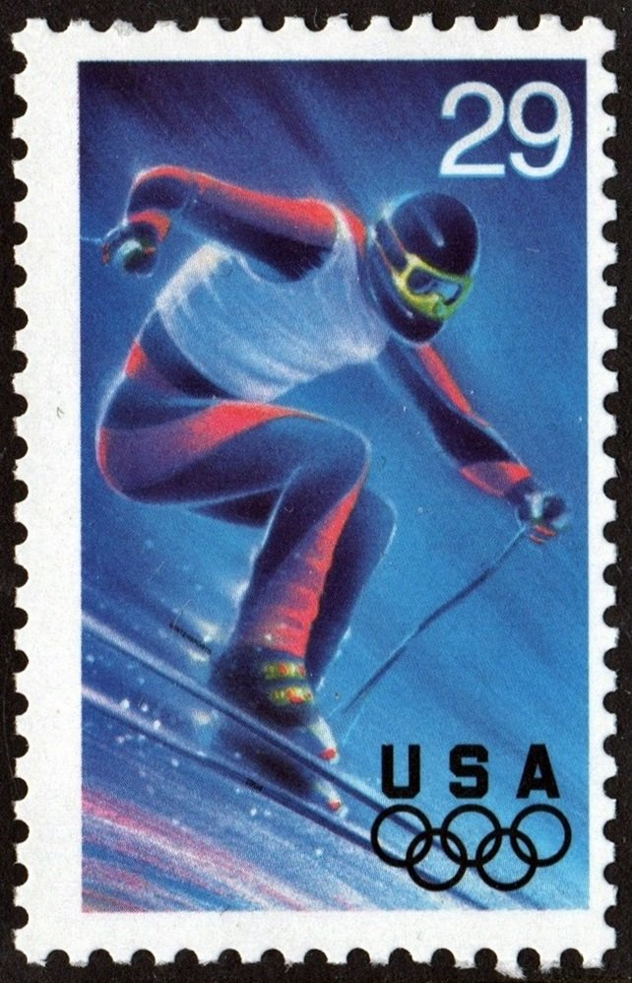Many countries have issued stamps to promote their participation in the Summer and Winter Olympic Games. Greece issued the first set of Olympics stamps on March 25, 1896 to commemorate and help finance the first Modern Olympic Games in Athens. Olympic philately was born. Olympic stamps did not reappear until 1920, and while there have been stamps for every Games since, it was really from 1956 and the Melbourne Olympic Games that Olympic stamp issues took off.

The United States hosted the 1904 Games in St. Louis. The Post Office Department did not issue a stamp to mark the occasion. It wasn’t until 1932 that the first U.S. Olympic Games stamp was issued to highlight the international competition. The third Winter Games were held in Lake Placid, a small town in upstate New York. The Lake Placid Chamber of Commerce asked the village postmaster to suggest a commemorative stamp for the event. A New York congressman helped persuade reluctant officials, and the stamp was approved.

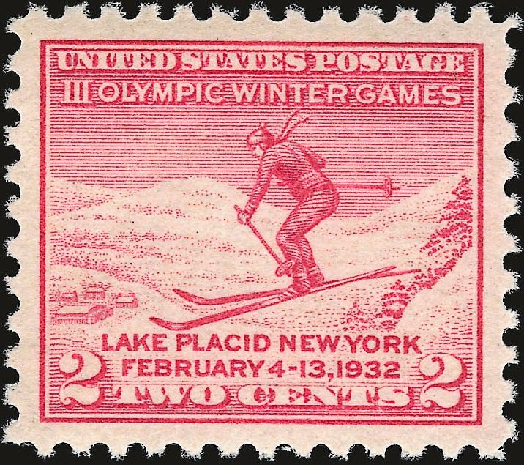The 2¢ Winter Olympic Games stamp (Scott 716) was issued just days before the opening ceremonies. It was only sold in Lake Placid and Washington, D.C. There was a great demand for the stamp from the moment the Lake Placid Post Office opened at 7 AM. Its entire supply of 400,000 stamps was exhausted by mid-morning. It is said that the State police had to be called in to control the crowd.

The stamp’s image features a ski jumper. The athlete pictured on the stamp is clearly grasping a pair of poles as he soars through the-air. Ski-jumpers don’t use poles. The design error embarrassed postal officials.

Fewer than five months later, the Post Office issued its second and third Olympics stamps, honoring the Summer Games. Both stamps were issued on June 15, 1932, in Los Angeles, the site of the games. One covered the newly approved rate (3¢, Scott 718) for first-class postage. The other covered the international letter rate (5¢, Scott 719) and was used by athletes from other countries. The design is based on a classic Greek sculpture called *Discobolus* which dates from the 5th century BC.

It would be nearly 30 years before the US issued another stamp honoring the Olympics. That issue commemorated the return of the Games to the USA. The 1960 Winter Olympics were held in Squaw Valley, California. Since 1972, the USPS has issued stamps for many Summer and Winter Olympic Games. None has been issued since the Winter Games held in Vancouver in 2010.

Artist Lon Busch designed the five stamps (Scott 2807-2811) released for the 1994 Winter Games held in Lillehammer, Norway. Each stamp features the color of one of the Olympic rings – the Alpine skier is blue, the luge is yellow, the ice dancing is black, the Nordic skier is green, and the ice hockey is red. Security features were incorporated into the stamps’ designs in order to thwart counterfeiters. The USPS chose to use a classic security element. It incorporated words into the design that are nearly invisible to the naked eye (microprinting). For example, “WINTERSPORTS” is embedded in a small dark line behind the skier’s right foot and “1994” is microprinted on the side of the ski under his left foot.

The First Day of Issue program was held in Salt Lake City, Utah – America’s proposed city to host the 2002 Winter Olympics. It won the bid.

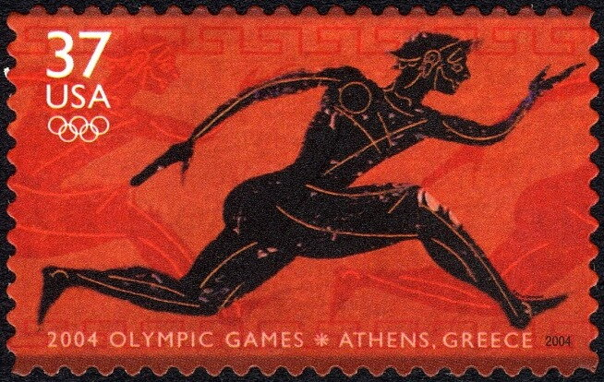The first Olympic Games took place in Athens, Greece, in 776 B.C. The Olympics returned to their origin when Athens hosted the XXVIII Olympiad in 2004. The USPS issued a single stamp (Scott 3863) to mark the event. This stamp was also designed by Lon Busch. The stamp features a stylized depiction of a Greek runner and is reminiscent of the artwork on ancient Greek black-figure vases that inspired this stamp. The phrase “XXVIII Olympiad” is microprinted above the runner’s right foot.

Louis Morel