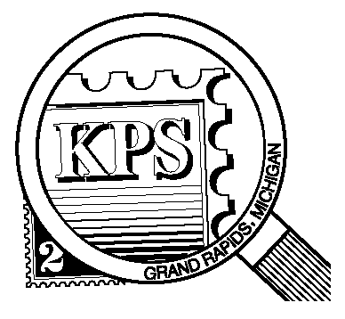

## 



NEWSLETTER OF THE KENT PHILATELIC SOCIETY

P.O. Box 1156, Grand Rapids, Michigan 49501-1156

Jerry Frye, President 616-538-6069

Louis Morel, Editor 269-420-3128

KentPhilatelicSociety.com

K.P.S. Philatelist

Volume 69 - No. 8 August 2025

KPS Club News

|  |  |
| --- | --- |
| Our Club has yet another member, the eighth this year. Mike Baranoski follows in the footsteps of Madeline and Bill Medonis who joined recently. All are also members of the Kalamazoo Stamp Club. Mike collects stamps from the US and its possessions, worldwide prior to 1940, as well as Michigan postal history. We hope to learn about his philatelic journey at our Club meetings.  🟋🟋🟋  The July Club meeting was a resounding success. About twenty-five members attended. Nearly eighty lots from Richard Walquist’s worldwide collection were auctioned off. Recall that Richard has been a KPS member since 1962! The cumulative catalog value of the lots was a few dollars shy of $3,000. “Auctioneer” Bill Sobotka pronounced it the liveliest auction he has ever held at KPS! Will the excitement be repeated at this month’s meeting? Fifteen to twenty more lots of Richard’s collection of canceled stamps are expected to be on the auction block.  🟋🟋🟋  In addition to the floor auction, the August meeting will feature a presentation by member Bob Toland. He will discuss coil plate numbers. Coil stamps are issued in rolls for use, chiefly, in vending machines. Businesses can use them for bulk mailings as they are available in rolls of 3,000 and 10,000 stamps. Canadian, Swedish and US coil stamps are perforated | horizontally or vertically. German and British coils, for example, are perforated on all sides like sheet stamps.  🟋🟋🟋  KPS member, Carol Ligda-Wong, will put her Canadian collection up for auction at the September meeting. Her collection consists of more than 1500 stamps. Acquiring such a trove is an ideal way to jump start a new country collection or to fill gaps in an existing one. Interested? You can request a partial list of the available stamps by writing to [kps.stampclub@gmail.com](mailto:kps.stampclub@gmail.com).  🟋🟋🟋  The theme of the Kentpex 2025 Stamp Show will be Benjamin Franklin as we celebrate the 250th anniversary of his appointment as the first American Postmaster General. Contact Ron Rich ([kcrichfamily@gmail.com](mailto:kcrichfamily@gmail.com)) to obtain a registration form if you wish to exhibit at Kentpex in October.  🟋🟋🟋  Darrin Lettinga’s work schedule in the foreseeable future will prevent him from actively participating on the Club’s Board. While he will remain a member, Darrin has resigned his position on the Board. He will continue to oversee the Club’s presence on social media. Are you interested in filling the vacancy on the Board? Contact Jerry Frye for more details (616-538-6069). |

The KPS Board will enhance our monthly auctions by holding a drawing for a **FREE** $10 certificate toward the winning purchases of one lucky member. You need to be present to participate in the drawing.

**MONTHLY PROGRAM SCHEDULE**

The Kent Philatelic Society meets on the 4th **Tuesday** of the month at the Byron Center Baptist Church, 7343 Byron Center Ave SW, Byron Center.

|  |  |
| --- | --- |
| August 26, 2025: **KPS CLUB MEETING**  5:30 PM Board Meeting  6:30 PM Lot Viewing  7:00 PM Presentation and Floor Auction | September 23, 2025: **KPS CLUB MEETING**  5:30 PM Board Meeting  6:30 PM Lot Viewing  7:00 PM Chris Daly Auction |
|  |  |

*Members are invited to share their philatelic experiences in this space. Perhaps you made a special acquisition, or thrive on an uncommon collecting topic, or saw a remarkable exhibit. Share it with your fellow collectors. Contact the Editor with your stories.*

**A Withdrawn US Stamp**

This month marks the 80th anniversary of the attacks on Hiroshima and Nagasaki. The USPS issued five sheetlets from 1991 to 1995 each consisting of ten stamp designs. They highlighted significant events that determined the course of World War II. The USPS ensured uniformity in the design by using a single designer, British-born WWII veteran William Bond, and a single art director, Howard Paine.

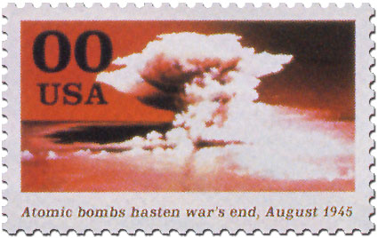Bond included a stamp that depicted a mushroom-shaped nuclear bomb cloud against a red sky (shown at right) for the last sheetlet “1945: Victory at Last”. The caption read “Atomic bombs hasten war’s end, August 1945”. The prototype sheetlet was unveiled in November 1994. All the stamps had a denomination of 00 $¢$ as shown above.

Japanese government officials got wind of the proposed stamp and expressed their anger. The Japanese ambassador to the USA asked the government to reconsider issuing the stamp. The Foreign Minister told reporters “As the only country to have suffered the atomic bombings, the Japanese people will not have positive feelings toward the design of the stamp.” At first the Postal Service held firm. It refused to omit such a historically critical event as the use of atomic bombs. Its intent was “to provide a comprehensive history of the events of WW II…and we are not making a value judgment on any of those events.”

The Postal Service Board of Directors discussed the controversy. The Board directed Postmaster General Marvin Runyon to keep the design unless the President asked him to change it. The next day the State Department formally requested that the USPS reconsider the design due to “Japanese sensitivities”. A day later, coincidentally December 7, Leon Panetta, White House Chief of Staff, conveyed the administration’s concern about the stamp. While there was agreement that the war ended sooner because of the use of atomic weapons, the White House thought there were more appropriate ways to depict the events.

The Postmaster General received assurances that President Clinton personally wanted a new design. The next day the USPS announced in a press release that the stamp would be replaced with one of President Truman announcing the surrender of the Japanese. Bond was surprised by the uproar but substituted the scene below instead (1995, Scott 2981h).

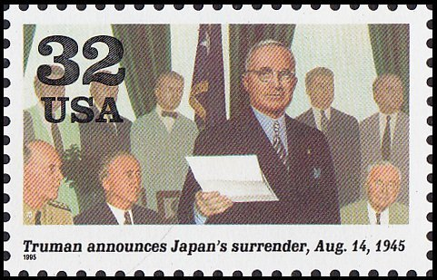Runyon acknowledged the importance of US-Japan relations at a critical time in US foreign policy, and because the President expressed his desire for a different design. The Postal Service “would not want to do anything that would affect the friendship between the two countries.” This may be the only proposed stamp design to ever be withdrawn because of political interference.

In 1945 military experts estimated one million US casualties would be incurred in a planned invasion of Japan, Japanese losses would have been much higher. Some historians contend that it was unnecessary for Truman to use atomic bombs and that the predicted outcome was greatly exaggerated.

Some members of the public registered their objection to the design’s withdrawal by creating stamp-like labels (cinderellas as they are known in the philatelic world) depicting the A-bomb cloud and using them on their mail along with valid postage. Mark Warda, who sold stamp reproductions to collectors, and Jerry Herr, a graphic artist, each produced unique designs. Their work is difficult to find in the marketplace.

More common is the item created by Gerry Newhouse, an ex-Marine, and Ron Kaplan. They created the label shown at right. They added a B-29 bomber (similar to the *Enola Gay* that dropped the bomb on Hiroshima) where the 32/USA denomination would have been, and changed the caption to “Atomic bombs end WW II”. This label was sold to the public. Covers exist bearing this label, many with cachets referencing the end of WW II. At least one cover never destined to be mailed bears the signature of Colonel Paul Tibbets, the pilot of the *Enola Gay*.

Newhouse is aware of bootleg copies of his label. They are narrower than the original, the die cut is different and the text is printed in a different font.

Louis Morel