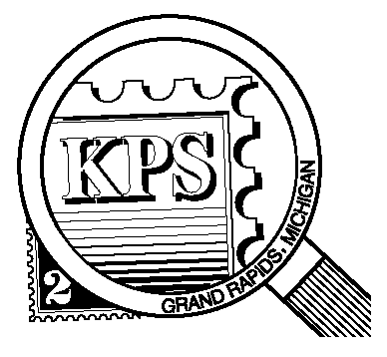

## 



NEWSLETTER OF THE KENT PHILATELIC SOCIETY

P.O. Box 1156, Grand Rapids, Michigan 49501-1156

Jerry Frye, President 616-538-6069

Louis Morel, Editor 269-420-3128

KentPhilatelicSociety.com

K.P.S. Philatelist

Volume 69 - No. 7 July 2025

KPS Club News

|  |  |
| --- | --- |
| Our Club has two new members. Doug Door collects primarily US stamps issued prior to the end of the second millennium. His interest extends to issues dealing with occupation and conflict. Jim Strohmer joins our ranks as well. He focuses on stamps from the People’s Republic of China. We hope to see them at our Club meetings and learn from their journey in the hobby.  🟋🟋🟋  The second annual KPS Summer Stamp Social was declared a success. Nearly 60 people participated in this year’s installment. Worldwide dealer Chris Daly and US dealer David Alex were on site to cater to collectors’ needs. Many stamps changed hands filling gaps in collections. We can look forward to a third iteration in 2026.  🟋🟋🟋  June was rife with patriotic celebrations. The Continental Army, which spawned the U. S. Army, celebrated its 250th anniversary. The 148th occurrence of “Flag Day” took place as well. Amid these patriotic celebrations, KPS member, David Luke, offered his presentation titled “What Makes a Good Flag Stamp a Great Flag Stamp?” at the June meeting. He showed many examples of the U. S. flag on stamps from its humble beginnings to the familiar current version. He also pointed to some subtle appearances of the flag on stamps such as seen on the spacesuit of the Moon landing issue (C76) of 1969.  🟋🟋🟋 | David’s knowledge of flag sizes and their purpose was most insightful. We look forward to hearing from David again.  🟋🟋🟋  The auction at the July meeting will focus on the collection of member Richard Walquist. Richard collected almost exclusively canceled stamps. Stamps from seven countries will be available in this first auction of his materials: Canada, Denmark the Faroe Islands, Japan, New Zealand, Norway, the Pitcairn Islands, and Sweden. See the enclosed list of all the lots that will be available at the auction.  KPS member, Carol Ligda-Wong, will put her Canadian collection up for auction at the September meeting. More than 1500 stamps comprise her collection. The acquisition of such a collection is an ideal way to jump start a new country collection or to fill gaps in an existing one. The insert enclosed with this newsletter will give you a taste of what is available. Read the instructions at the top of the insert for more details.  🟋🟋🟋  It was 250 years ago this month that the Second Continental Congress appointed Benjamin Franklin as the first American Postmaster General. Accordingly, the theme of the Kentpex 2025 Stamp Show will be Mr. Franklin himself. Contact Ron Rich ([kcrichfamily@gmail.com](mailto:kcrichfamily@gmail.com)) to obtain a registration form if you wish to exhibit at Kentpex in October. |

The KPS Board will enhance our monthly auctions by holding a drawing for a **FREE** $10 certificate toward the winning purchases of one lucky member. You need to be present to participate in the drawing.

**MONTHLY PROGRAM SCHEDULE**

The Kent Philatelic Society meets on the 4th **Tuesday** of the month at the Byron Center Baptist Church, 7343 Byron Center Ave SW, Byron Center.

|  |  |
| --- | --- |
| July 22, 2025: **KPS CLUB MEETING**  5:30 PM Board Meeting  6:30 PM Lot Viewing  7:00 PM Richard Walquist Auction | August 26, 2025: **KPS CLUB MEETING**  5:30 PM Board Meeting  6:30 PM Lot Viewing  7:00 PM Presentation and Floor Auction |
|  |  |

*Members are invited to share their philatelic experiences in this space. Perhaps you made a special acquisition, or thrive on an uncommon collecting topic, or saw a remarkable exhibit. Share it with your fellow collectors. Contact the Editor with your stories.*

**The Arrondissement of Inini**

The French established a settlement on the northeast tip of South America in 1604. In the Dutch wars of Louis XIV, the port of Cayenne was captured in 1676 by the Dutch but was later retaken. French Guiana was used as a penal colony and place of exile during the French Revolution. The Portuguese and British occupied it during the Napoleonic Wars. The Congress of Vienna restored French authority in 1815. After the emancipation of slaves in 1848, it became a center of French penal settlements in Guiana. In 1852 Napoleon III decreed that convicts with sentences of more than seven years were to be sent to French Guiana. Cayenne became known as the city of the condemned. Many have heard of the notorious Devil’s Island. Located a few miles off the coast, it was the setting for Henri Charrière’s book, “Papillon”, later developed into a movie starring Steve McQueen.

French Guiana is not an independent nation but rather an overseas possession of France. Its relatively large land area actually makes it France’s second largest region. It is composed of two arrondissements: the coastal region of Cayenne and Inini inland.

In 1930, the arrondissement of Inini separated from the colony of French Guiana. Inini covered more than 85% of French Guiana’s land mass. Inini consisted of largely unexplored dense tropical rain forests. With the separation, the Cayenne arrondissement, which contained most of the population, remained as a strip of land on the coast of the Atlantic Ocean separating Inini from the ocean.

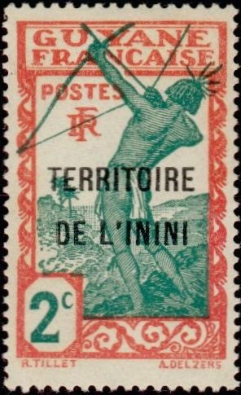Between 1930 and 1946, the Inini territory was administered separately from French Guiana in the hope of developing the interior. Although gold was found in Inini and attracted fortune-seekers, the harsh tropical nature of the environment limited gold-mining. Prisoners from Indochina, who had revolted against French rule there, a revolt which eventually evolved into the Vietnam War, were brought in to construct a railroad.

During this time, the Inini Territory overprinted stamps that had been printed for French Guiana. At right, is a stamp (INI 2) from the first series issued in 1932 by Inini. It features a Carib (from which we get the name Caribbean) archer. The Caribs are one of the two main tribes of native people who inhabited the Caribbean at the time of Christopher Columbus’ “discovery” of the New World. The other tribe was known as the Arawak.

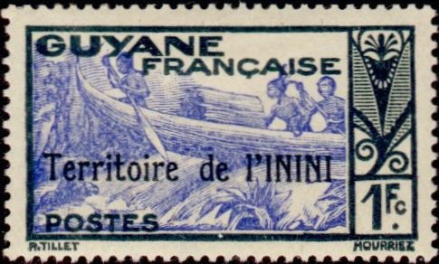The design of this stamp was used throughout the period 1932-1940 offering ten combinations of denominations and colors. Two other designs accounted for 31 additional issues during that period. In 1942, the issues no longer included “RF” in the design which stood for “République française” as seen in the stamp at right (INI 47). It shows two natives in a canoe on the Maroni River.

During WW II, the Vichy government issued several stamps in France that were never sold in Inini but were available in Paris. The stamp below (1942, CB1), a semi-postal airmail issue for the welfare of indigenous children, is one example.

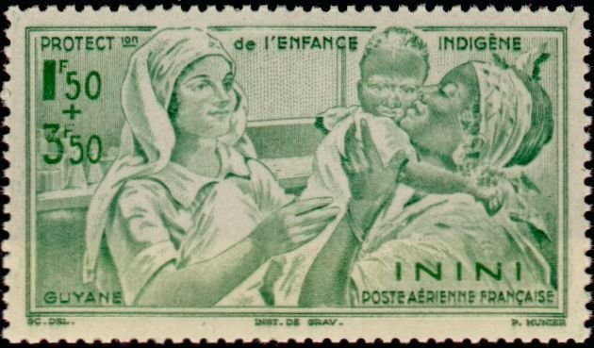The separate territory of Inini was abolished in March 1946. It was incorporated back into French Guiana as an overseas department of France. The Inini issues were replaced by stamps of French Guiana and ultimately by those of metropolitan France in 1947.

The Guiana Space Center, a spacecraft-launching base, was established in 1968. It is used by the European Space Agency, Arianespace, and the French space agency, the “Centre national d’études spatiales”. Economic problems and divisions between the white European elite and the Creole majority persisted into the 1990s accompanied by increasing local demands for autonomy. A proposal for an unspecified increase in French Guiana's autonomy was rejected in a referendum in 2010.

Created by French authorities, Inini was meant as a solution to three colonial problems: 1) saving the dwindling gold industry by improving infrastructure, 2) using the forced labor of political convicts from around the empire (mostly Indochinese) thereby neutralizing their dreams of independence, and 3) shielding the coastal areas of French Guiana from being known solely as a penal colony. None of it worked out well. Beyond that, Inini was a short-lived stamp-issuing territory (1930-1946).

Louis Morel