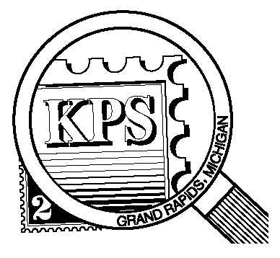

NEWSLETTER OF THE KENT PHILATELIC SOCIETY
P.O. Box 1156, Grand Rapids, Michigan 49501-1156
Gerry Frye, President 616-538-6069
Louis Morel, Editor 269-420-3128
KentPhilatelicSociety.com

K.P.S. Philatelist
Volume 70- No. 3 March 2026

KPS Club News
It is with regret that we inform you of the passing of KPS member Sam Barravecchia at age 85. Sam started collecting stamps about fifty years ago. He joined KPS in 2006. His collecting interests included US definitive and commemorative stamps which he famously stored in White Ace albums. Later, he expanded his interests to include Vatican City and US territories. Sam helped at the registration desk at KPS shows for many years. Our condolences go to his spouse, Rose, on losing her life’s partner. Rose accompanied Sam to the Club meetings and helped him with his acquisitions.  We are still looking for enthusiastic members to help run different aspects of the club's activities. Two positions on the board remain to be filled. Please consider pitching in. for the advancement of our Club. Please contact Louis Morel (269.420.3128) if you would like to volunteer or have questions about the roles.  Stamps issued by two or more postal administrations to commemorate the same person, place, or event are known as joint issues. Most often, the stamps from all participants have the same design in which only the lettering and denomination differ. A great number of joint issues have been released over the years. They are listed in a specialized catalog. This month’s meeting will feature a presentation by KPS member Pastor | John. Russell, our gracious host at the Byron Center Baptist Church. He will present fascinating facts about joint issues. Collecting joint issues is certainly an interesting area to consider.  Factoid: The US makes up about 4% of the world's population. The US Postal Service processes and delivers 46% of the world's mail.  The Archives: The May 1958 issue of the KPS Philatelist reported that a panel of experts (all Club members) had been featured at the April meeting. They answered all questions on the various elements of stamp collecting and stamps themselves. The large crowd had a lot of questions to ask the panelists. Time ran out before some had a chance to ask their questions or got up enough nerve to talk! The members could not stump the five collectors who made up the panel.  Separately, there was a reminder that a postal rate increase was on its way. The new rates would be four cents for first class mail and seven cents for air mail. US collectors were licking their chops contemplating the possibility of re-issues and new issues to cover these rate increases.
The KPS Board will enhance our monthly auctions by holding a drawing for a FREE $10 certificate toward the winning purchases of one lucky member. You need to be present to participate in the drawing.

MONTHLY PROGRAM SCHEDULE
March 24, 2026: KPS CLUB MEETING  5:30 PM Board Meeting  6:30 PM Lot Viewing  7:00 PM Presentation and Floor Auction | April 28, 2026: KPS CLUB MEETING  5:30 PM Board Meeting  6:30 PM Lot Viewing  7:00 PM Presentation and Floor Auction
The Kent Philatelic Society meets on the 4th Tuesday of the month at the Byron Center Baptist Church, 7343 Byron Center Ave SW, Byron Center.

Members are invited to share their philatelic experiences in this space. Perhaps you made a special acquisition, or thrive on an uncommon collecting topic, or saw a remarkable exhibit. Share it with your fellow collectors. Contact the Editor with your stories.
A Challenge of the Gender Roles
Elizabeth Blackwell established equality of gender within the medical field. Throughout her life, she fought for women's rights, advocated for the poor, and established the path for women to become Doctors of Medicine in the United States and in England. She was the first woman to be accepted into a Medical College and graduate to receive a Doctor of Medicine degree in the United States.

Elizabeth Blackwell was born on February 3, 1821 in Bristol, England into a Quaker family. Her father was a sugar refiner and a social activist thereby instilling a strong sense of justice and education in his children. The Blackwell family migrated to the United States in 1832, settling in Cincinnati. Her father died six years later. Ms. Blackwell, alongside her mother and her older sisters, worked as teachers to support the family.

Elizabeth’s friend, Mary Donaldson, who was dying of cancer, expressed great distress over the lack of female physicians to treat her. This prompted Elizabeth to consider a medical career with the firm belief that women could offer care that was more empathetic and relevant to other women’s unique medical needs.

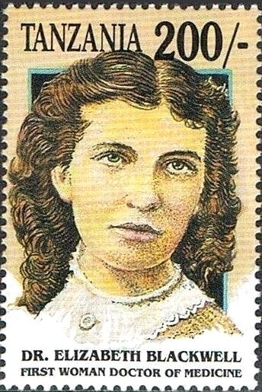
In 1846, Elizabeth (shown at left on a Tanzanian issue of 1998, Scott 998g) applied to multiple medical schools in New England but was met exclusively with rejection. She corresponded with notable physicians to seek their support for her goals. Only one of them, Dr. Joseph Warrington in Philadelphia, encouraged her to pursue her dreams. He allowed her to attend house calls and see patients with him. When it was time for her to apply to medical colleges, Dr. Warrington, thoroughly impressed by Ms. Elizabeth Blackwell’s earnest efforts and interest in the profession, offered to write her a letter of recommendation to attend medical school.

After more rejections, the recommendation paid off. Geneva Medical College (today Hobart and William Smith Colleges in New York State) accepted her only after all faculty and medical students voted to accept her. The students thought her application was a hoax perpetrated by a rival college and voted her in. It was too late when they found it wasn’t a joke. She faced multiple challenges, such as exclusion from dissections and condescension from faculty and students alike. She remained steadfast in her commitment to her studies and excelled academically. She graduated at the top of her class in 1849, finally achieving her long-held dream of becoming a physician. This momentous occasion was celebrated widely, drawing public attention and marking a significant milestone toward gender equality in medicine.

After graduation, she was not granted a position for clinical training at any US hospital. She traveled to Paris with the hope of gaining her clinical training at the well-established hospitals there. She was again barred from attending lectures in the European institutes on the basis of her gender. A teaching hospital for midwifery training was the only opportunity for clinical training availed to her.

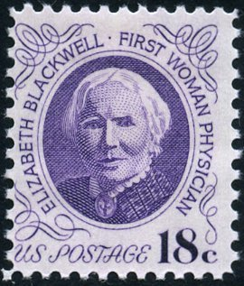
Dr. Blackwell, seen on a US stamp at right issued in 1994 (Scott 1399), moved back to New York City in 1851 to open her medical practice. Few patients sought her care. The societal bias against a female physician was far from broken by her acquisition of an MD. Her sister, Emily, the third woman in the USA to earn a medical degree, joined her and opened the Infirmary for Indigent Women and Children to provide care to the underserved communities of the city. The Infirmary was staffed and run entirely by women. Financial subscriptions and donations supported the Infirmary. This was the first institution of its kind in the United States and abroad.

The Blackwells wanted to open the door to the study of medicine for future women. In 1868, they founded one of the first four-year medical schools in the country - Women’s Medical College of the New York Infirmary. Elizabeth taught hygiene while Emily served as the dean. The Women’s College became known for its excellence and rigorous curriculum. In the present day, the historic College and New York Infirmary for Indigent Women and Children are still operating as part of Weill Cornell Medicine and has been renamed the “New York Presbyterian Lower Manhattan Hospital”.

In 1869 she moved permanently to England. She established a successful private practice, helped organize the National Health Society in 1871, and taught at the London School of Medicine for Women. She retained the position until 1907, when an injury forced her to retire. She authored several books on medical topics. She died on May 31, 1910, in Sussex, England.

Louis Morel

