

## 



NEWSLETTER OF THE KENT PHILATELIC SOCIETY

P.O. Box 1156, Grand Rapids, Michigan 49501-1156

Jerry Frye, President 616-538-6069

Louis Morel, Editor 269-420-3128

KentPhilatelicSociety.com

K.P.S. Philatelist

Volume 69 - No. 3 March 2025

KPS Club News

|  |  |
| --- | --- |
| Leslie Johnson and Henry Barry joined us for the first time at the February meeting. We hope that the newcomers will join the Club and enrich our ranks with their collecting journeys.  🟋🟋🟋  We trust that you have marked your calendar. The Spring Dealer Bourse originally scheduled for April 26 will be held on Saturday, May 3 due to a scheduling conflict. As in the past, it will be held at the Neal Fonger American Legion Post in Walker.  🟋🟋🟋  We are looking for a member to step forward and volunteer to *oversee the organization* of the June Stamp Social. The Chairperson will receive plenty of assistance to ensure that none of the necessary preparations (purchase of food, plates and plastic ware, setup and tear-down, etc.) falls through the cracks. Please give Bill Sobotka a call (616.531.3295) to volunteer.  🟋🟋🟋  It’s March already. While spring is just around the corner, we know from recent experience that snow storms are still a possibility. The Club is adopting the following protocol as of this month in the event of inclement weather on the day of a Club meeting or other event. We will not hold our event if the schools in Grand Rapids are closed on that day. We will rely on the school closings as reported on the Web sites of WOOD and | WXMI to determine if a meeting will be held.  🟋🟋🟋  The March meeting will feature a presentation by KPS member Darrin Lettinga. He will discuss interesting postal history that involves the Oriental Shipping Company. A floor auction will follow. It will include several lots from the collection of longtime-member (he joined KPS in 1962), Richard Walquist.  🟋🟋🟋  **KPS Archives**: MemberJames Engels reported in the June 1962 issue of the newsletter that “Birds on Stamps” was the topic of discussion at the most recent Club meeting. Members viewed a series of slides prepared by Sidney Esten of Indianapolis and obtained through the American Topical Association. Clark Apten “ran the machine” and Art Bean read the comments. The presentation revealed that the first stamp to feature a bird was issued by the Canton of Geneva in 1843. The bird was a part of the coat of arms on the stamp. Members learned that there were more than 150 stamps with pigeons on them (how many are there now?). It was mentioned that more than 3,000 European stamps feature a golden eagle on them. Birds on stamps is a very popular topic for collectors. |

The KPS Board will enhance our monthly auctions by holding a drawing for a **FREE** $10 certificate toward the winning purchases of one lucky member. You need to be present to participate in the drawing.

**MONTHLY PROGRAM SCHEDULE**

The Kent Philatelic Society meets on the 4th **Tuesday** of the month at the Byron Center Baptist Church, 7343 Byron Center Ave SW, Byron Center.

|  |  |
| --- | --- |
| March 25, 2025: **KPS CLUB MEETING**  5:30 PM Board Meeting  6:30 PM Lot Viewing  7:00 PM Presentation and Floor Auction | April 22, 2025: **KPS CLUB MEETING**  5:30 PM Board Meeting  6:30 PM Lot Viewing  7:00 PM Floor Auction |
|  |  |

*Members are invited to share their philatelic experiences in this space. Perhaps you made a special acquisition, or thrive on an uncommon collecting topic, or saw a remarkable exhibit. Share it with your fellow collectors. Contact the Editor with your stories.*

**Butterflies and Moths**

At this time of the year, Meijer Gardens & Sculpture Park hosts the largest temporary exhibit of tropical butterflies in North America. We are very fortunate to have the unrivaled opportunity to view such an abundance of beautiful and graceful creatures. This year, Meijer Gardens has released more than 60 species of butterflies and moths in its tropical conservatory.

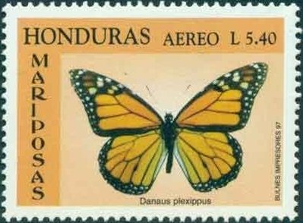Collector Greg Herbert’s 2021 exhibit informs us that butterflies and moths existed for millions of years prior to the relatively recent appearance of *Homo sapiens*. Yet, during our relatively short time of co-existence, this group of fragile insects has greatly influenced our culture through the arts and humanities. Man, for his part, has celebrated their beauty while at the same time contributing to their population decline. The stamp at right shows a *Danaus plexippus* butterfly (aka Monarch) on a Honduran air mail stamp (1991, C1003).

The products of several insects and spiders have fascinated humans for millennia. These creatures secrete a protein fiber with tremendous properties. A particular moth has been farmed for millennia for that purpose. It gives us what we call silk.

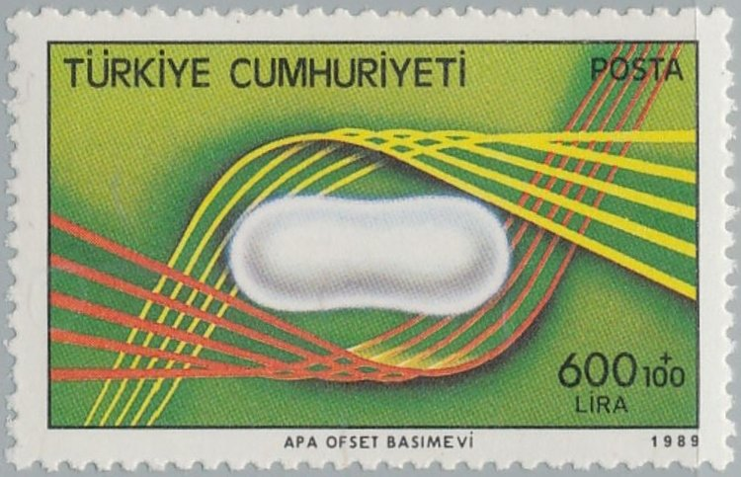Briefly, the history of silk began in the 27th century BC in China where it remained in sole use for centuries. During the latter half of the first millennium BC, the so-called “Silk Road”, actually a network of trade routes, opened. It facilitated the distribution of this luxury product across new regions of the known world. Cultivation of silk spread to Japan somewhere around 300 CE while by 522 the Byzantines managed to obtain silkworm eggs and were able to begin silkworm cultivation of their own. In time, the Chinese lost their secret to the Koreans and later to the Indians. Today, countries with silkworm farms stretch from Asia to Italy. A silkworm cocoon is shown at left on a 1985 Turkish issue (Scott B227).

We remain in awe at the sight of many butterflies due to their intrinsic beauty. Yet, the eggs, larvae, pupae, and adults of certain species of butterflies and moths have been eaten by man since prehistoric times and continue to be an item of the human diet in modern times. Human butterfly and moth eating is common to cultures in most parts of the world while rare in the developed world.

Are butterflies nutritious? Butterflies are a part of the lepidoptera order with dozens of species used as food around the world. Nearly two dozen species of butterfly and moth caterpillars have been analyzed by nutritionists. They found that their crude protein content averaged more than 63 percent, compared to the meager 18 percent found in beef. The calorie count was about the same. Where beef contained about 58 percent water, the caterpillars came in at a dry four percent.

In Thailand, China, Vietnam, India, Korea, Japan, and other Asian countries where there was a silk industry, cocoons of the silkworm moth were collected and sold commercially and the pupae boiled, steamed, baked, fried, or roasted, depending on locality and individual preference. In China they are pickled with salt, or softened with water and fried with chicken eggs in an omelet, or simply fried with diced onion and a thick sauce. In Thailand, in 1987, the Thai Ministry of Public Health included silkworm pupae on a list of local foods that could be used in supplementary food formula developed for malnourished infants and pre-school children.

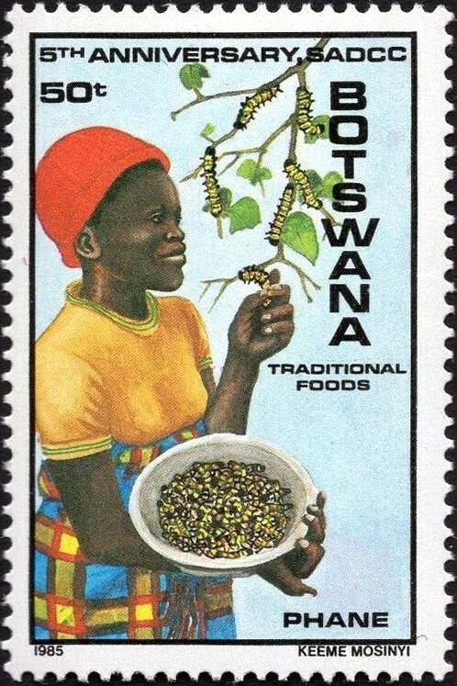In some areas of Africa, the large, spiny mopane worms (caterpillars of the *Gonimbrasia belina* moth) are so popular that when they are in season, crawling all over village and jungle trees, the sale of beef and other protein meats is seriously affected. This collection of the caterpillars is shown in the Botswana issue at left (1985, Scott 362).

In the Cascade and Sierra Mountains of North America, native tribesmen harvested the large caterpillars of the moth *Coloradia pandora*. The full-grown caterpillars measure from two to two-and-one-half inches in length and are as fat as an index finger. Normally, these caterpillars live on pine trees, far out of reach, but in order to pass into the pupal stage they descend in great numbers to burrow into the soil. Just before this takes place, the tribesmen build fires under the trees. The smoke stuns the caterpillars. They lose their grip on the trees and fall to the ground where they are collected in baskets. They are then prepared as food.

Without any doubt, humans continue to have a diverse relationship with butterflies and moths.

Louis Morel