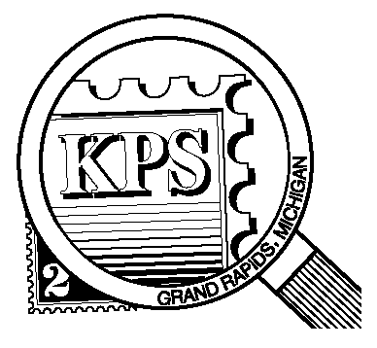

**75 YEARS**

## 



NEWSLETTER OF THE KENT PHILATELIC SOCIETY

P.O. Box 1156, Grand Rapids, Michigan 49501-1156

Gerry Frye, President 616-538-6069

Louis Morel, Editor 269-420-3128

KentPhilatelicSociety.com

K.P.S. Philatelist

Volume 69 - No. 1 January 2025

KPS Club News

|  |  |
| --- | --- |
| It is with regret that we announce the passing of long-time KPS member, Brian Pekala. He joined the Club in 2010. Brian was an avid collector of stamps, coins and cars. Some members are familiar with his Corvette. His wife, Mary Riley, is also a member of the Club. We extend our condolences to her and her family.  🟋🟋🟋  Jim Coleman, Chris Daly, and Bill Sobotka were re-elected to the board at the December meeting. The Officers of the Club will be chosen at this month’s board meeting on January 28. There is one remaining position on the board following the passing of Bernie Jager. Are you the one who will take that position? Please contact Jerry Frye (616.538.6069) if you have questions about the position or if you have already decided to contribute to the advancement of the Club.  🟋🟋🟋  Twenty-two people attended the December potluck dinner. Some members went home with door prizes. Paul Slachter went home with the winnings from the 50/50 raffle. All present had a good time. | 🟋🟋🟋  The program calendar for this year accompanies the newsletter. It lists the various auctions that will take place at our monthly meetings. Also, we can look forward to a number of presentations by Club members on various topics.  🟋🟋🟋  It is time to renew your KPS membership for 2025. The cost remains unchanged at $15 for the year. Please make your payment as soon as possible. You can drop it off at the next Club meeting. You can also send a check made out to Kent Philatelic Society to the address found above in the masthead.  🟋🟋🟋  January is “National Hobby Month”. The origin of the word hobby can be traced back to the middle of the XVIth century. “Hobyn” designated a small horse or pony. The “hobby horse” made of a straight stick with a horse’s head made of wood or fabric could be purchased in Reading, England, in 1557. Fast forward three centuries. Hobbies were no longer considered childish pursuits. At the dawn of the industrialized society, hobbies had gained respectability. Rowland Hill led the reform of the English postal system which included the introduction of the adhesive postage stamp (1840) which today anchors our hobby. |

The KPS Board will enhance our monthly auctions by holding a drawing for a **FREE** $10 certificate toward the winning purchases of one lucky member. You need to be present to participate in the drawing.

**MONTHLY PROGRAM SCHEDULE**

The Kent Philatelic Society meets on the 4th **Tuesday** of the month at the Byron Center Baptist Church, 7343 Byron Center Ave SW, Byron Center.

|  |  |
| --- | --- |
| January 28, 2025: **KPS MEMBERS POT LUCK**  6:00 PM Board Meeting  6:30 PM Lot Viewing  7:00 PM Floor Auction | February 25, 2025: **KPS CLUB MEETING**  6:00 PM Board Meeting  6:30 PM Lot Viewing  7:00 PM Dealer Auction: Chris Daly |
|  |  |

*Members are invited to share their philatelic experiences in this space. Perhaps you made a special acquisition, or thrive on an uncommon collecting topic, or saw a remarkable exhibit. Share it with your fellow collectors. Contact the Editor with your stories.*

**“Take Two and Call Me in the Morning”**

Holiday parties can be a source of hangovers for those who imbibe too much alcohol. There are many suggested remedies to cure the headache and the overall bad feeling. Some are even scientifically sound! Some work better than others but none is an actual cure.

Briefly, alcohol dehydrates the body so drinking plenty of water is important to recover. Alcohol also causes stomach irritation, the release of proteins from the immune system that cause inflammation, and a lowering of blood pressure, all of which can make one feel achy, nauseous, and fatigued.

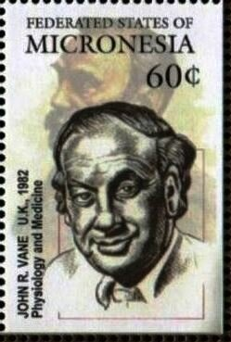

An over-the-counter analgesic will calm a pounding headache. Ibuprofen, naproxen, and aspirin are prime candidates. Avoid acetaminophen as it can damage the liver when there is alcohol in the system. What about this aspirin that has been around for more than a century?

The story of aspirin is ancient and begins with the willow tree. Its bark was used to cure fever and rheumatism and was described by the Greek physicians Hippocrates and Dioscorides, and later by the Swiss physician, Paracelsus. Johann Buchner at the University of Munich isolated the active ingredient of willow bark in 1828. He named it “salicin”. Charles Gebhardt, a French chemist, later developed a derivative of “salicin” that worked to relieve pain (1853). It was acetylsalicylic acid. Gebhardt had no interest in commercializing the product.

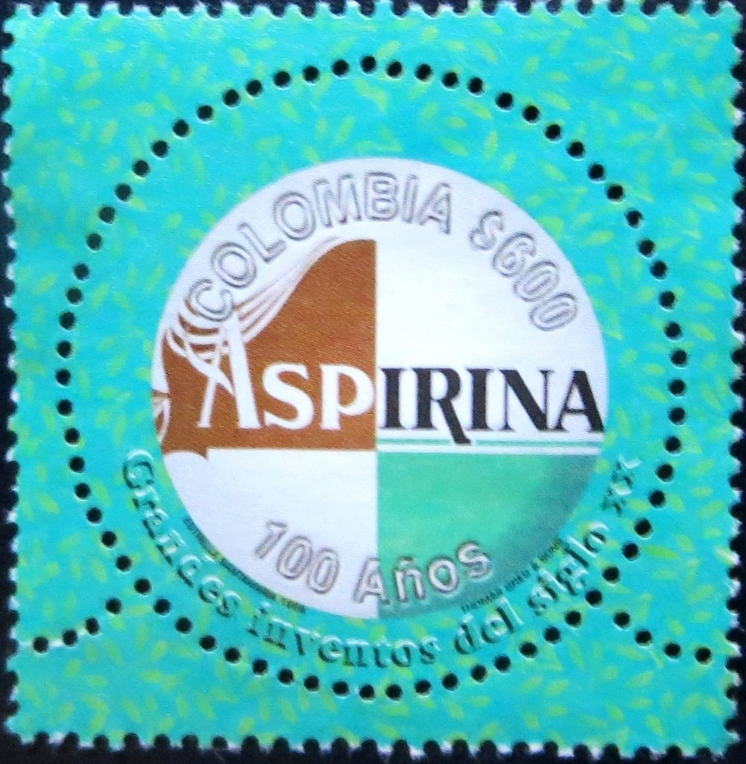Bayer, originally a dye manufacturing company in Germany, had concentrated on the more lucrative production of pharmaceuticals. Felix Hoffmann, a young chemist, "rediscovered" Gerhardt's formula and obtained acetylsalicylic acid (1897) by using a simplified procedure. He tried it on his father who was suffering from arthritic pain, with good results. Bayer introduced the drug in clinical medicine under the trade name **aspirin**, in 1899, and patented it. A tablet is shown on the Colombian stamp at left (1999, Scott 1160). After Germany lost WW-I, Bayer was forced to give up trademarks of aspirin according to the Treaty of Versailles (1919).

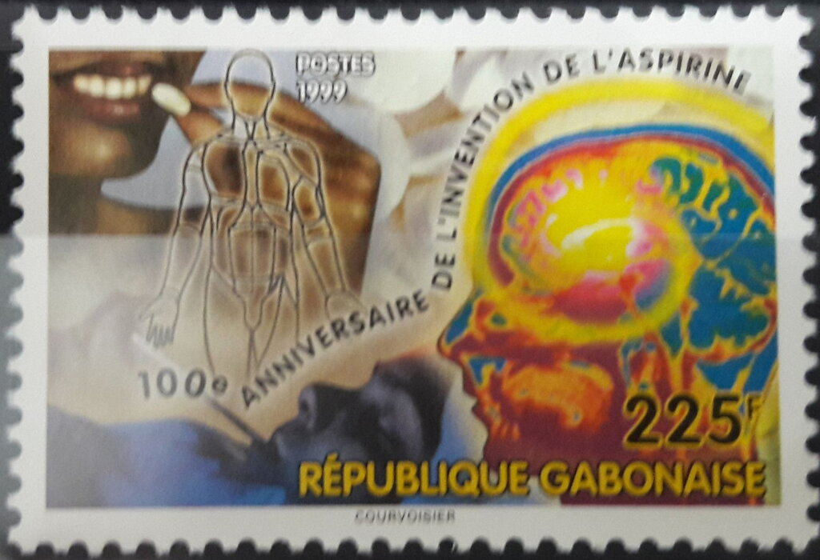The stamp at right was also issued in 1999 by Gabon (Scott 951) to commemorate the centennial of the introduction of aspirin.

As early as 1956, Dr. Laurence Craven, a Californian physician, noted that aspirin had reduced the risk of heart attacks in his patients. The explanation for such diverse and seemingly disconnected therapeutic properties of aspirin was revealed in the 1970s by the discovery of certain chemical mediators in the body.

British pharmacologist, John Vane, (1927-2004) (below, Micronesia, 2001, 469f) began his career as a researcher at Oxford University in 1946. After two years teaching at Yale University, he returned to England and spent eighteen years at the Royal College of Surgeons in London. While there, he developed a technique that allowed the measurement of the biological effects of several substances simultaneously in parallel test systems. Using this procedure, Vane and his colleagues studied a group of naturally-occurring compounds called prostaglandins. Vane discovered that aspirin blocked a key enzyme needed for the production of prostaglandins which are involved in many body processes. These include the sensation of pain, tissue injury, body temperature, inflammation, blood pressure, and the inhibition of blood platelet aggregation. They also come into play when the body is under attack. This discovery provided a physiologic rationale for the effectiveness of aspirin.

He shared the Nobel Prize in Medicine in 1982 for his work. His co-laureates were Swedish scientists Sune Bergström (1916-2004) and Bengt Samuelsson (1934-2024). They too were recognized for their discoveries concerning prostaglandins and related biologically active substances. Bergstrom elucidated the chemical structure of two major prostaglandins. Samuelsson showed how prostaglandins are formed and converted in the body.

The global aspirin market, branded and generic, has an estimated worth of $2.58 billion. The value is expected to grow at a rate of about 3% per year for the foreseeable future. Global aspirin production was roughly 41 thousand tonnes in 2023. Aspirin is among the highly trusted products by a range of customers worldwide compared to any other over-the-counter medicine for reducing pain.

Louis Morel