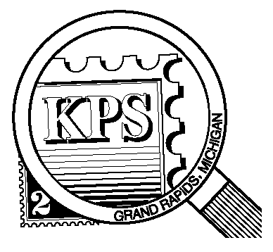

## 



NEWSLETTER OF THE KENT PHILATELIC SOCIETY

P.O. Box 1156, Grand Rapids, Michigan 49501-1156

Jerry Frye, President 616-538-6069

Louis Morel, Editor 269-420-3128

KentPhilatelicSociety.com

K.P.S. Philatelist

Volume 69 - No. 2 February 2025

KPS Club News

|  |  |
| --- | --- |
| At the January Board meeting, the Officers agreed to continue in their present roles. Jerry Frye, President; Louis Morel, Vice-president and Chair of the Program Committee; Dan Ondersma, Treasurer; Ron Rich, Secretary. As announced in last month’s issue, Jim Coleman, Chris Daly, and Bill Sobotka will continue to participate on the Board. We welcome Bob Toland to the Board. He replaces Richard Walquist who has moved to warmer climes.  🟋🟋🟋  We welcome our newest member, David Baker. He collects stamps from around the world, both new and used. He also collects birds on stamps. We look forward to hearing about his journey in the world of philately.  🟋🟋🟋  KPS member and dealer, Chris Daly, will be the feature of the February auction. Information about the lots up for auction is included with this newsletter.  🟋🟋🟋  Our program calendar is meant to be flexible! Things happen. The Spring Dealer Bourse originally scheduled for April 26 will now be held on Saturday, May 3 at the Neal Fonger American Legion Post in Walker. Mark your calendars now. | 🟋🟋🟋  Speaking of calendars, are you considering going for a day to the Great American Stamp Show? It will be held in Schaumburg on the outskirts of Chicago. The Kalamazoo Stamp Club is planning to charter a bus on Friday, August 15 for a day trip to the Show. Contact Jerry or Louis for more information.  🟋🟋🟋  Three quarters of our Club’s members have renewed their membership for 2025. Will you renew now if you haven’t already? Send a check made out to Kent Philatelic Society for $15 to the address above or drop it off at this month’s meeting.  🟋🟋🟋  **KPS Archives**: Sixty years ago this month, the KPS members held a special election. Their purpose was to judge the 18 commemorative designs that had been issued in 1964 by the Post Office Department. Covers franked with a single stamp or a block of four were evaluated. Three members commented on the various covers offering a short history of the subjects depicted on the stamps, the colors used, the printing processes chosen, the paper types, and the numbers issued. Most thought that issuing 18 commemoratives was too many. And the winners were…Best Design: “American Music” (Scott 1252). Least Needed: “Homemakers” (Scott 1253). Worst Design: “Modern Art” (Scott 1259). |

The KPS Board will enhance our monthly auctions by holding a drawing for a **FREE** $10 certificate toward the winning purchases of one lucky member. You need to be present to participate in the drawing.

**MONTHLY PROGRAM SCHEDULE**

The Kent Philatelic Society meets on the 4th **Tuesday** of the month at the Byron Center Baptist Church, 7343 Byron Center Ave SW, Byron Center.

|  |  |
| --- | --- |
| February 25, 2025: **KPS CLUB MEETING**  5:30 PM Board Meeting  6:30 PM Lot Viewing  7:00 PM Dealer Auction: Chris Daly | March 25, 2025: **KPS CLUB MEETING**  5:30 PM Board Meeting  6:30 PM Lot Viewing  7:00 PM Floor Auction and Presentation: |
|  |  |

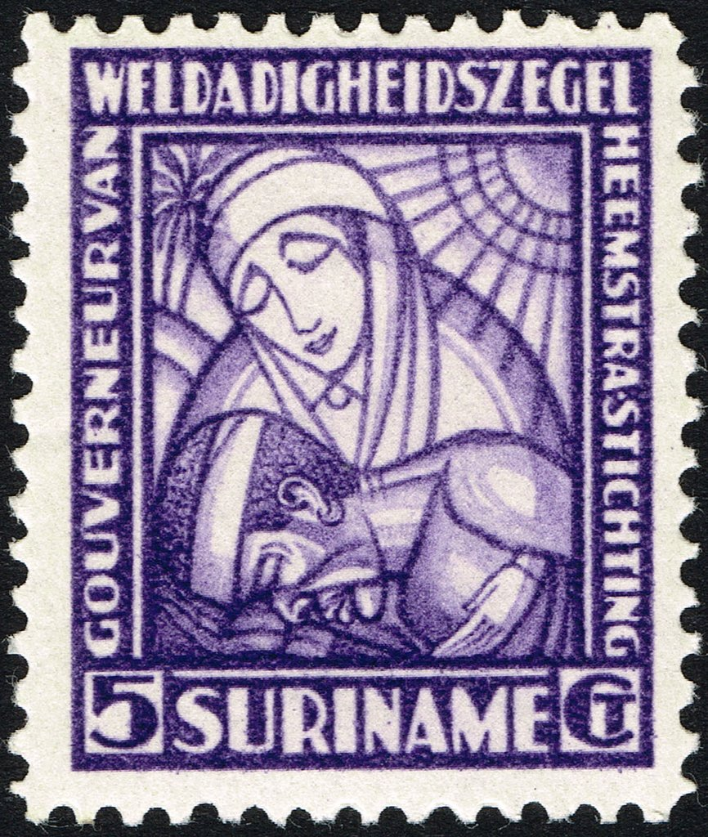

*Members are invited to share their philatelic experiences in this space. Perhaps you made a special acquisition, or thrive on an uncommon collecting topic, or saw a remarkable exhibit. Share it with your fellow collectors. Contact the Editor with your stories.*

**A Baron and His Famous Grand-daughter**

Baron Aarnoud Jan Anne Aleid van Heemstra was born in 1871 n Vreeland, a village in the province of Utrecht, in the Netherlands. His father had been a town mayor. His great uncle had been Prime Minister of the Netherlands in the early 1860s.

Van Heemstra earned his law degree from Utrecht University. For 14 years, he worked as a prosecutor and then as a judge in several Dutch cities. In 1910, he was elected mayor of the city of Arnhem. He improved public housing, attracted several new businesses, and served as a savvy administrator through the chaos of World War I. He resigned as mayor in 1920 after a budget dispute.

Queen Wilhelmina appointed the newly unemployed Baron van Heemstra to be the governor of the colony of Suriname (Dutch Guiana). He took office in the capital city, Paramaribo, in 1921. Van Heemstra took his responsibilities to the colony seriously and advocated for economic development, infrastructure improvement, and gradual independence from the Netherlands. He traveled to the dense rain forests in the interior of the country to observe conditions among the “Maroons” (descendants of runaway African slaves) and indigenous Amerindians living there.

Van Heemstra was the first leader of Suriname to recognize the economic potential of the massive bauxite mineral reserves in the country. In 1922, the Aluminum Company of America (Alcoa) started bauxite mining in Suriname. Bauxite remains Suriname’s most important export. Van Heemstra tried to attract German mining interests to counter American influence in Suriname. The Dutch Parliament, fearing retaliation by the American government in the form of tariffs or sanctions on the Royal Dutch Shell oil company, overruled his plan. The Parliament resisted his proposed reforms and lost interest in the colony. The Baron resigned as governor. Suriname achieved independence in 1975.

The Netherlands and its colonies had been early adopters of semi-postal stamps to raise money for charities. The Netherlands were the first to issue semi-postal stamps in continental Europe. The 1906 series (Scott B1-B3) supported the prevention of tuberculosis (mint set, never hinged, catalog value $475). Suriname issued the first semi-postal stamps in South America in 1927 to support public health services. In 1928, the Suriname postal service issued a series of four semi-postal stamps (Scott B4-B7) showing a nun with a patient (Scott B6 at right). The surcharge generated funds for the Governor van Heemstra Foundation which supported health programs among the indigenous population in Suriname. Note that the United States issued its first semi-postal stamp in 1998 to promote breast cancer research.

After returning to the Netherlands in 1928, van Heemstra edited a magazine about politics and economics. His initial pro-German and pro-Japanese stance gradually evolved. In 1938, he promoted the formation of a European alliance to counter the growing influence of Japan in the Pacific region as he believed it threatened the Dutch East Indies.

Van Heemstra had six children with his first wife. His third daughter, Ella, sowed controversy by keeping company with German army officers during the Second World War. In 1942, German invaders confiscated van Heemstra’s residence, bank accounts, and jewelry because he refused to collaborate. They executed his son-in-law in retaliation for a sabotage attack by the Resistance. Van Heemstra’s widowed daughter, Wilhelmina, his divorced daughter, Ella, and her teenage daughter, Audrey (1929-1993), lived with him.

Audrey’s father, James Ruston, was a former British consul to the Dutch East Indies. He later adopted the more aristocratic surname Hepburn-Ruston because of a mistaken belief that he was descended from James Hepburn, the third husband of Mary Queen of Scots. Audrey Hepburn went on to fame as a fashion and film icon, winning an Academy Award for Best Actress in a Leading Role for “Roman Holiday” in 1953. She was nominated for four additional performances in subsequent years.

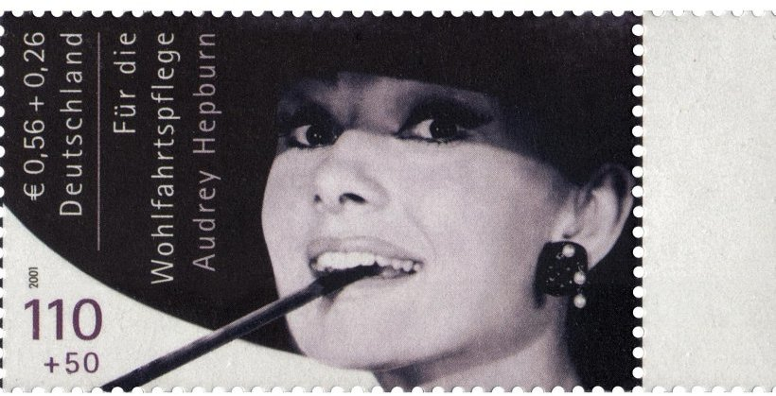

Gibraltar issued two mini-sheets in 1995 to celebrate the centenary of cinema. A label featuring a movie poster accompanied each stamp. Hepburn’s (Scott 697a) was for “My Fair Lady”. The German stamp (above right) was designed in 2001 but never issued. Nevertheless, a number of used examples are known. Unlisted by Scott, the Yvert & Tellier catalog lists it as #2054A. It is a footnote in the Stanley Gibbons catalog.

Louis Morel