

NEWSLETTER OF THE KENT PHILATELIC SOCIETY
P.O. Box 1156, Grand Rapids, Michigan 49501-1156
Gerry Frye, President 616-538-6069
Louis Morel, Editor 269-420-3128
KentPhilatelicSociety.com

K.P.S. Philatelist
Volume 70- No. 2 February 2026

KPS Club News
Both the American and European forecasting models predicted inclement weather in West Michigan on January 27. They were excruciatingly correct! Accordingly, our Club experienced a rare occurrence: a meeting cancellation due to bad weather! For future reference, the Club follows the action of Byron Center schools. The Club’s policy is to cancel meetings scheduled on days when local schools close due to the weather. We rely on information communicated by local broadcasters on air (radio and TV) and on their websites. These include WOOD, WZZM and WXMI.  The cancellation of the January meeting delayed the selection of the Officers of the Club. We will proceed at this month’s board meeting with that important task. Dan Ondersma and Louis Morel were re-elected to the board at the December meeting. There are, however, two remaining positions on the board that need to be filled. Are you going to step up to contribute to the advancement of our Club? Please contact Jerry Frye (616.538.6069) if you would like to volunteer or have questions about the roles.  Some members have yet to renew their membership for this year. The dues remain unchanged at $15. Please make your payment as soon as possible if you have not done so already. You can drop it off at the upcoming Club meeting. You can | also send a check made out to Kent Philatelic Society to the address found above in the masthead.  The February auction will feature lots selected by KPS member Chris Daly. The auction list is included with this newsletter. Note that all seven continents are represented in these selections.  The Archives: The more things change, the more they stay the same! The July 1958 issue of the KPS Philatelist cited the article “How to End Our Post Office Mess Permanently” published in the February 1958 issue of Reader’s Digest. Linn’s Stamp News reprinted it in its June 16 issue. The optimistic author detailed the services offered by the Post Office, many of which were not associated with postal services. Critics argued that these tasks should be charged to other departments thus reducing the financial burden on the Post Office Department.  Members had discussed the plight of the Post Office Department at a Club meeting. While the times have changed substantially and the USPS has different challenges some seven decades later, the fact remains that the Postal Service needs to tackle serious financial and labor issues.
The KPS Board will enhance our monthly auctions by holding a drawing for a FREE $10 certificate toward the winning purchases of one lucky member. You need to be present to participate in the drawing.

MONTHLY PROGRAM SCHEDULE
February 24, 2026: KPS CLUB MEETING  5:30 PM Board Meeting  6:30 PM Lot Viewing  7:00 PM Dealer Auction: Chris Daly | March 24, 2026: KPS CLUB MEETING  5:30 PM Board Meeting  6:30 PM Lot Viewing  7:00 PM Floor Auction and Presentation

The Kent Philatelic Society meets on the 4th Tuesday of the month at the Byron Center Baptist Church, 7343 Byron Center Ave SW, Byron Center.

Members are invited to share their philatelic experiences in this space. Perhaps you made a special acquisition, or thrive on an uncommon collecting topic, or saw a remarkable exhibit. Share it with your fellow collectors. Contact the Editor with your stories.
Forgotten Fruit
Count Giacomo Carraro founded the Academy that bears his name in 1795. He donated his remarkable art collection to this museum. Donations and acquisitions have augmented the Academy’s inventory to more than 1500 artworks by Italian and European painters that span the period from the 14th to the 19th century. They include originals by Botticelli. Titian, Carpaccio, and Bellini.

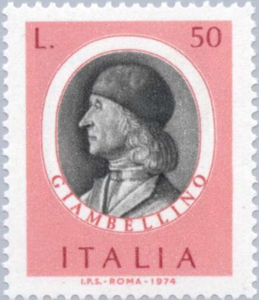
Giovanni Bellini, seen in the Italian stamp (1974, Scott 1125) at right, was born in Venice sometime between 1430 and 1435. Art historians state that few artists in the history of painting can match his contribution. He is credited with bringing a humanistic quality to his religious and mythical scenes. His figures brought a new human tenderness to his painted parables. He was at the vanguard of developments in oil painting. He abandoned the then-current use of egg and tempera method in favor of oil-based paints to evoke a heightened sense of scenic ambience. Bellini mastered the use of light and color which was evident in his rendering of costumes, skin pigmentation, and the mood created by his skyscapes. Bellini produced at least two dozen paintings featuring the Madonna and Child during his lifetime.

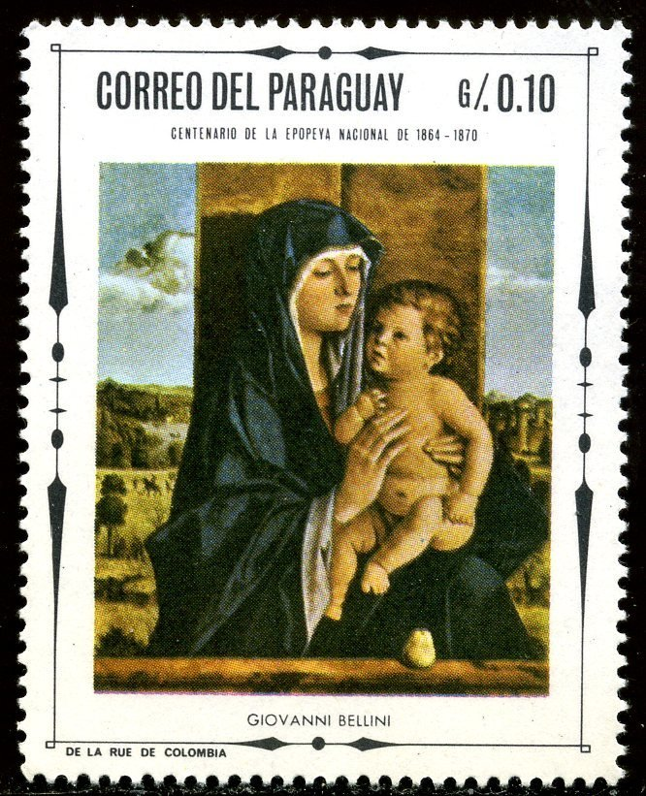
The Madonna and her Child were featured in many paintings during Bellini’s era. One crafted by Bellini hangs in the Carraro Academy. Art historians, seeking to distinguish Bellini’s work from the others, referred to it as “Madonna della Pera” (“Madonna of the Pear”). The painting is depicted in this Paraguayan stamp (Scott 1070) issued in 1968. Indeed, in front of the Madonna there is a lone fruit that looks like a pear. But it’s not.

During the 1980s the rise of industrial-scale farming in Italy and around the world was driving a rapid decline in crop diversity, as generic seeds that could be grown over vast areas replaced those adapted to specific regions. Local fruit varieties disappeared from the fields and the market; thousands of local breeders were bought out or were unable to compete.

Isabella Dalla Ragione is an Italian agronomist. She and her father interviewed local farmers about lost and disappearing fruit varieties. Dalla Ragione combines her knowledge of agricultural products with her other passion: assessing Renaissance paintings! Unlike most of us, she doesn’t immediately notice the brushstrokes or the magnificence of the imagery. The first thing she notices is the fruit. Referring to the aforementioned Bellini painting, she declared “It’s not a pear—it’s an apple!” Dalla Ragione identifies it as a “cow-nose” apple, quite common 600 years ago, extremely rare today and so named because its shape recalls an elongated snout.

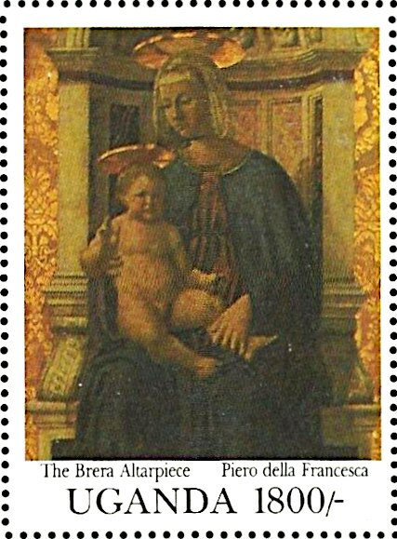
She’s often finding such mistakes. Dalla Ragione made similar discoveries in other well-known paintings. One is reproduced on the Ugandan stamp at right (Scott: unlisted; Michel 1016) issued in 1991. It was painted by Piero della Francesca (1416-1492) and is titled Polyptych of St. Anthony. Dalla Ragione points out that what looks like a small bunch of translucent marbles in Jesus’s tiny left hand are actually cherries! Don’t despair if you can’t see them. They are barely visible on the stamp. They are pale red with a white tint—acquaiola cherries, a variety that has almost disappeared in Italy but back then was quite common.

Central Italy is blessed with very fertile soil. It also is host to a great number of monasteries that have old gardens and orchards. The monks’ unwillingness to sell their lands to agribusiness and their isolated locations avoided ceding to farm consolidations over the past half-century. Dalla Ragione began visiting the active monasteries. There, she found the long-sought trees originally planted centuries ago. Often untended for years, they had aged and survived for generations. Many were the direct descendants of the trees in the Renaissance paintings that she studies intently. From their branches hung abundant quantities of fruit—often pockmarked and misshapen, but nevertheless real and sometimes even delicious.
Louis Morel

