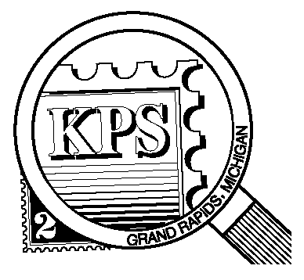

## 



NEWSLETTER OF THE KENT PHILATELIC SOCIETY

P.O. Box 1156, Grand Rapids, Michigan 49501-1156

Jerry Frye, President 616-538-6069

Louis Morel, Editor 269-420-3128

KentPhilatelicSociety.com

K.P.S. Philatelist

Volume 69 - No. 5 May 2025

KPS Club News

|  |  |
| --- | --- |
| Sixty-six people attended the KPS Spring Bourse on May 3. Many collectors left with items acquired from one or more of the six dealers who were on site. There were five first-time visitors at the Bourse. We hope to see them again soon.  🟋🟋🟋  Long-time members of the Kalamazoo Stamp Club, Bill and Madeline Medonis, are now members of the Kent Philatelic Society. Welcome to the Club! We hope to see them at our next KPS meeting.  🟋🟋🟋  Here is a note of optimism, however modest, for the future of the hobby. During the Spring Bourse, a Boy Scout expressed serious interest in collecting stamps. We hope to see him at the upcoming Stamp Social in June. A little encouragement and a little direction can go a long way in inspiring a prospective collector. And earning a Merit Badge for stamp collecting.  🟋🟋🟋  With regards to the second annual Stamp Social, KPS member Darrin Lettinga has volunteered to be the Chairperson for the event. The event will take place at the Byron Center Baptist Church (address below) on **Saturday, June 21** from 10 AM to 3 PM. If you would like to help with the preparation of the event, please contact Bill Sobotka (616.531.3295). Have you signed up to attend? If not, please call Bill and let him know that you plan to do so. We would appreciate knowing ahead of time how many people to expect. | Dealers Chris Daly and David Alex will be present. Many lots of stamps will be available for collectors to inspect.  🟋🟋🟋  KPS member, David Luke will be our speaker at the June meeting. His presentation will ask “What makes a good flag stamp a great flag stamp?” A great question to ask on the heels of the celebration of Flag Day.  🟋🟋🟋  **KPS Archives**: The May 11, 1966 issue of The KPS Philatelist announced that Miss Sarah Hamilton, a resident of Grand Rapids, would speak at the next Club meeting. Miss Hamilton taught mathematics in Ionia. She started collecting flowers on stamps six years earlier. During that time, she amassed six hundred pages of stamps! She selected a few to show at the meeting. She described how she made and annotated her album pages. Miss Hamilton shared her frustration at getting information about the subjects of her stamps. She had yet to find the common name or the scientific name for a large number of them. The article concluded that this type of research makes topical collecting interesting. The author of the article added that “even some of our “anti-topical” members seemed interested”. A significant endorsement of Miss Hamilton’s presentation! The next issue of the newsletter went on to state that “you missed something if you didn’t come to this meeting”. |

The KPS Board will enhance our monthly auctions by holding a drawing for a **FREE** $10 certificate toward the winning purchases of one lucky member. You need to be present to participate in the drawing.

**MONTHLY PROGRAM SCHEDULE**

The Kent Philatelic Society meets on the 4th **Tuesday** of the month at the Byron Center Baptist Church, 7343 Byron Center Ave SW, Byron Center.

|  |  |
| --- | --- |
| May 27, 2025: **KPS CLUB MEETING**  5:30 PM Board Meeting  6:30 PM Lot Viewing  7:00 PM Floor Auction | June 24, 2025: **KPS CLUB MEETING**  5:30 PM Board Meeting  6:30 PM Lot Viewing  7:00 PM Presentation and Floor Auction |
|  |  |

*Members are invited to share their philatelic experiences in this space. Perhaps you made a special acquisition, or thrive on an uncommon collecting topic, or saw a remarkable exhibit. Share it with your fellow collectors. Contact the Editor with your stories.*

**Is the Sky the Limit?**

Humans have gazed at the night sky in wonder since the dawn of civilization. They sought to understand celestial movements and their significance. Ancient cultures such as the Babylonians, Greeks, Mayans, and, later, the Arabs of the Middle Ages meticulously observed and recorded astronomical phenomena, laying the foundations for modern astronomy. The ancient pioneers of astronomy created star catalogs and predicted some celestial events with surprising accuracy. Their efforts not only shaped the understanding of the cosmos in their own time but also set the stage for future discoveries.

In our own lifetimes we have witnessed the exploration of outer space. The “Space Race” started with the successful flight of the Soviet spacecraft, Sputnik (USSR, 1957, Scott 1993), the first artificial satellite to circumnavigate the Earth. The first man in space was Soviet cosmonaut Yuri Gagarin aboard Vostok 1 (USSR, 1961, Scott 2463). Not to be outdone, Colonel John Glenn was the first American to execute a space flight (USA, 1962, Scott 1193). The 1960s culminated with the landing on the moon of Apollo XI (USA, 1969, C76). The world heard Colonel Neil Armstrong pronounce the phrase “That’s one small step for man, one giant leap for mankind.”

Many milestones would follow: the development of the International Space Station (Japan, 2005, Scott 2917e), probes flying by various planets such as the Voyager missions (USA, 1991, Scott 2574-6; New Zealand, 2019, 2862a), and the construction of space telescopes such as the Hubble (Vietnam, 1992, Scott 2361) and James Webb Space Telescopes (Belgium, 2024, Michel 5305).

Many of us are intimately acquainted with all things “Star Trek” (USA, 1999, Scott 3188e, part of the “Celebrate the Century: 1960s” series; and for the 50th anniversary of the TV series, USA, 2016, Scott 5132-5). The mission of the S. S. Enterprise was to “boldly go where no man had gone before”. Some of us have felt compelled to follow Buzz Lightyear “to infinity…and beyond” (USA, 2011, Scott 4555; USA, 2022, Scott 5709-5712).

The first true astronomical object to appear as a stamp design was Crux Australis (the “Southern Cross”, the smallest of all 88 known constellations) on stamps of Brazil (1887, Scott 94) and Western Australia (1902, Scott 86). In 1929, Uruguay introduced a set of air mail stamps (1929-1943, Scott C27-C60) depicting a winged horse set against a background of the constellation Pegasus as viewed from the southern hemisphere.

The Tonanzintla Astrophysical Observatory became operational in 1942 in San Andrés Cholula, México. The country issued six stamps (Scott 774-6, C123-5) on the occasion of its inauguration. The stamps featured the Horsehead Nebula in the constellation Orion, a solar eclipse, the Whirlpool Nebula M51 also known as the spiral galaxy in the “Hunting Dogs” constellation, Spiral galaxy NGC 4594, a planetary nebula in the “Lyre” constellation and, a rare sight, a Hertzsprung-Russell spectral diagram.

While celestial bodies have adorned many stamps, so have many observers. We are familiar with images of Johannes Kepler (German Democratic Republic, 1971, Scott 1275), Galileo Galilei (Italy, 1933, Scott D16), William Herschel (Nicaragua, 1994, Scott 1985g), Friedrich Bessel (Germany, 1984, Scott 1422) and many more.

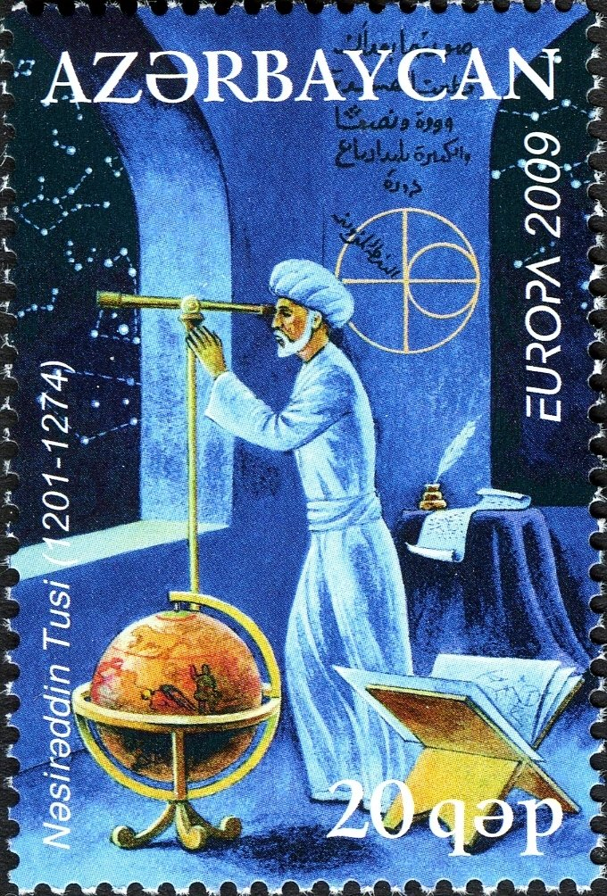One issue is particularly interesting because of its historical inaccuracy. Persian astronomer, Nasiruddin Tusi, is featured on the Azerbaijani stamp issued to celebrate the International Year of Astronomy in 2009 (Michel 758A, at right). The years of Tusi’s birth and death (1201-1274) are clearly indicated on the stamp. Stamp designer, Khasay Mirzoyev, chose to portray the astronomer in full action peering through a telescope. That instrument would not be invented until 1609!

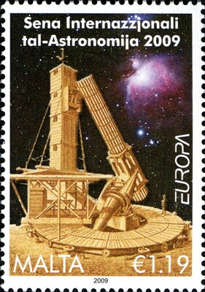

In sharp contrast, English amateur astronomer, William Lassell (1799-1880), built his own telescopes. With them he discovered several moons of Saturn, Uranus, and Neptune. He brought his last endeavor, a 48-inch reflector, to Malta (2009, Scott 1366, at left). There he observed several nebulae.

In 1997, the Lockheed Martin Aerospace Company decided to hold a National Space Day. The purpose was to encourage students to consider a career in the aerospace industry. The event was so successful that a movement formed to establish a permanent day of recognition by the United States government. In 2001, the aforementioned astronaut, then a U.S. Senator, John Glenn declared an **International Space Day** to take place on the first Friday of May. Students everywhere take the opportunity to consider the vast possibilities that the starry sky above us presents.

Louis Morel