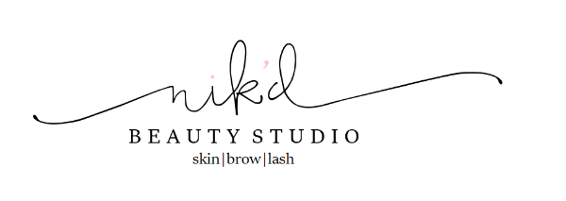

FAQ: Dermaplaning

What is Dermaplaning?

Dermaplaning is a treatment that uses a medical scalpel to gently exfoliate the outer layer of dead skin cells and remove fine facial hair commonly known as “peach fuzz”, technically called “vellus” hair. This procedure will give your skin a brighter, more radiant appearance. Following the treatment, makeup application is smoother and other skincare products are able to penetrate deeper in turn making them more effective.

Am I a good candidate?
ll skin types I-VI can benefit from dermaplaning. This is a great treatment for Global skin types IV-VI. Dermaplaning removes these extra layers of skin, helps correct pigmentation concerns and provides a more youthful and healthy glow.
Typically clients with drier, and even aging skin, will benefit most.

Is the treatment safe?
This treatment is extremely safe when performed by an properly trained skincare professional. There is no more risk to the skin than when you shave your legs. There is also no downtime associated with this procedure. As with any skin procedure, all skin is different and we cannot be held liable if your skin should react to the treatment.

Does it hurt? Will it cause cuts?
Dermaplaning is effective by performing a gentle scraping motion across the skin’s surface. With hair removal such as waxing and threading, most people have the idea that all hair removal is painful, but Dermaplaning is entirely painless. There are risks of cuts on the skin, however they are small and very minor as the pressure used for Dermaplaning cannot cause a deep cut. These nicks and scrapes heal within 24-48 hours.

Will it make the hair on my face grow back thicker and darker?
NO!! This is quite literally, physiologically impossible. The soft, fine vellus hair will grow back slowly – usually in about 4 weeks. There are different types of hair that grow on the body; vellus hair and terminal hair. Vellus hair is found on most areas of the body except palms, soles, lips and genital areas, whereas terminal hairs are found on the scalp, underarms and pubic region. The soft and fine vellus hair grows back at the same rate and texture.

How long is the treatment? How often can I have it done?
Dermaplaning itself takes anywhere between 30-45 minutes and can be performed every 3-4 weeks. It can also be done at the beginning of a facial, so that any products after will penetrate better. The treatment itself removes approximately 21 days worth of dead skin so it is important to let your skin rejuvenate before your next appointment.

What is the difference between dermaplaning and microdermabrasion?
Both options are a form of physical exfoliation. In addition to removing the surfaces of dead skin cells, Dermaplaning removes vellus hair (peach fuzz), microdermabrasion also exfoliates the surface of the skin, but not as thoroughly or deeply as dermaplaning does.

Who cannot be treated?
Clients with active acne outbreaks or cold sores should not be treated until lesions are healed. Dermaplaning is great for diminishing acne scars but should not be performed during active outbreaks. Clients with bleeding disorders or difficulty clotting should not be treated. Clients with diabetes not under control by diet or medication should not be treated. Clients undergoing cancer treatment should also not be treated.

