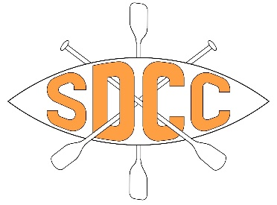
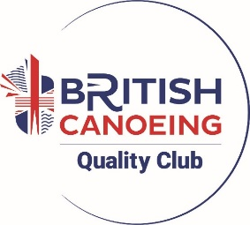
Kit Hire Form – Personal Use

Name of Hirer:
Date of proposed use:
Location of use:
Grade of water:
Who are you paddling with?
How will the equipment be transported:
Have you attended a PRSC/FSRT Course (required for kit hire)? Yes/No
Issue Date: Return Date:
ITEM | NUMBER | NOTES
Kayak/Canoe/SUP
Paddle
Buoyancy Aid
Helmet
Spraydeck
Cag
Pogies

Kit hire cost is £10 for flat water and £20 for white water or weirs.
A deposit of £50 is required that will be refunded upon the safe and timely return of all kit.
Payment via bank transfer preferred to the following account:
Account Name: Swindon and District Canoe Club
Account no: 69977062
Sort Code: 30 98 97
Reference: KIT

I understand that all equipment is hired out on a trust basis and that I am liable for any damage or loss and note that any borrowing of club equipment for personal use is done so completely at my own risk, I agree to report any damage or loss to a committee member immediately.
Swindon and District Canoe Club accepts no responsibility for any third-party loss, injury or damage to property in connection with any equipment borrowed.
Loan of equipment is done so at the discretion of the committee and their decision is final.
Paddling is a risk sport, and every effort should be made by the hirer to ensure they are suitably competent on the water they intend to paddle.
I agree to only use the kit for the purpose stated above and not for any other purpose.
Failure to return the kit by the agreed date will result in extra charges being incurred.
I understand that failure to abide by these conditions may result in kit not being hired to me in the future.

Signed: Signed:
(Hirer) (Committee Member)
Date:

