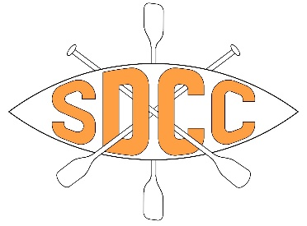
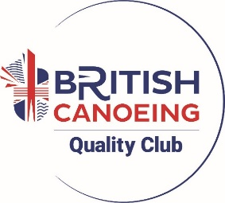
Kit Hire Form – Club Trips

Name of Hirer:
Date of Trip:
Location of Trip:
Trip Leader:
Issue Date: Return Date:
ITEM | NUMBER | NOTES
Kayak/Canoe/SUP

Paddle

Buoyancy Aid

Helmet

Spraydeck

Cag

Pogies

Kit hire cost is £5 for flat water trips and £10 for white water trips or trips with a weir.
Payment via bank transfer preferred to the following account:
Account Name: Swindon and District Canoe Club
Account no: 69977062
Sort Code: 30 98 97
Reference: KIT

All equipment should be returned clean and having been rinsed in fresh water.
I understand that all equipment is hired out on a trust basis and that I am liable for any damage or loss and note that any borrowing of club equipment for personal use is done so completely at my own risk, I agree to report any damage or loss to a committee member immediately.
Loan of equipment is done so at the discretion of the committee and their decision is final.
I agree to only use the kit for the trip stated above and not for any other purpose.
Failure to return the kit by the agreed date will result in extra charges being incurred.
I understand that failure to abide by these conditions may result in kit not being hired to me in the future.

Signed: Signed:
(Hirer) (Committee Member)

Date:

