GWTA Chapter S
Cow Pie Ride Lunch Ride
Nov. 27th, 2026
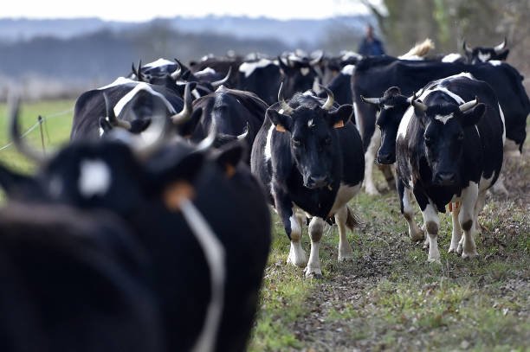

Leaving at the Shell station at 9:00am
101 Bernal Rd San Jose, CA
101 & 85 South San Jose
We will be riding to Coalinga, CA
Mexican food for lunch is the plan.

