

**2023 LARGE SCALE**

**ON-ROAD RULES**

Forward:

The rules have been adopted at the 2018 Large Scale AGM held in South Australia via a majority vote of Clubs. The premise of the agreement is to follow the **EFRA** rules with *Australian by-laws (that are not in conflict with the* ***EFRA*** *technical specifications for cars)* with Clubs reaching agreement for their implementation from January 2019.

The below rules are EFRA rules with the agreed Australian by-laws combined into one document in an attempt to maintain an easy to read ruleset for participants. Large Scale participating Clubs have signed an administrative agreement setting out the administration terms for the agreed rules moving forward.

Background documents supporting these rules are: **1:** Administrative agreement between Clubs, **2:** Standard scrutineering check sheets and **3:** A register of agreed by-laws. Further guidance is taken from the EFRA Handbook in the first instance.

Changes to the below rules will be made to maintain consistency with EFRA rules as they occur, alternative changes require a proposal from a Large Scale RCRA Affiliated Club and a supporting vote by the majority of Large-Scale Affiliated Clubs in Australia

Acknowledgement for the contributions to this ruleset are made to: Daniel Shaw (NSWRCRCC & LS Section Head), Paul Leaf-Milham (RRSA & LS Secretary), Trent Aquilina (NSWRCRCC & LS Committee) & David Mohorovicic (MRCCR). (2018)

**LARGE SCALE ON-ROAD I.C. RULES**

**1. RACE FORMAT & ADMINISTRATIVE REQUIREMENTS**

1. *There will be one National Championship, known as the Australian Championship to be held in the 2nd weekend of November rotating between States annually. 2018 – South Australia, 2019 – Queensland, 2020 – Victoria, 2021 – New South Wales and rotating so on.*
2. *There will be one State Championship for each State annually (NSW – 2nd weekend of September, SA – 4th weekend of February, VIC – 2nd weekend of April & QLD – 4th weekend of June). Other States by arrangement with the Section Committee.*
3. *Australian Sanctioned classes are Sedans (Open Class) and Minis.*
4. *A standard technical checklist aligned to EFRA Technical specifications must be used for scrutineering at all sanctioned race events. If there are no technical specifications listed by EFRA they are to be agreed to by a vote of Clubs.*
5. *Where possible a host club should prioritise a State Championship over two days (plus up to 2 days practice) and a National Championship over three days (plus 2 days practice).*
6. *Host Clubs must advertise and open registrations at least 2 months before an event.*
7. *Entries, including payments close 3 weeks before any event. This allows clubs to make the required plans to successfully host the event.*
8. *Host Clubs must publish an event schedule and race structure no less than 2 weeks before the event commences. Schedules must prioritise completion of sanctioned classes.*
9. *For National Championships the club must host a dinner for participants (and their guests) and the Section AGM. The Host Club must announce this in the Schedule.*
10. *Representatives from each participating State will be elected at events to form a State Jury. Working with the Race Director the State Jury, taking guidance from the EFRA handbook and other supporting documentation, will be responsible for managing disputes and other decisions critical for the management of events. A decision arising from the Race Director and State Jury cannot be appealed.*
11. *Participants must raise concerns or grievances with their State Jury representative.*

**2. SAFETY**

1. Motor sport has inherent risks and potential dangers, including within scale model radio-controlled car racing. The safety of visitors, spectators, officials, volunteers and competitors is of prime importance and must be considered when laying out track, competitor and spectator areas.
2. Spectators, competitors and officials must be efficiently protected against the cars by adequate safety barriers. Track barricades and markers must be shaped and placed in a way that prevents cars from being projected into public areas.
3. First Aid - It is recommended that a qualified First-aid Officer is present throughout the Championship including practice.
4. A current and suitable first aid kit must be available and its location clearly marked throughout the Championship including practice.
5. Marshals - Marshals must be adequately protected from being hit by cars whilst at their marshalling location.
6. Marshals must be provided with a fluorescent safety vest or similar item to aid being seen whilst in the track area.
7. Marshals must always put their safety first.
8. In the event that a marshal is incapacitated or falls onto the track surface placing themselves in danger, the heat or final in progress must immediately be stopped. All cars must stop where they are and follow the instructions of the Race Director.
9. Access for emergency services must be available to all areas at all times.
10. Suitable fire extinguishers must be available at all times in areas around the track such as pit lane, the pits, technical inspection and other areas identified by the host club.
11. Technical inspection must always include the safety aspects of the cars. No sharp edges or other protruding parts of the cars that may cause serious injuries in case of an accident are permitted.
12. The only people authorised to be within the enclosed track area are officials, marshals, competitors and mechanics. All other people must be removed from the enclosed track area whilst the Championship is in progress.
13. All personnel within the enclosed track area must wear fully enclosed shoes. Thongs, sandals, slippers etc are not allowed.
14. Under no circumstances are engines to be run in an enclosed space or building.
15. Where extension leads are used, the host club must follow relevant electrical safety procedures as applicable in that State.
16. Host clubs must be adequately insured. Host clubs must have public liability insurance of not less than $A10 million or a higher amount as determined by individual club requirements. Clubs should obtain expert advice to determine their insurance requirements.
17. Smoking is not allowed within the enclosed track area, driver’s stand, race control, pit lane, pit areas nor any other areas identified by the host club. Any designated smoking areas must comply with relevant state government legislation.
18. Whilst the racing is in progress, the consumption of alcohol or illegal substances by competitors, mechanics and officials will not be tolerated.
19. In the event of an electrical storm in the immediate area, the racing will be suspended. Racing will resume once the storm has passed. During this time, the drivers stand will be closed.

**3. CONCOURSE**

Host Clubs must convene a concourse of cars immediately before the events driver briefs occurs. The concourse must have all cars lined up on the track or other suitable location for assessment of a concourse winner. There will be one winner for each class. Winning cars will be assessed on their artistic designs and overall presentation. Concourse bodies must run at least one qualifier (excl Warm-up).

**4. TROPHIES**

The host Club must present substantive trophies for Positions 1 to 3. The Trophy for position 1 must be of the grandest in nature with positions 2 and 3 reducing slightly thereafter. Positions 4 through to 12 must receive something for their efforts. Concourse and Top Qualifier trophies must be considerable in nature but not outshine that of positions 1 – 3. Trophy requirements apply evenly to all classes (sanctioned or not) for the event.

**3. RACE STRUCTURE**

1. Warm up: max. 5 minutes
2. Heats: 10 minutes (plus the last lap and time of the last lap)
3. A minimum 5-minute break must be given between Heats and 15 minutes between rounds.
4. Sub-finals: (Sanctioned Classes) 15 minutes for ¼ or lower, 20 minutes for semi finals
5. Main Final (Sanctioned Classes): *30 minutes* (plus the last lap and time of the last lap)
6. *Host clubs must announce the race structure when advertising the event and taking registrations.*
7. No competitor is allowed to drive a model car on any other place other than the track and the marked pit lane
8. A Christmas Tree final structure will be used
9. *Where events reach 15 entries for a sanctioned class the event must be run as per EFRA rules. If there is less than 15 entrants, the host Club may elect to run a traditional race format (e.g. Rocket Round or Points) but this must be agreed at the drivers brief and is not permitted to be changed anytime thereafter* 
   1. Each Super Pole must provide a 3-minute warmup to competitors and allow 6 laps over a minimum of 3 minutes for competitors to submit their fastest lap.
10. For Sanctioned classes the No 1 ranked driver after completion of the qualifying heats will move up directly into the main final and take the pole position on the starting grid. The drivers ranked 2nd to 5th will compete in a “super-pole” final after completing the last round of qualifying. Each driver will drive the “super-pole”, The running order will be 5, 4, 3, 2. The driver that scores the fastest lap will also move up straight to the main final and take second position on the grid. The other drivers from the super-pole will start in the semi-finals as per their qualifying position.
11. The first 3 drivers from each sub-final will progress up to the next final.
12. Semi Finals; the first 4 drivers from each semi final will progress to the main final. The next 2 fastest drivers across both semi finals will progress to the main final.
13. Grid positions for places 3-12 in the main final will be based on laps and times arising from the semi finals (e.g. Fastest of the 10 progressing will take position 3 and so on through to position 12)
14. Practice once an event has commenced is at the discretion of the Race Director

**4. Number of drivers:**

1. Heats – Maximum 10 Drivers
2. Sub-finals – Maximum 10 Drivers
3. *Final – Maximum 12 Drivers*

**5. Transponders:**

1. *A working transponder is the driver’s responsibility.*
2. *If identified that a competitor’s transponder has during a race failed the Race Director or Timekeeper will notify the competitor by announcement.*
3. *If the Race Director or timekeeper can clearly account or demonstrate the correct outcome for that competitor, he/she maintains the discretion to amend the race record if a protest is lodged.*
4. *The Race Director or Timekeeper is not obligated to manually count laps or time laps for a competitor whose transponder has failed. There is no avenue of appeal against any race official for not manually recording laps or times.*

**6. Technical Inspection:**

1. *All sanctioned class cars must pass technical inspection before commencing qualifying. Cars will be randomly inspected throughout qualifying heats.*
2. *All sanctioned class cars will be impounded after each sub and semi-final and not released until after the corresponding final has been completed.*
3. *All sanctioned class cars will be impounded at the conclusion the main final.*
4. *A RCRA standard scrutineer checklist and procedure must be used.*

**7. Starts:**

The arrangement of the free practise heats will be created from drivers previous meeting results and known ability. The arrangement of the heats and numbering will be done using the driver’s best 3 consecutive laps or previous results. The drivers must stand adjacent to their numbers on the rostrum, the mechanics must remain in their boxes along the pit lane. For all finals, drivers with the lowest starting numbers may choose their position on the rostrum and the mechanics must stand under the driver where this is possible.

1. *A rolling start will be used for all qualifying heats.*
2. There must be a 3 min. gap between the end of one heat and the start of the next heat.
3. During qualifying an audible warning will be given at 1 minute and again at 30 seconds prior to the official start, in English and other languages as appropriate.
4. For all sub finals and main finals, a “Formula 1” type grid start will be used with each grid start position spaced a minimum of 5 meters apart.
5. *For all finals, the track will be opened 5 minutes prior to the start of the final. At 45 seconds to go the cars are called to the start line. The 10 second count-down will commence within 5 seconds of all cars being stationary in their correct grid position. If a car has not left the pit lane at 30 seconds due to unforeseen problems, the car may start from the pitlane after the other cars have officially started. The race director and referees will monitor the pitlane for the abuse of this facility.*
6. From 10 seconds until 3 seconds prior to the start a second by second countdown will be made in English.
7. From 3 seconds the verbal count down stops and the actual start-signal will be given when the computer reaches 0. If the grid is not to the satisfaction of the race director, he may require a re-start, re-commencing the count down.
8. The official start signal will be audible by means of a hooter, operated by the Starter. This signal will also start the Timing Systems.
9. Early starts (i.e. any part of the car touching the starting line), will be penalised. (stop and go) This penalty is issued by the Starting Official or the Time- keeping official and must be announced immediately after the start. The penalty will be marked on the result sheet.
10. Under no circumstances will the race be stopped due to a jump start.
    1. The Race Director may only interrupt the race and make a re-start in the event that he considers the starting procedure or the start was not carried out correctly.

Delayed start. As long as the Race Director has not called the cars to the start line, any participant of the semi-finals and final may request a delay of 10 minutes to carry out repairs on his car. This delay can be granted only once for each semi final and final. - the track is closed, if the delay is requested as a result of frequency or radio problems - the track is open, if the delay is requested for mechanical repairs or problems. If a driver is asking for a delay due to frequency problems, the mechanics are only allowed to turn off the engine and receiver. They are not allowed to make any repairs including change of tyres. At the end of the 10-minute delay period, a complete new warm up time and start procedure will begin.

* 1. When the Race Director calls the main final to the start line, the mechanics are not allowed to touch the cars.
  2. The driver asking for the delay for what ever reason, except an error in frequencies of the race control, must start from the pit lane after the last car has passed the pit lane

**8. STARTING PROCEDURE OF HEATS:**

1. For qualifying heats, no stop between practice time (warming up) and start of the heat. Just start the clock when practice time is over. (Flying start.)
2. Starting for Sub Finals and Final will be on a Formula 1 grid depending on the track layout, with the faster Qualifier starting in front of the slower.

**9. Finishing Heats**

1. When the time is over, an audible signal is given. A car finishes when it passes the finish line after the finish-signal is given. The car must immediately return to the pits and may not hinder other cars still racing.
2. In case of doubt (on the finish-line when time is over), a car may race one more lap. Whether he finishes or not when time was completed, is up to the Time-keepers and cannot be disputed.
3. After returning to the pits, the engine must be stopped immediately and the transmitter turned off.

**10. Qualification Order and Finals:**

In each round the drivers will score points based on laps and times achieved. Event will aim to complete 6 rounds of qualifying, of the 6 (six) completed rounds 4 (four) will count.

1. After all qualification rounds have been completed the Qualification order is established, by taking the best result of each driver.
2. In case of more than one driver recording identical results of qualifications the next best result is taken.
3. Starting order for the drivers who moved up to the final is based on number of laps and time.
4. *Sedans are only issued 700cc of fuel for the main final which must be verified by the scrutineer who will also ensure the car is presented completely empty before receiving the measured volume of fuel.*

During the warm-up period, or at any other time of a race in progress, deliberate stopping a car on the race track will lead to the driver being penalised with a “stop and go” after the start of the race. Consecutive stopping on the race track will lead to immediate disqualification.

**11. RAIN SITUATION**

*Where event entries are less than 15 for a class and the race structure is being run under a traditional rocket round system* and in case of different weather conditions during subfinals the final classification will be as follows: Place 4 of subfinal A and Place 4 of subfinal B will both be awarded place 11th equal in the general classification. Place 5 of subfinal A and place 5 of subfinal B will both be awarded place 13th equal in the general classification .... and so on.

*The State Jury, via a majority vote may elect before an event commences not to run in the rain. A decision not to run in the rain cannot be made after an event has commenced after which the procedures and rules herein apply.*

**12. RACE INTERRUPTIONS**

1. In the case of a race which is interrupted for more than 60 minutes for reasons beyond the control of the organisers, the jury will decide whether to cancel or continue the meeting.
2. In the case of an interruption of a heat the entire heat will be re-run.
3. In the case of an interruption of sub-final or a final the following procedure will be used:
   1. If less than 10 minutes of a final has been run, the results will be cancelled and a new start given for the total time of the final. Vehicles may be repaired before the new start.
   2. If more than 10 minutes of the final have been run, the results at the moment of the interruption will be kept. The new start will be given for the time which remains to complete the final. The two results will be added to give the final and definitive placing. If the second start cannot be made for any reason, the results from the first part will be used as the final and definitive placing.
4. When the interruption takes place after 75% or more of the race is past, the results as at the time of the interruption becomes the final result. At the moment of the interruption of the race, the drivers will leave their vehicles on the start-line under the control of the Race Director. They may switch off the radio and stop the engine. There will be no repairs carried out to the vehicle or changing of tyres. Any driver who does not observe this rule will be immediately disqualified.

**13. RAIN PROCEDURE DURING QUALIFYING:**

1. The Race Director and the Referees are jointly responsible for the decision to stop a race in the event of rain.
2. On the result sheets the Race Director or the appointed official must mark a heat” WET” when the heat was raced under wet conditions. On the corresponding record sheets, this must also be marked. The Race Director together with the Referees will decide in case of doubt. Heats are generally considered to be” WET” when average lap times are approximately 20% slower than before, due to rain or moisture on the track.
3. When all drivers have had at least one dry heat, all results will be counted.
4. When weather and time permits, the Race Director may decide to offer an extra heat to those drivers who did not have a chance to drive a heat dry
5. If all drivers have not had a chance to run a dry heat, only the wet results will be counted.
6. When continuation is judged to be senseless, or when other drivers should be offered a fair chance to drive under dry conditions, the Race Director together with the Referees may decide to end a heat or cancel a complete heat.

**14. ACCIDENTS/CRASHES**

1. A yellow flag situation will be announced, if an accident occurs. (This must be a yellow flashlight combined with an audible signal, that can be operated by the referees and the race-director *– IF AVAILABLE*). *Other means can be adopted by host clubs so long as this is clearly explained to all competitors*. During this period overtaking other cars is not allowed. Cars are required to slow down so that they can stop immediately. Disregarding this rule will be penalised by deducting one lap from the result of the driver concerned in that particular heat, sub-final or final. An official warning has also to be issued. Racing will recommence at racing speed following display of a green flag *or the official announcement “track is clear”*. Signals given by flags have to be visible for all drivers.
2. *Mechanics are not allowed to enter the track, they can receive the car from a marshal but must not leave pit lane. A marshal may attempt to restart the engine (3x) beside the track, but not repair the* *car. If the car does not restart the marshal shall return the car via the outside of the track to the pits. No person other than the Race Director is permitted to disturb the progress of other cars in the race. Mechanics or Spectators entering the track from outside the pit lane to save a car will produce a penalty for that particular car. (Penalties can be given as stop and go or one lap penalty. The referees will inform the Team Managers about the sort of penalty given.)*
3. If a driver is given a penalty, they have three laps to come in. If the race ends before three laps have lapsed the driver will incur a 1 lap penalty.
4. If a driver received three penalties during a race they will be disqualified.
5. *Drivers or their delegate must marshal the following race. Failure to be in marshalling position for the start of the warm-up for the next race will result in immediately loosing your best round of qualifying or finals position. (event organisers must allow drivers enough time between heats to reasonably fulfil their marshalling responsibilities)*
6. *Marshalls must at all times wear the provided safety vests*.

**15. Tracks and facilities**

1. *No event will be run at a facility which does not have a permanent fence of at least 1 metre in height that eliminates the risk of any car leaving the racing precinct*
2. *Each competitor must be provided a pit area of no less than 1800mm X 600mm which must include power, lights, shade, a concrete floor and a stool/seat. Pitting areas must be directly adjacent to the track.*
3. *No event shall be run at a facility which does not have permanent and physical protection barriers for marshals in high-speed high-risk locations.*
4. *Tracks must have internal barricades which prevents (as far as reasonably practical) a car entering another lane or cutting corners*
5. *Pits must include car washing and compressed air facilities*
6. *Pits and pitting areas must have live monitors displaying race outcomes and a PA system to effectively communicate with participants.*
7. *Facilities must provide for Toilets, hand washing and first aid facilities.*
8. *Sanctioned events must be run at facilities which are the most compliant with the specifications as described by IFMAR rule 20150424 as endorsed by EFRA:*

**SURFACE:**

Track surface should be unsealed asphalt or coarse finished concrete with smooth joints, if any.

**LENGTH:**

The minimum length is 250 metres/820 feet. Advised is 300-350 metres/984 feet-1148 feet.

**WIDTH:**

The minimum width of the track is 4.5 metres/l5 feet between marking lines. The maximum width is 6.5 metres/ 2l feet. The marking lines must be 8-10 centimetres/3-4 inches wide.

**PODIUM:**

Maximum distance from the middle of the drivers' podium to the furthest point of the track is 60 metres/l97 feet. Minimum height of the drivers' podium is 2.5 metres/8 feet from track level and the podium is at least l0 metres/33 feet long. (10 Drivers)

**VISION:**

No obstacles may interrupt the vision from the drivers' podium to all parts of the track.

**MARKING:**

A broken line may be painted in the middle of the straight to increase the vision.

**PITS:**

The (refuelling) and pit area should be clearly distinct and separated from the main track and as close as possible to the drivers' podium. A fire-extinguisher is mandatory. Exit from and entrance to the main track is advised to be on a slow section of the track. Drivers have to reduce speed while entering the pit area.

**DESIGN:**

Track design must include both right and left turns and must have a straight of minimum 60 metres / l64 feet.

**OUTSIDE BARRIERS:**

Outside barriers must provide positive means of stopping a car when missing a corner or out of driver's control. The consideration at selection of the outside barriers shall be the protection of the spectators and not the cars, although, if both can be obtained, it is ideal. The outside barriers must be at least 40 centimetres/l6 inches away from the marking lines of the track. A solid fence of one (1) metre/3.30 feet in height must be placed behind the outside barriers made from a material to stop an out of control car.

**INSIDE BARRIERS:**

Inside barriers must avoid short-cutting of corners or cars getting on other parts of the track. Inside barriers must be positioned and dimensioned to avoid cars flying over the outside barriers into the public. Inside barriers must be smooth and must be 20 cm/8 inches away from the marking lines on the track.

**DOTS:**

No dots will be used on high speed sections.

**SURROUNDINGS:**

The inner and outer surroundings of the track must have grass or other suitable materials, such as concrete. The object of these surroundings is to slow down the car that leaves the track. The car must be able to leave the infield or outfield on its own to minimise marshal assistance.

**STARTING LINE:**

A starting line must be painted across the track, preferably in front of the time keeping. The starting line must be located more than 10 metres/33 feet away from the first corner.

**FORMULA 1 START:**

The grid will be painted on the track, preferably on the straight. Two (2) rows of numbered boxes will be located on the track with approximately 2.5 metres-3 metres/ 8.20 feet-9.84 feet space between each row. On one (1) side, the boxes will be numbered 1, 3, 5 etc. and on the other side 2, 4, 6 etc. No. 1 box is situated 3 metres/9.84 feet in front of No. 3; No. 2 stands 3 metres/9.84 feet in front of No. 4 etc. The boxes should have a width of 50 centimetres / 19.68 inches.

**TECHNICAL SPECIFICATIONS**

**(Sedan and F1)**

**16. Engine and Fuel:**

Sedans and Formula One Classes:

1. *Two engines may be entered into any event. If a driver changes engine they must notify the race director and will be given a 5 second stop and go penalty on the first lap of their next final. Existing engines must be impounded if a driver changes engine.*
2. *An engine can be repaired in front of a technical scrutineer providing the engine seal has not been broken and it has been previously registered prior to qualifying. If this occurs the driver will incur a 5 second stop and go penalty in the first lap of their next final.*
3. The engine to be a single cylinder, 2 or 4 stroke, maximum 23cc for sedans, maximum 26cc for F1. Electric starters can only be used in the pitlane and under no circumstances to be used on the race-track. There must be a secure protection on the flywheel cover to prevent people touching the flywheel or moving parts.
4. 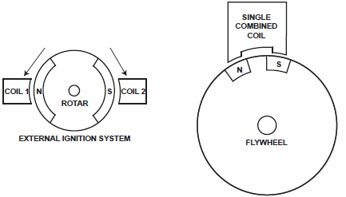No Turbo charging, Fuel injection, Supercharging, Wankel or rotary valve/ distribution engines are allowed.
5. All ignition must be mechanically fixed, only manual static adjustment is allowed. The flywheel can only have 1 (one) pair of magnetic poles (i.e. one north and one south).
6. No Battery-operated ignition allowed. Only a passive ignition system using R.P.M. as the single input parameter is allowed.
7. Only open deck admission ports are allowed. The removal of material is free as long as the modified shape of the transfer/admission port walls are in the direction of the cylinder bore at all times.
8. The Cylinder block must be of a single casting. No independent liners or slipping liners are allowed.
9. 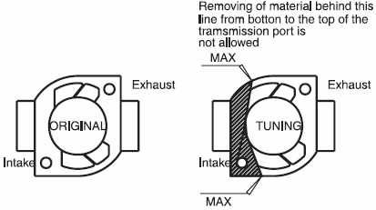The maximum numbers of admission ports are 4.
10. Engine must be air cooled. The air being driven directly by the flywheel.
11. The crankshaft must be of split shaft configuration, with enclosed big end. No half crankshafts allowed.
12. An air filter must be fitted to the carburettor.
13. The maximum venturi diameter of the carburettor is limited to 13 mm.
14. Only fuel admitted will be petrol normally available at street petrol stations.. Special fuel’s like Avgas, race fuel etc. are strictly forbidden. The only additive allowed is mass production two stroke oil. Technical inspection may ask for a sealed bottle of that oil, to check it. If a fuel is found suspect, the driver will be asked to mix his fuel at technical inspection, so it can be verified. If an organiser is able to provide fuel at the track, all competitors have to use this fuel. The price of this fuel must not exceed the normal street price by more than 5%. Fuel tests may be made at random during the race. If a fuel is found illegal, the driver will be disqualified from the particular event and they will not be allowed to enter an EFRA Large Scale event for the remainder of the current year and the full 12 months of the following year. The fuel tester must be available to the competitors during the event. If a driver wants to protest that decision, he has to make a written protest to EFRA with a deposit of 500.- EUR.

**17. Exhaust/Noise Reduction:**

1. Maximum noise level is 81dB (A) measured at 10 metres, 1 metre above the track. The race director has the authority to decide a different method of measuring (using the EFRA noise trap) as long, as the result will be the same. If a cars average over 10 or more laps exceeds the limit (with an additional +4db (A) for off Road and F1 classes) during the qualifying, then the driver will lose their best qualifying result. If this level is exceeded during a final then the penalty is a 1 lap deduction at the end of that final. Under exceptional circumstances common sense will be used. Both the Race Director and Referees can decide if any car producing excessive noise is allowed to race. Exhausts have to be of minimum three chamber type. No open exhausts or pipes are allowed. The total exhaust must be inside the body, with the exception of the tail end of the pipe, which may protrude the body by no more than 10 mm. No adjustable or moving parts are allowed in the manifold or muffler. The body may be cut out at that point max. 20 mm more than the tail end diameter. Max. inside diameter tail end 13 mm.
2. All cars to be equipped with an air - box to reduce the intake noise of the carburettor. The air box must change the direction of air entering the carburettor by 90 degrees (or more) and be made of a rigid material. The exhaust must have a second muffler (if a two-chamber exhaust is used) or be a three-chamber type muffler. All three chambers must be designed so that the exhaust fumes will pass through and have to change direction twice to get the maximum possible noise reduction. The design of that additional silencer is free, but with both systems together, the max. noise level must not be over 81 dB (A).
3. No refuelling allowed during racing for all cars.
4. The Engines adjustments and warming are strictly forbidden in pits and working areas. They are allowed only on protected tables supplied by the Organisers, and in the proximity of pit lane, and of the Rostrum.

**18. Car:**

1. The car has to have a functioning brake, which has to be capable of keeping the car stationary whilst the engine is running.
2. A mechanical fail-safe has to be fitted to the carburettor which returns the throttle to a closed position in case of breaking of the throttle linkage.
3. Variable ratio transmission is not allowed.
4. Only 2WD (rear-wheel drive) drive cars are allowed.
5. No other function than steering and throttle/brake are allowed to operate with radio control by the driver. Any other electronic or hydraulic systems are not allowed in the car, with the exception of electronic fail save to stop the car in case of radio failure and the hydraulic brake system. Movable upper Formula 1 wing (DRS) can be operated together with brake or throttle function. A separate radio channel to operate DRS is not allowed.
6. The use of an electronic fail-safe system is highly recommended.
7. The ignition kill switch must be on its original place on the engine and the window on this side must be cut. The position must be market with an E (size 20 mm) on the bodyshell. To create more safety, it is allowed to have a second kill switch fixed near the rear window to allow easy access. This kill switch should be away from hot or moving parts.

**19. Tyres:**

Tyres have to be black. The design of the tyre profile is free. It is not allowed to

treat the tyres in a racing facility. This means it is clearly forbidden. But if someone

use it at home, it is recommended that the chemical components of these

products must be harmless for people and environment. Liability at the use

of tyre additives lies at the user and manufacturer. Oil of wintergreen, paragon

and other strong-smelling products are prohibited

**SPECIAL TECHNICAL SPECIFICATIONS**

**Large Scale Formula One:**

Only Formula 1 cars following the FIA 2000/1 (or younger) Formula 1 Regulations are allowed. Paintwork and colour are free. The design of the visible suspension parts must have the same appearance than the original F1 cars.

All cut-outs must exist also in the full-size car. Cut outs for the engine and fuel tank are allowed in the area of the tank seal, starting device and adjusting screws for carburettor i.e. choke, neutral gear etc. For Formula cars the side pods have to be used for the starting number.

**TECHNICAL SPECIFICATIONS:**

|  |  |
| --- | --- |
| Minimum weight dry: | 10.000 g |
| Width Formula maximum: | 450 mm (incl. tyres) |
| Height maximum: | 250 mm |
| Wheel base: | 620 mm +/-15 mm |
| Fuel tank capacity: | 700 cm³ (incl pipes to & from the carburettor and any fittings) |

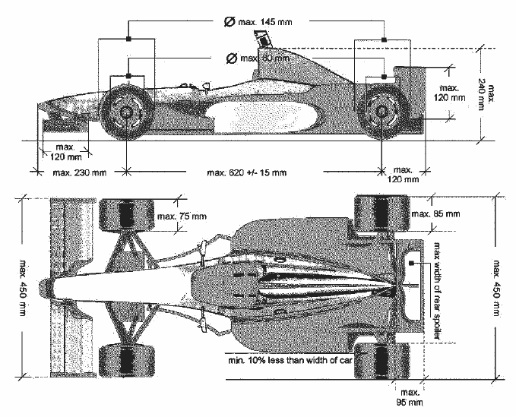

|  |  |
| --- | --- |
| Tyres front diameter: | 142 mm +/- 5% = 134,9-149,1mm |
| Tyres rear diameter: | 142 mm +/- 5% = 134,9-149,1mm |
| Tyre width front: | min. 60mm, max. 75mm |
| Tyre width rear: | max. 85mm, (rear wheels must be min. 5mm wider than front wheels) |
| Rims outside diameter: | 80mm +/-5mm, (indicators must be the same on tyres & rims) |

No mixture of +/- is allowed on the wheels and tyres. No tyre will be measured

after the race.

**TYRES:**

* Tyres must be semi-pneumatic rubber.
* They must be moulded in one piece
* In case of rain the use of rain tyre can be allowed by the race director.

**FRONT SPOILER:**

* Max width 450 mm max. cord 120 mm.
* The front spoiler must be fixed at the chassis, so that it can bend up or down in case of an accident.

**REAR WING:**

* The rear wing must fit into a side profile box of 95x120 mm.
* The number of added wings inside is free.
* The rear wing must not be wider than the space between the rear tyres.
* The front part of the car should not overhang the centre of the front wheel by more than 230 mm.
* The rear wing and at the diffuser should not overhang the car by more than 120 mm.
* The width of the side-pods must be min. 10% less than the overall width. They should not be higher than the tyres.

**TANK SIZE, ENGINE RULES, AIR BOX, MUFFLER ETC:**

* Air box, muffler, engine rules, etc have to follow Large Scale General Technical Specifications.
* Exhaust outlet pipes must exit within the body shell side pods and point down to the track.

**F1 WINGS:**

Front and rear wing are part of the bodyshell of a F1 car and must be repaired

immediately if they get damaged or come off the car.

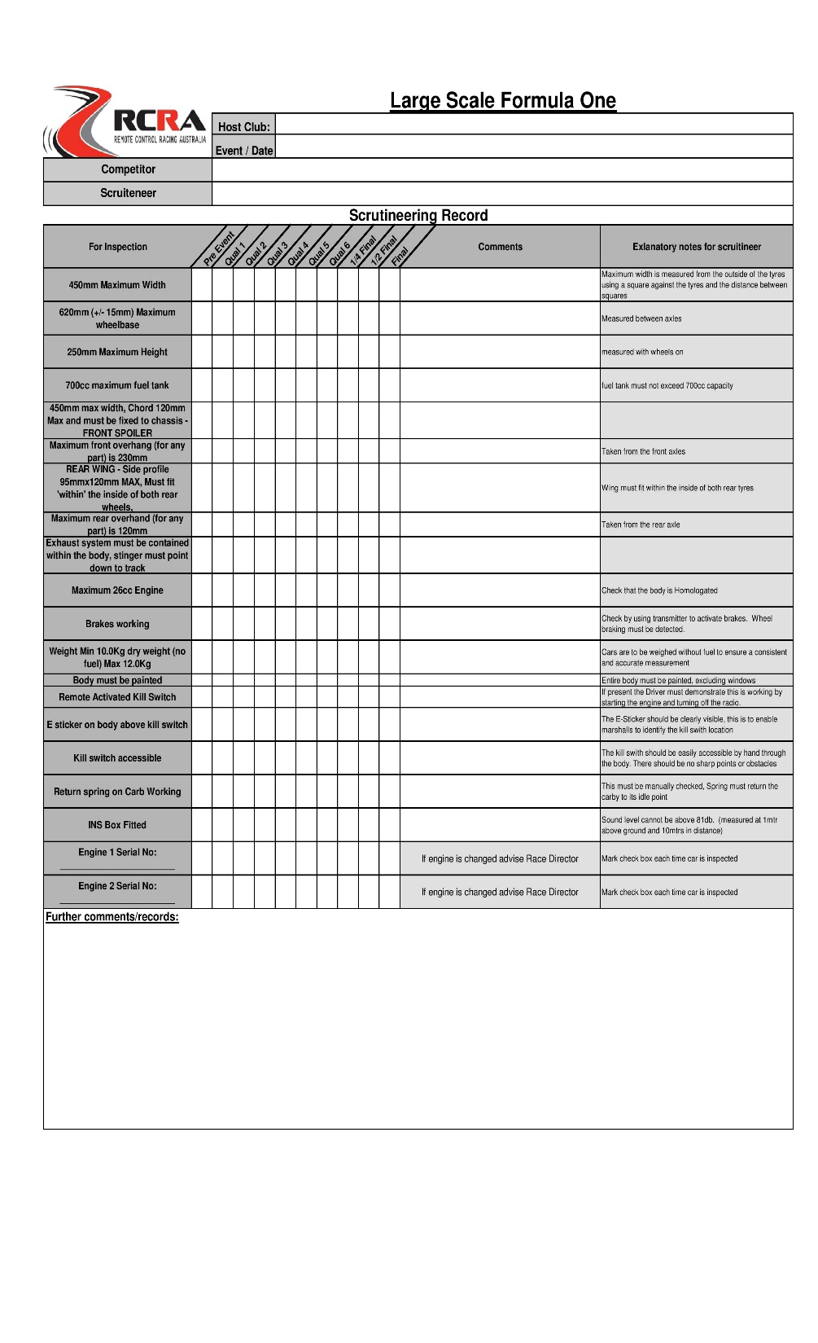

**Large Scale Touring Cars:**

There is one series recognized in accordance to the 1:1 scale series namely the

Touring Car Championship Series, following FIA class 2 Super Touring Car, FIA

Group N and Touring Cars Super 2000.

Touring cars raced in national series like Australian V8 Supercars, CTCC; German

Pro-car, Italian Super Stars will also be allowed with the only restriction that rear

wing has to follow the specifications described herein.

**GENERAL SPECIFICATIONS:**

The car body has to comply with the calculated scale dimensions 1:5 with the

allowance of using the following tolerances.

|  |  |
| --- | --- |
| Length: | within scale +/- 5% |
| Width: | max. 395 mm measured at the widest point of the bodyshell |
| Height: | within scale +/- 5% |
| Minimum weight, without fuel: | 10.000 g |
| Maximum weight, without fuel: | 12.000 g |

All 1:5 cars have to be genuine scale in all details and proportions and be a fully detailed model of an existing 1:1 touring race car. If the allowed tolerances are used, then all parts of the model in that particular view have to be within the same sign (wheelbase-, length,- //wheelbase+, length+). Mixtures of car designs are not allowed.

The minimum length of a Super Touring Car is 4.200 mm that gives a minimum length of 798 mm in scale including max.-tolerance. All recognized cars must have a minimum length of 4,200 mm / 165.35 in. All bodies that are produced world-wide, descend from an original touring car racing and are commercially available. Only bodyshells that are approved by EFRA will be allowed to race in EFRA sanctioned events. The EFRA homologation number has to be permanently engraved or moulded in within the space normally used for car registration numbers at the rear end of the model. The minimum weight of the body is 500g (ready to race including wing but excluding any air ducting). Weights are NOT allowed to be added to the body.

**BODY:**

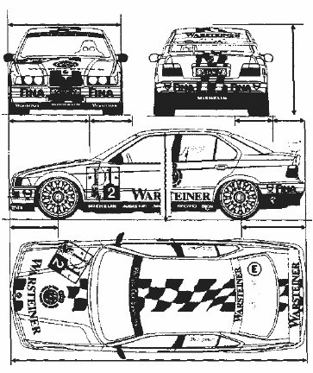Bodies must be EFRA homologated *or otherwise approved in Australia (See Australian Body List)*. They have to be properly fixed to the chassis and *must cover the outer edge of the wheels at the centre of the axle when viewed from the top.* It is not permitted to cut the windscreen out. The side and rear windows may be cut out for cooling. It is not allowed to open them by cutting out only some holes. Also, it is not allowed to mould air channels into the side windows to guide air into the interior. The body shells have to be painted and all windows to remain clear.

All parts of the car have to be covered by the body. Only the radio antenna is allowed to come outside. All openings in the body have also to be in the existing 1:1 race car. It is not allowed to modify the car body by cutting it over the marked trim lines or to widen it by heating it or parts of it.

The start numbers must be placed according to the drawing (and the corresponding picture).

If the race-meeting has started, a competitor is only allowed to change the body shell in case of damage to a body shell of the same brand and car design.

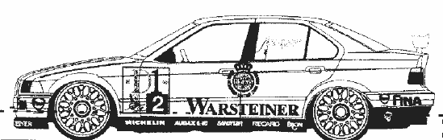Only allowed for manufactures:

Aerodynamic modifications at the

front, the sides and the rear below the wheel hub centre are free subject to the requirements for ground clearance, overall length and overall width.

The modifications have to correspond to the original. The materials have to be the same as that of the bodyshell. The homologation number has to be engraved. A photo of the modification 1:1 / 1:5 have to be sent to the responsible Homologation Officer.

**GROUND CLEARANCE:**

The measurement of the body shell height will be made with 6mm ground clearance.

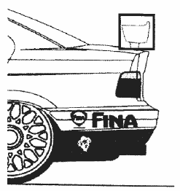**WING/SPOILER:**

A single rear wing is permitted as long as it does not exceed the front view profile and the width of the car. The wing has to fit in a side “profile box” measuring 60 mm x 60 mm per side and should not overhang the end of the car. Extension pieces extending past the main end plates are not allowed

**BUMPER:**

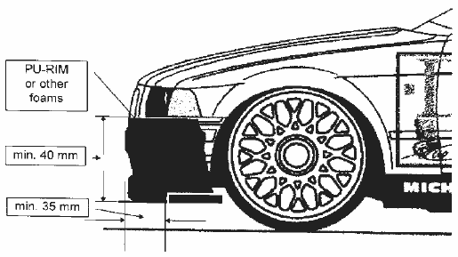A bumper has to be fitted to the chassis. Bumpers have to be designed in a way that they fill the front of a car body completely and be a minimum height of 40mm.The material

used has to be flexible

like PU-RIM or other

foams, that are used in

1:1 car construction to

absorb impact energy. At

no point may any part of inflexible material for bodyshell mounting protrude

from the body more than 10mm. If an opening is created through the foam

bumper for cooling air, the combined thickness of the foam (above and below

the cooling hole/slot) must still be a minimum of 40mm in height.

**TYRES:**

|  |  |
| --- | --- |
| Rim Diameter max: | 107mm |
| Rim and fitted tyre Diameter max: | 136mm |
| Rim and fitted tyre width - front max: | 75mm |
| Rim and fitted tyre width - rear max: | 80mm |

Only semi pneumatic rubber is allowed. Foam tyres are not allowed.

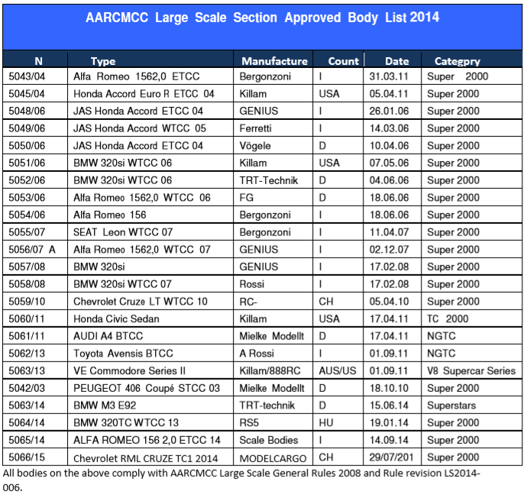

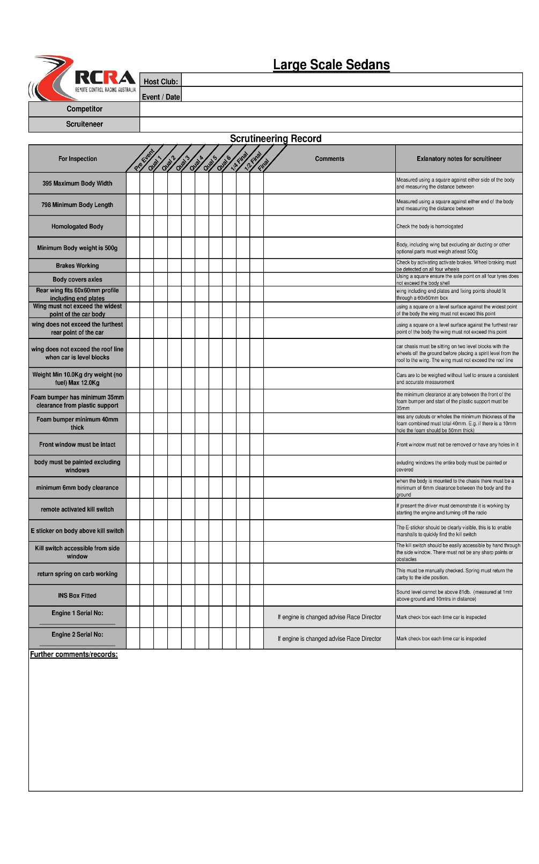

**Large Scale Minis: (Old Rule)**

**Will be known as 510 4WD (NEW RULE)**

**Chassis can Be from any manufacturer providing they fit within the following rule set.**

The purpose of these technical specifications is to enable drivers to compete in a controlled class, which offers both a low cost and a level playing field.

No modifications are permitted other than the modifications, option and aftermarket parts as listed.

The intent of this class is; that it be an out of the box class with minimal modification allowed. Each approved modification from stock will be listed in these rules, approved optional parts will be shown with **. If a modification is not listed, it is not allowed. i.e. Aftermarket alloy screws, coloured washers, home built parts etc.

**TECHNICAL SPECIFICATIONS:**

* The large scale **510 4WD**, apart from the listed optional parts, must be presented in stock condition.
* The term **510 4WD** --- Refers to the original (OEM) **510 4WD**
* The term OEM --- Refers to original specified parts or specification from the manufacturer
* The term Stock Condition --- As supplied from the original (OEM) **510** 4-wheel drive
* Manufacturer in stock condition (without upgrades)

**GENERAL SPECIFICATIONS:**

* The large scale **510 4WD** Mini /**BMW M3/Porsche** body has to be a genuine scale in appearance and be a true represented model of a 1:1 racing Mini Cooper/**BMW M3/ Porsche**. Maximum fuel capacity is 700cc (700ml)
* Minimum weight (without fuel) is 10kg
* Minimum wheel base is 510mm (Old Rule)
* Wheel base is 510mm only (NEW RULE)

**MINI /** **BMW M3 and Porsche:**

* The 510 4WD has to have a functioning mechanical brake, which has to be capable of keeping the car stationary whilst the engine is running.
* An electrical failsafe Kill Switch can be fitted to the car. The only function this switch can perform is shutting the engine off remotely via the transmitter or automatic engine shut off if radio contact is lost. (This function must be demonstrated at Technical Inspection)
* Variable ratio transmission is not allowed.
* The 4 Wheel Drive system (drivetrain) and chassis for the 510 4WD are to be of the originally specified design and manufactured using the materials, as supplied by the manufacturer. 5. No other function/s, other than steering, throttle/brake are permitted to be used on the radio controller by the driver. Any other electronic or hydraulic systems is not allowed in on the car, with the exception of a transponder and electronic kill switch, to stop the Mini in case of radio failure.
* The position of the ignition cut---out switch must be marked on the body shell with a white circular decal, 30mm in diameter, outlined in red with a red E in the centre. The switch must remain in the manufacturers original position and not be modified.

Side intrusion bars if fitted must be made of nylon, plastic, carbon fibre or aluminium angle (Bunnings I/N:1067823) 20x12x1.4mm thick only. Any manufactured side intrusion bars MUST have all corners rounded and sharp edges removed.

**SERVO’S & RADIO:**

* Maximum two servos are allowed, a single steering, and one brake / throttle servo.
* Transmitter radio, servos and batteries are open.

**BODY:**

* Bodies have to be properly fixed to the chassis and must cover the outer edge of the wheels at the centre of the axle when viewed from the top. 2.
* It is compulsory to cut out the 2 front side door windows.

1. Option #1: To remove rear windscreen
2. Option #2: Cut out one or both side rear windows – Rear windscreen must remain

*NOTE: **Only one option can be selected not both. Front windscreen must remain at all times.*

* The body shell must be painted or wrapped with all windows to remain clear.
* All parts of the Mini Cooper have to be covered by the body. Only the radio antenna, body posts, body pins and body options i.e. Mirrors, wipers etc. may protrude outside of body. You are not allowed to modify the Mini---body by cutting it over the marked trim lines or to widen it by heating it or parts of it.
* The OEM **510 4WD** Mini Cooper body **BMW M3 and Porsche** is approved for use. i.e. (Original Equipment Specified from the Manufacturer)
* An optional body mount for the bonnet may be used: **Part Number: FG---090 for Mini body shell
* **Body Shell List**
* **BMW M3 FG08059**
* **Mini FG05180**
* **Porsche FG 05170/5**

**WING / SPOILER:**

* Only wings or spoilers supplied with the original **510 4WD** Mini/**BMW M3 and Porsche** bodyshell are permitted. No angle changes or modifications are allowed to wing or mounting.

**BUMPER:**

* Foam must be attached to front bumper securely and fitted to suit front of the 4WD 1/5TH Mini body with a minimum 15mm foam overhang forward of plastic bumper

**CLUTCH:**

* The clutch must be a non---modified standard two---shoe clutch as per OEM specified with the **510 4WD** with no adjustment capability.
* **An optional aftermarket clutch spring is allowed, it must not exceed 9500 RPM with a tolerance of + 5% on engagement.
* Clutch engagement will be checked at Technical Inspection

**BRAKES:**

* Front --- Only cable activated brakes with pressed steel rotors are permitted – as per **510 4WD** OEM specification. 2. Rear --- Lay shaft brake only as per OEM specification.

**SHOCKS and SPRINGS:**

* Original Shock absorbers must not be modified in any manner.
* Only the following optional springs are allowed:

**Part Number: 07182 – Yellow

**Part Number: 07183 – Red

**Part Number: 07184 – Blue

**Part Number: 07185 - Violet

**\*\* Part Number: 07193 – Yellow Progressive 58mm (NEW RULE)**

**\*\* Part Number: 07197-- Yellow Progressive 68mm (NEW RULE)**

* Shock oil open.
* Plastic shock adjusting 16mm rings can be used as an optional part: **Part Number: 07205/06.

**SWAY BARS / ANTI ROLL BARS:**

* Only original sway bars as per OEM specification for the 510 4WD may be fitted front and rear.
* **66260 4mm add 66261 5mm front Sway bars are allowed (NEW RULE ADDED)**
* **07071/05 SwayBar Rear 4mm and 07071/06 5mm Rear Sway Bar are allowed (NEW RULE ADDED)**

**FUELTANK SEAL/LID:**

* Fuel tank lid can be modified or replace to prevent fuel leaking. FG OEM 700ml tank must be used. Can also use Optional Fuel Tank Cap set FG08385.
* **Fuel tank from other manufacturer may be used providing it does not exceed 700ml capacity**

**WHEELS and TYRES**:

Tyres have to be black. The design of the tyre profile is free. It is not allowed to

treat the tyres in a racing facility. This means it is clearly forbidden. But if someone

use it at home, it is recommended that the chemical components of these

products must be harmless for people and environment. Liability at the use

of tyre additives lies at the user and manufacturer. Oil of wintergreen, paragon

and other strong-smelling products are prohibited, Tyre cleaners are not allowed.

* No tyre warmers of any type are permitted
* Dry Weather Tires: A maximum of two complete sets (4 pairs) of any GRP “C” compound equivalent tire is permitted for each event. Tires must be commercially available and identified as “C” compound equivalent by GRP through the large-scale executive. Older versions of the “C” compound tire are permitted for use as long as they can accurately be identified as “C” compound with the original manufacturer mark.
* **PMT SUPREEM V2 MEDIUM GRP XS5 Also GRP S5 are Allowed with the above rule set.**
* Wet Weather Tires: A maximum of one set (two pairs) GRP wet weather compound tires. Only when the track is declared wet (OLD RULE)
* **Choice of PMT or GRP Wet Tyres Allowed one set (two pairs) (NEW RULE)**
* All tyres must be presented prior to scrutineering for security marking. Once tires are presented a compound change cannot be made during the event. Only the tires that are marked can be used.

**DIFFERENTIAL:**

* Only original OEM specified **510 4WD** differentials with plastic cover and housing. For durability the following optional parts are approved for use as well.

1. **Part Number: 08484 – ALLOY DIFFERENTIAL CONVERSION KIT
2. **Part Number: 68405/01 – 4WD ALLOY DIFFERENTIAL CONVERSION KIT

* Alloy Housing open centre diffs are permitted
* No adjustable differentials or limited slip type differential or inserts are permitted. Also, no mechanical modifications ie. springs, washers are to be used in the differential.
* Differentials must not be locked.
* No Front One---Way Clutch Differentials allowed.
* Output gear on differential is to be as original OEM specified --- 48 Teeth.

**GEAR RATIO AND GEAR PLATE TRAIN:**

OEM specified gear ratio to remain being --- 24/40 (LAY SHAFT), 15/48 (DIFFERENTIAL) For durability the following optional parts are approved for use **Part Number: 07439 --- ALLOY GEAR CARRIER 52mm --- SPECIAL **Part Number: 07439/05 --- ALLOY GEAR CARRIER 52mm

For durability the following optional aluminium gear plate assembly (2 components) are approved for use Large Scale Mini On Road Section Part number--- FG07474 ALLOY GEAR PLATE and FG07040/01--- ALLOY BRAKE CALIPER

**BEARINGS:**

* Only standard bearings as original OEM specified with the **510 4WD** are to be used
* High speed and ceramic bearings are not permitted.

**ENGINE:**

* The engine is to be a stock, Zenoah G270-4 bolt cylinder, G260 – 2 bolt cylinders, CYR260 – 4 bolt cylinders non-modified single cylinder, 2 stroke, maximum 26cc
* Engines may be stripped down and measured for legality at Major events after the completion of the main final
* Permitted Carburettors include WT603, WT668 & WT997. Must have operating choke. The WT990 Carburettor is not permitted for us on any of the approved engines.
* **Throttle shaft bearings are allowed for use on the above carburettors**
* All ignition timing must be mechanically fixed as originally supplied by OEM 510 4WD manufacturer.
* No Battery-operated ignition allowed. Only a passive ignition system using R.P.M. as the single input parameter is allowed.
* The Cylinder block must be of a single casting. No independent liners or slipping liners are allowed.
* The maximum number of admission/transfer ports is limited to four (4).
* Engine must be air---cooled, the air being driven directly by the flywheel. The flywheel is not to be modified in anyway.
* The crankshaft must be of split shaft configuration, with enclosed big end. No half crankshafts allowed.
* An air filter must be fitted to the carburettor. The maximum venturi diameter of the carburettor is limited to 13mm/0.51 inch.
* An air filter outer cover may be used.

The original engine as supplied by the OEM 510 4WD manufacturer must not be tampered with in any manner.

* **Optional alloy (A)small engine mount and (B)lay shaft mount can be used:
  1. Part Number: 06485/01 in place of OEM supplied plastic mount.
  2. **Part Number: 66215 Aluminium Engine/Layshaft Mount**
* In the event of major engine issues, rules allow replacement of, barrel, piston, ring, gaskets, standard carburettor or other issues at the discretion of appointed scrutineering group and under scrutineering supervision.

**FUEL:**

* Only fuel allowed for use will be petrol/gasoline normally available at automobile service stations. Special fuel like avgas, race fuel etc. is strictly forbidden. The only additive allowed is oil.

**EXHAUST:**

* Standard OEM specified **510 4WD** (OEM Supplied) Alloy Tuned side mounted 3---unit (chamber) pipe.
* If a car produces a noise level much in excess of the other Mini’s, it is at the Race Director's discretion on whether this Mini is allowed to continue in the race. No open exhausts or pipes are allowed.
* The total exhaust has to be inside the body.
* A 7.5% + tolerance for pipe capacity allows for pipe repair work. i.e. 50mm +7.5%= 53.75mm, over this tolerance would requires pipe to be repaired or replaced.

**DRIVE LINE:**

* **Optional CV (Constant Velocity) joints for the front-end drivetrain Part Number 68415 may be used in place of original front drive shafts
* **0607905 8mm Rear axle shafts are allowed**

**NOISE REDUCTION SYSTEMS:**

* The application of this rule is at the discretion of the organising club through the Race Director and must be applied and advertised prior to issuing or accepting race entries.
* All **510 4WD** to be equipped with OEM specified/supplied Foam Filter to reduce the intake noise of the carburettor.

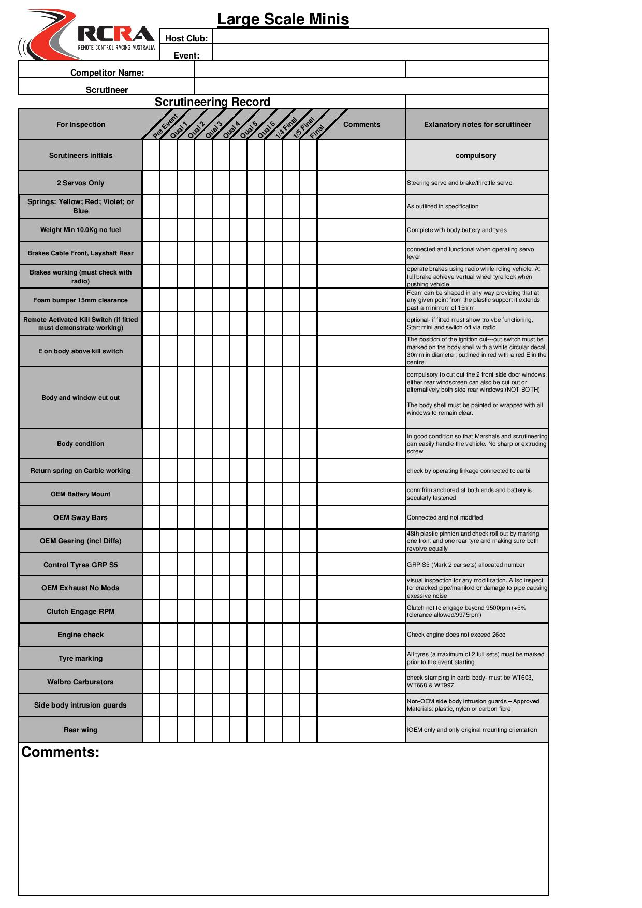

**SUMMARY OF CHANGES/HISTORY OF DOCUMENT**

|  |  |  |
| --- | --- | --- |
| **Version** | **Date** | **Changes Made** |
| 1.0 | December 2018 | Initial document |
| 1.1 | February 2019 | Add Concourse, Trophy requirements, correct omissions to mini specifications, correct time allowance for super-pole, correct race procedure (no changes after event has started), correct errors in Sedan specifications (maximum to minimum) & add version tracking record |
|  |  |  |
|  |  |  |
|  |  |  |