**KSHITIJ TUTORIALS**

**(**Shop no. 15, First Floor Tropical lagoon shopping center, Anand Nagar, Thane West**)**

**(Amines)**

Standard :- XII (CBSE Board) Marks :- 20 Time:- 45 minutes

I). Do as directed 10 Marks

1. Give the IUPAC name of H2N — CH2—CH2—CH = CH2.

2. Write the structure of 2-aminotoluene.

3. Write the structure of prop-2-en-l-amine.

4. The conversion of primary aromatic amines into diazonium salts is known as………………..

5. Arrange the following in increasing order of basic strength:-

Aniline, p-Nitroaniline and p-Toluidine

6. Give reasons : (a) Aniline is a weaker base than cyclohexyl amine.

7. Giving an example for each describe the following reactions :  
(i) Hofmann’s bromamide reaction (ii) Gatterman reaction

8. Complete the following reaction equations:   
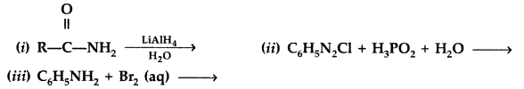

II). Answer in brief 10 M

1. In the following cases rearrange the compounds as directed : (Delhi 2010)  
   (i) In an increasing order of basic strength :  
   C6H5NH2, C6H5 N(CH3)2, (C2H5)2NH and CH3NH2  
   (ii) In a decreasing order of basic strength :  
   Aniline, p-nitroaniline and p-toluidine  
   (iii) In an increasing order of pKb values :  
   C2H5NH2, C6H5 NHCH3, (C2H5)2NH and C6H5NH2
2. State reasons for the following  
   (i) pKb value for aniline is more than that for methylamine.  
   (ii) Ethylamine is soluble in water whereas aniline is not soluble in water.  
   (iii) Primary amines have higher boiling points than tertiary amines
3. Give the structure of A, B and C in the following reactions   
   