**KSHITIJ TUTORIALS**

**(**Shop no. 15, First Floor Tropical lagoon shopping center, Anand Nagar, Thane West**)**

**(3-D Geometry)**

**Standard :- XII (CBSE Board) Marks :- 20 Time:- 45 minutes**

**I). Choose the correct alternative 5 Marks**

1. The distance of point (2, 5, 7) from the x-axis is  
(a) 2  
(b) √74  
(c) √29  
(d) √53

2. Direction ratios of a line are 2, 3, -6. Then direction cosines of a line making obtuse angle with the y-axis are  
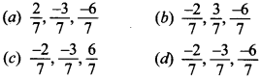

3. A line makes angle α, β, γ with x-axis, y-axis and z-axis respectively then cos 2α + cos 2β + cos 2γ is equal to  
(a) 2  
(b) 1  
(c) -2  
(d) -1

4. Distance between planes  
Maths MCQs for Class 12 with Answers Chapter 11 Three Dimensional Geometry 8  
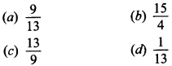

5. The vector equation of the line  
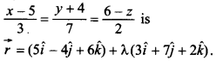  
State true or false.

**II). Answer the following 6 Marks**

**Q1. Find the equation of a plane which is at a distance 3 √3 units from origin and the normal to which is equally inclined to coordinate axis.**

**Q2. O is the origin and A is (a, b, c). Find the direction cosines of the line OA and the equation of plane through A at right angle to OA.**

**Q3. What are the direction cosines of the equation of the plane 2x + 3y – z = 5?**

**III). Answer in Brief 9 Marks**

**Q1. Find the equation of the plane through the points (2,1, -1) and (-1,3,4), and perpendicular to the plane x-2y + 4z = 10. 4 Marks**

**Q2. Show that the straight lines whose direction cosines are given by 2l+2m -n=0 and mn + nl + lm = 0 are at right angles 5 Marks**