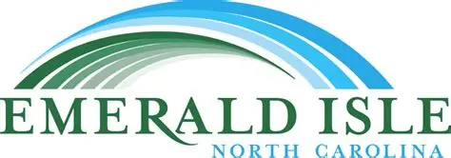

Emerald Isle Fishing Tournament Scholarship
2026 Application

An electronic copy of this application is available at eifishing.com/scholarship-information

The Board of Directors and sponsors of the Annual Emerald Isle Fishing Tournament invite applications for the 2026 Emerald Isle Tournament Scholarship. Graduating seniors from Swansboro, Croatan and East and West Carteret high schools may apply. Applicants must have been accepted by an accredited 2-year Community or Technical College or a 4-year College or University. They must have an interest in some aspects of Marine or Coastal Science or Engineering, or in Environmental Science, Policy, or Sustainability. The Board is hopeful that successful scholarship recipients might return to Eastern/Coastal North Carolina to pursue their post-graduate career.

The award: $3,000 paid directly to the recipient’s college or university. For 2026 there may be
as many as six scholarships awarded ($18,000).

Eligibility: Any graduating senior from these local high schools with an interest in a marine or
environmentally related career, except children of members of the Tournament
Organizing Committee.

Applications and supporting documents must be turned in to Mrs. Nicole Rains (Swansboro), Ms. Karen Davis (Croatan), Ms. Pam Roberson (East), or Ms. Melissa Smith (West) no later than Friday March 31, 2026.

In addition to this application form, applicants must submit a LETTER OF RECOMMENDATION from a teacher or guidance counselor, as well as a copy of their high school ACADEMIC TRANSCRIPT.

