Renaming 3i/Atlas
To
Four-phased Galactic Redesign

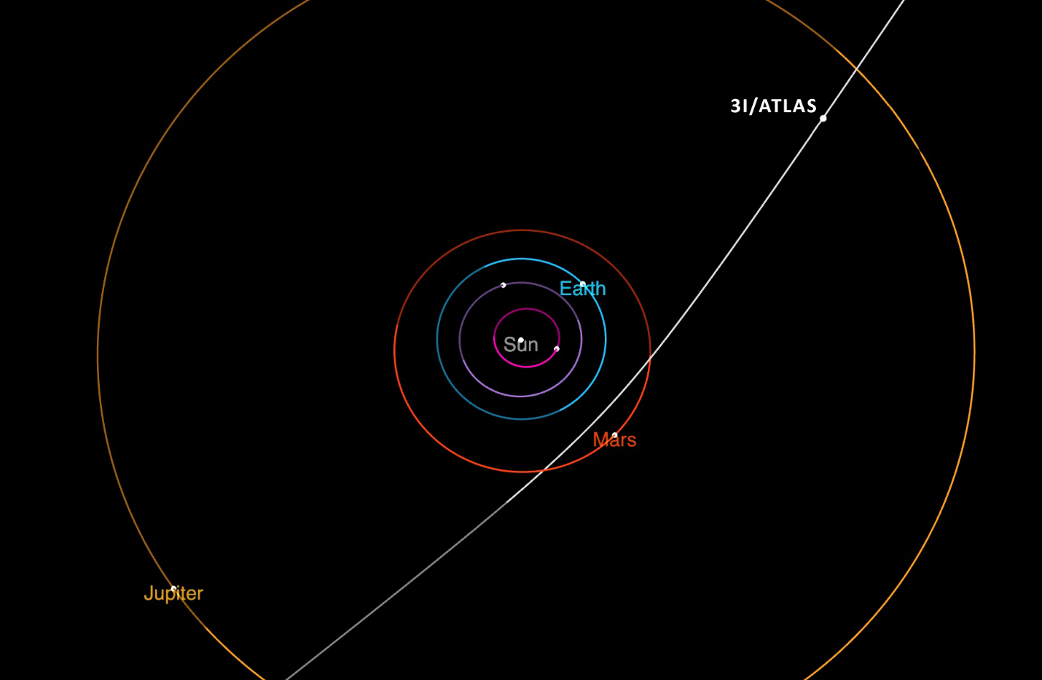
From the National Aeronautics and Space Administration (NASA) webpage. 3i/Atlas’ trajectory.

As we discussed before, 3iA isn't a comet, even though it has seemed like one at times in recent months. There’s no clear technological name for it; we only know it’s artificial and not natural. Since Israel's Executive Body in Exile understands its mission, a simple description is enough to rename 3i/Atlas as F-PGR.
Archangel Michael serves as the reference point for the Four-Phased Galactic Redesign. Comparatively, Joshua (from the tribe of Ephraim) commanded the Sun to stand still and the Moon to move into position for a future event.
- Archangel Michael stood beside Joshua when he commanded the Sun to stand still, marking a key moment when the Sun would be reset for Babylon's rise as a global model. It would disappear and reappear as part of the fourth and final Gentile social system. Joshua showed that a small person, like himself, could do the unthinkable by commanding the Sun to stand still. Many biblical scholars have different views on this event. For many, it is primarily an allegory. Still, the point remains: if Joshua’s voice commanded the Sun to stand still, then it makes sense that F-PGR is carrying out the redesigning operations for Earth’s quantum leap.
- The Moon. A time of divine judgment. The Judahite watched the Moon move across the night sky for five hours before it vanished. Indeed, the Moon, as a time marker, signaled to the Judahite that it was time to resume the fight against the Amorites, who symbolize the banking and financial systems of extortion, fraud, and social oppression. Who has the power of science to make the Moon disappear?
- When the Sun and Moon are combined, the Israelites fully grasp the significance of prophecy, while others do not. This is evident in events like the crossing of the Red Sea and the ten plagues of Egypt. Many non-congregational members struggle to believe in God's supernatural powers.
The July 4th review indicates that 3iA appeared in harmony with the supernatural sign given to the Judahite, who reported that his bathroom and closet were partially flooded on July 4, 2025. Within hours, flooding occurred across America and Texas. When examining the timing coordination between heaven and the earth, Wormwood’s judgment seems consequential, an association of bitterness, reflecting man’s lack of deep knowledge about 3i/Atlas. Also, to know that what follows is toxic water reserved for those who have shown contempt toward God’s people.

According to standard comet science, we all expected 3iA to enter our galaxy and then exit—never to be seen again—heading back into deep space. But when 3iA was ready to leave, it encountered an invisible barrier that pushed it back into alignment with Earth's and our galaxy's orbital mechanics. Speechless and utterly in disbelief, everyone questioned the invisible barrier that forced 3iA to return.
Only Archangel Michael could and did do this, as it was his time to begin redesigning our galaxy for the Stone Kingdom, an eternal kingdom. As part of his dual mission, he will oversee the fulfillment of all prophetic judgments, thereby allowing everlasting righteousness to take root on Earth.
At that time, Michael will rise, the great prince who watches over your people’s children. There will be a period of distress unlike any since the nation’s beginning until that time. But at that time, your people shall be saved, everyone whose name is written in the book.” Daniel 12:11

All nations have been captivated by 3iA because they perceive it as an artificial object. Space- and ground-based telescopes have observed everything 3iA has done, or everything that 3iA has allowed to be seen and recorded. Whenever technically possible, all fields of science are studying the communication forms emitted by 3iA; in some cases, Earth responds and interacts with 3iA’s configurations and components.
Over the months, 3iA has improved its communication to make it easily understood by humans. Symbolism is now used in messages sent to Earth and outward to other galaxies. Generally, consider that 3iA mainly communicates with Earth’s core, the surrounding magnetic fields, the Moon, the Sun, and similar regions on one level; on another level, it communicates with Earth's people and nations.
As mentioned earlier, the Judahite views 3iA as a Rubik's Cube — a straightforward analogy to grasp decentralized and centralized operations; however, 3iA rearranges, redesigns, and, at a chemical level, can break down into multiple functions at different locations simultaneously and then reassemble itself.

January 15 and 24 interpretations
Back in December 2025, the Judahite received an early warning that January 15, 2026, would be a significant date before receiving the January calendar from the Second Heaven. On December 28, 2025, the Judahite showed the calendar below.

15 | 8 | 13 | 12 | 10 | 9 | 16
15 | 13 | 12 | 10 | 9 | 16 | 15
14 | 17 | 16 | 17 | 24

F-PGR is actively developing infrastructure and sending notices to Earth via all available communication methods. These methods are complex and not fully understood by Earth's experts. The messages are intended for the entire planet; therefore, anyone with at least one capable communication device or a multi-spectrum system receives communications. Even amateur astronomers are observing 3iA.
On the 15th, all nuclear submarines worldwide halted operations. Repeating: every nuclear submarine, regardless of the country it belongs to, stopped operating. Such an event is impossible; there’s no way to stop patrols while still moving in the oceans. They travel undetected, and no one knows their underwater locations except their command centers.
In such an incident, all major powers on Earth have automatic triggering systems to prepare for launching both ballistic and nuclear weapons. All major countries are targeting each other. Naturally, when one or more nuclear submarines go offline, the logical conclusion is that they are under attack and preparing to retaliate.
All major powers are willing to accept a world without winners in the event of a full-scale nuclear exchange because there will be no winners afterward. There are underground facilities worldwide built to sustain life, maybe for three to four years. Even so, it takes hundreds of thousands of years to rebuild civilization, and there is no guarantee that the survivors will make it beyond four years!

Finally, at the last minute, the red phones in the nations’ capitals were lifted to make calls asking why they attacked each other’s submarines. After each denied involvement, they checked all communication systems related to their submarines on Earth and space satellites and discovered that 3iA caused the blackout.
The main advantage of 3iA is that it enables independent verification of its actions across multiple platforms, which can be documented or acknowledged by human-made systems in various scientific fields. Caution: there is a difference between detection and interpretation! Repeatedly, experts mention that they face challenges with interpretation and still cannot decode signals and communications from 3iA.
On the 15th, during a closed-loop operational communication, the USS Louisiana Nuclear Submarine (SSBN 743) sent a telecommunication or energy beam back to 3iA. The Judahite suggests that the code allowed the submarines to resume operations. Remember that 3iA has demonstrated control over all communication systems on Earth.
Choosing the USS Louisiana (SSBN-743) as the communication link to 3iA underscores Enoch’s focus on localizing prophecy to broadcast and trigger end-times events. In fact, it was Enoch who picked the specific location that would connect with 3iA and transmit end-times events.


Taken from the webpage of the Military Sealift Command. USS Louisiana Nuclear Submarine (SSBN-743)

January 24, 2026
As a preface and fitting passage for the 24th, the Judahite received supernatural insight from Isaiah 44:24-26, directly connected to 3iA and the July 4 floodwaters.
Isaiah 44:24-26
- Thus says the LORD, your Redeemer, And He who formed you from the womb: “I am the LORD, who makes all things, Who stretches out the heavens all alone, Who spreads abroad the earth by Myself;
- who foils the signs of false prophets and makes fools of diviners, who confounds the wise and turns their knowledge into nonsense,
- who confirms the message of His servant and fulfills the counsel of His messengers, who says of Jerusalem, ‘She will be inhabited,’ and of the cities of Judah, ‘They will be rebuilt, and I will restore their ruins,’

The following 3iA report is based on data compiled by the renowned theoretical astrophysicist on January 24, 2026.
- ❖ ❖ The encirclement of Earth is complete! 3i/Atlas has broken into 360 parts, all symmetrically arranged and evenly spaced. One astronomer described these pieces as a chain of pearls, with lights shining from within each segment. After surrounding the earth, the lights eventually faded.
After hearing the report, the heavenly host confirms it with the Judahite. However, the ongoing event is earth-shaking with deep prophetic significance. The Ten Tribes and Judah must remember that F-PGR is responsible for infrastructure work and carrying out judgment according to end-time prophecies.
In short, the January 24 event centers on the Law of Vibration and the Law of Attraction, with important implications we will explore in upcoming presentations.
The 24th symposium demonstrated how the Law of Vibration and the Law of Attraction operate, clarifying tribal Judah’s connection with Ishmale.

TAKEAWAYS FROM JANUARY 24.
One of the main takeaways from January 24 is that Earth has been encircled, which might be visible in the night sky. The 360 components circling Earth appear to be a permanent feature.
Also, a foreshadowed metaphor given to the Judahite indicates that the sixth vial approaches with heat and fire.
- Therefore, her plagues will come in one day—death and grief and famine—and she will be consumed by fire, for mighty is the Lord God who judges her.” Revelation 18:8
- “For behold, the day is coming, burning like a furnace, when all the arrogant and every evildoer will be stubble; the day is coming when I will set them ablaze,” says the LORD of Hosts. “Not a root or branch will be left to them.” Malachi 4:1
- You are powerless despite the advice you get. Let your astrologers come forward and save you--those people who study the stars, who map out the zones of the heavens and tell you from month to month what is going to happen to you. Isaiah 47:13
"They will be like bits of straw, and a fire will burn them up! They will not even be able to save themselves--the flames will be too hot for them, not a cozy fire to warm themselves by. Isaiah 47:14
- And a mighty angel took up a stone like a great millstone, and cast it into the sea, saying, Thus, with violence shall that great city Babylon be thrown down, and shall be found no more at all. Revelation 18:21
- And a mighty angel took up a stone like a great millstone, and cast it into the sea, saying, Thus, with violence shall that great city Babylon be thrown down, and shall be found no more at all. Matthew 3:12

A precise description of those who will be destroyed by fire.
The Judahite emphasizes what has been given to him. The January 24 Theme is FIRE.
- Then he said to me, "This is the curse that goes out over the whole earth: for everyone who steals shall be cut off according to it; and everyone who swears shall be cut off according to it." Zachariah 5:3
- I will send it out, declares the LORD of hosts, and it shall enter the house of the thief, and the house of him who swears falsely by my name. And it shall remain in his house and consume it, both timber and stones.” Zachariah 5:4

Galactic infrastructure formation.
F-PGR has initiated a mission to develop practical infrastructure for quantum entanglement and to improve the conceptual application of strain theory. So far, human theories have lacked clarity in designing galactic infrastructure because such advanced knowledge has been kept for the Stone Kingdom to propel human civilization thousands of light-years beyond the four Gentile social systems.
Albert Einstein provided spiritual insight into what F-PGR is doing with his famous statement: “God does not play dice.” Truly, it is not man but Archangel Michael who is now constructing the galactic structures designed to help the Stone Kingdom make a quantum leap during the millennium age.

Coming presentations
- India’s future.
- China’s future.

