SE Region TEAM
April 2023 Newletter

Gloria Stegman, Consultant
APRIL......SHOWERS BRING MAY FLOWERS 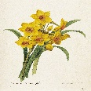....and Oh, the glorious array of beauty as we see the blossoms of every color on trees, bushes and in the fields and gardens. Photo shoot, here we come, and some with paint supplies and easel ready to capture all the glory around us. Our hearts
are filled with glory and our nostrils with the delicate perfume lingering on the gentle breeze. The fresh smell of the new grass with the animals feasting on the new growth. How could you not be thankful to our Heavenly Father who created all this glory and beauty around us? Many of us will be out in the gardens wanting to plant, that is if the ground and weather is ready for receiving the seeds. Sometimes haste too soon, delays or makes waste of germination. We delayed this addition as we all want to know about the St. Simon Conference. We will have to rely on those who were privileged to attend,
as I was not able to be there.

Cindy Makowski President Report

Well TEAM we have another one in the books!
Thursday night we had some fabulous MITI’s. New techniques were demonstrated, and great projects were completed. Thank you to Kathie Camara for the jewelry pieces, Judy Nicewicz for the tiles, Stephanie Robinson for the beautiful wreath, and Linda O’Connell for the dominoes turned into butterfly pins or magnets. Linda also let us know that the funds from her MITI were being donated to an organization that supports our veterans and their families. Everyone enjoyed MITI’s and had a chance to do multiple projects.

Maria Barry and her team of Julie Green and Kathie Camara took us to an English Tea party complete with the Queen mum herself. We had great English treats to go with our tea and lots of fun and games. Lots of laughs and friendly competition.

Congratulations to our ART WALL winners. We had some gorgeous paintings submitted and it sure made voting tough.

These are just a few of the highlights of the weekend. Check out the TEAM Southeast Facebook page for photos as they are shared.

Our new officers were sworn in on Saturday night also and already held their first meeting. More info coming in an email about improvements that will be coming that will hopefully help us turn around and once again grow into a powerhouse event. Any ideas and suggestions are greatly appreciated. We ALL need to take a hand in making this happen…..

Time to rest and get ready for 2024. Our theme will be RED-WHITE-BLUE with a country picnic theme.
The dates will be April 4-7, 2024. Make plans now to attend watch for the emails with the exciting news about the changes coming.

Judy Nicewicz Newsletter I did not want this newsletter to be delayed.. I will have to find a program and learn to use it. I have had several people that have offered to help and I thank Sue Schrieber who I will contact to help as well as Debi Linn. Please look on T.E.A.M Facebook page as well, as members pages for wonderful pictures
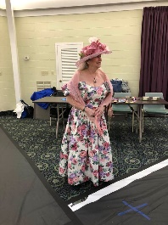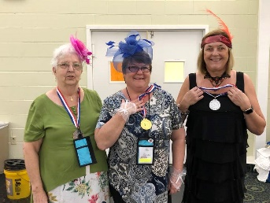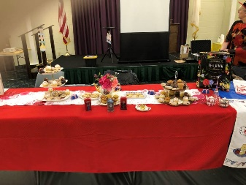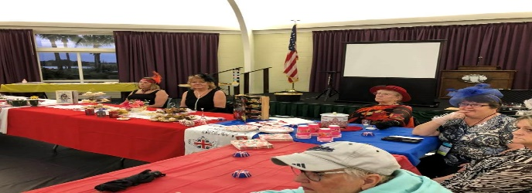
Brenda Harris Judy, Tina, Julie Tea Party Treats Tea Party Hosts and Guests
Please Plan to join us next year for a terrific experience..

WHOS WHO IN S. E. REGION
President - Cindy Makowski
Vice President -Judy Nicewicz
Treasurer - Diane Foreman
Secretary - Deborah Linn
Auxiliary Officer - Este Rayle
Counseling Alternate Officer -Gloria Stegman
TEAM Consultant - Este Rayle
Newsletter Editors-Gloria Stegman-Text, graphics -Judy Nicewicz
Sunshine Editor - Judy Nicewicz
WEBMASTERS - Cindy Makowski, Diane Forman, Webmasters
are working on updating our site, so if they contact
you, please supply needed info and updates. This is your advantage to be
listed if teaching art.
Chairperson for/2023 Regional meeting Cindy Makowski
teamseinformation@yahoo.com
FACEBOOK SE Reg Facebook Administrator -Judy Nicewicz
Check our TEAM SE. Facebook page for new of members.T.E.A.M. South East
(Teachers and Educators in Art Material) Public Group, Discussion,
Members, Events, Videos, Photos, Files, Search this group Shortcuts
DUES ARE DUE AS OF JANUARY 1ST, 2023
HAVE YOU CHANGED INFO?
We need an update on address, phone and e-mails. Many make changes and
never notify us of those changes. Contact Diane Foreman
treasurerofteam@gmail.com or to report those changes.

NEWSLETTER EDITORS. Terri will no longer add her magic color touch to the
newsletter text so others will do this task since the election, and I step down as officer in the
TEAM S. E. REGION and take on another position. Terri, I cannot thank you enough for your contribution to add such beautiful color to our newsletters. I know you spent many hours learning the program and use it so skillfully. I remember the times when we made changes and corrections, and you were able to do them. You learned how to upload the newsletters on our website. You took on the task of Sunshine Chairman for Circle of Concern. Our heartfelt thank you for all your contribution to enhance our journey, you are so special. I and S. E. Region will miss your work and touch. You are SO special to me.
TEAM IS NATIONAL AND INTERNATIONAL S. E. Region is an area of America working together to promote painting and sharing skills. All of America was divided into 6 regions to do as
They wished to promote art and painting. All are connected to welcome anyone who wishes to join and become a part of this great effort. Other regions may not be active at this time , but those in the Western states
can contact Carol Earle to find out about their activities.
artistcarolearle@att.net . Go to our website www.artteachers.org

