Test Your Motorman and Conductor Skills
Signals
Use pages 21 (below) and 22 (on back) from the May 1, 1921 Texas Electric Railway Employee Rule book to answer these questions:
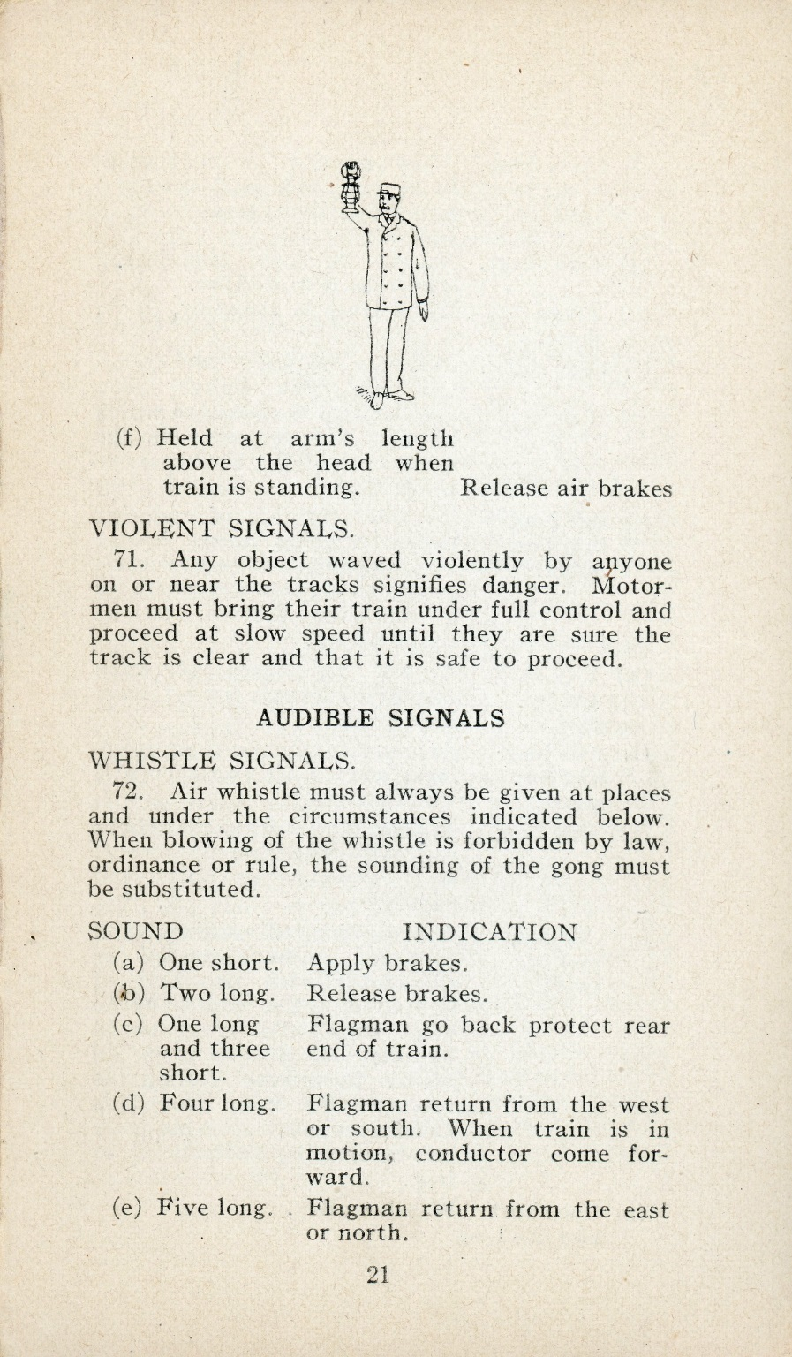
- How many short and long whistles indicate the train is approaching a public road or road crossing whistle sign?
______ shorts
______ longs

- How many short and long whistles indicate the motorman either has baggage to unload or he wants the agent to come out?

______ shorts
______ longs

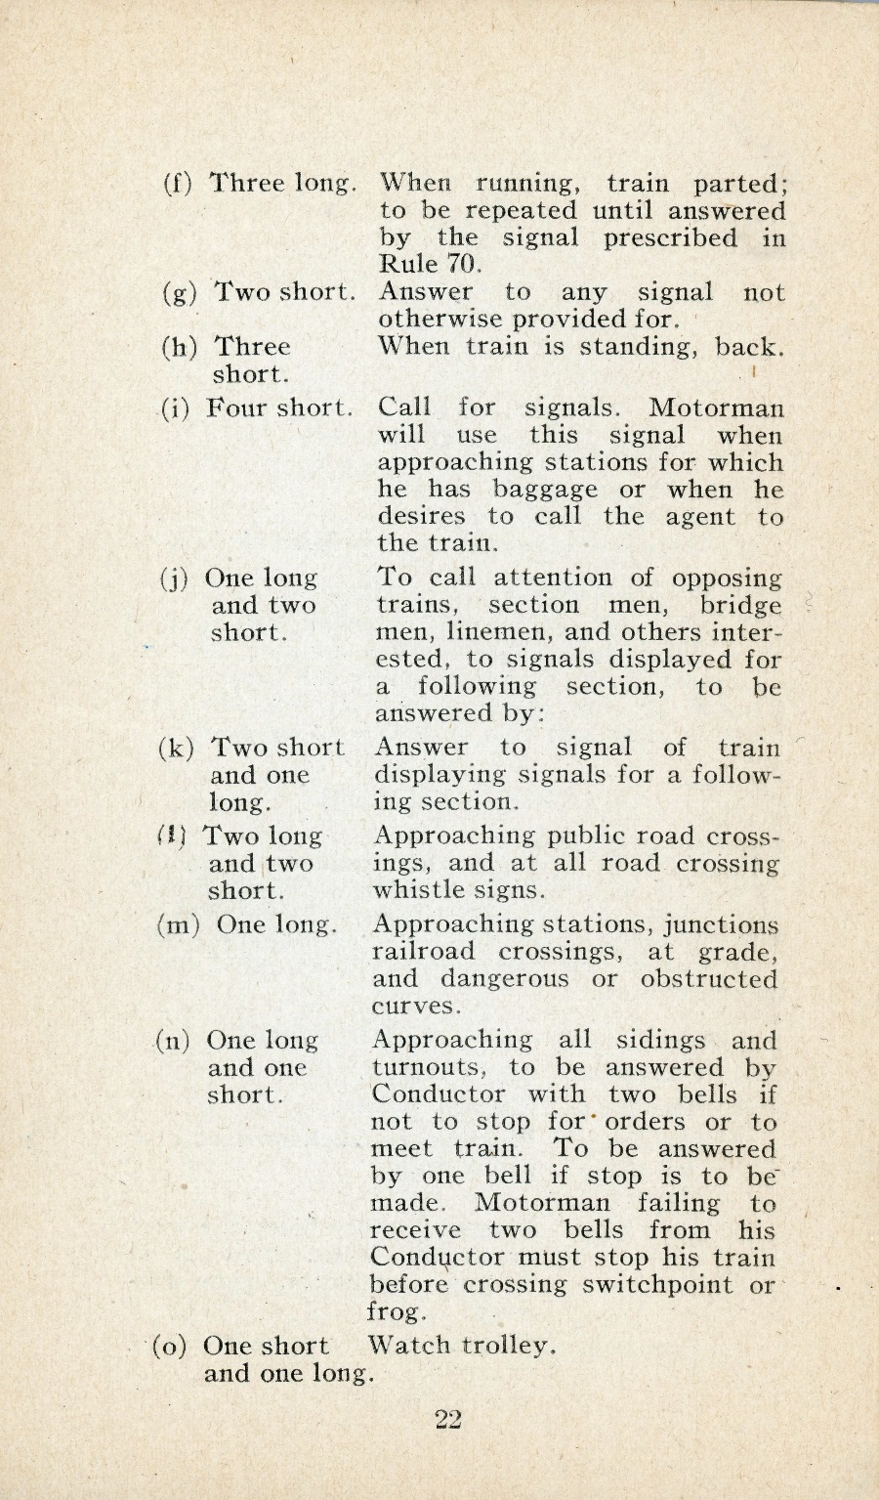
- How many short and long whistles indicate the brake needs to be applied?
______ shorts
______ longs

- How many short and long whistles indicate the train is approaching a siding or turnout?
______ shorts
______ longs

- How many bells must the Conductor answer with if the stop above is to be made?
______ bell(s)

Use pages 24 (below) and 25 (on back) from the May 1, 1921 Texas Electric Railway Employee Rule book to answer these questions:
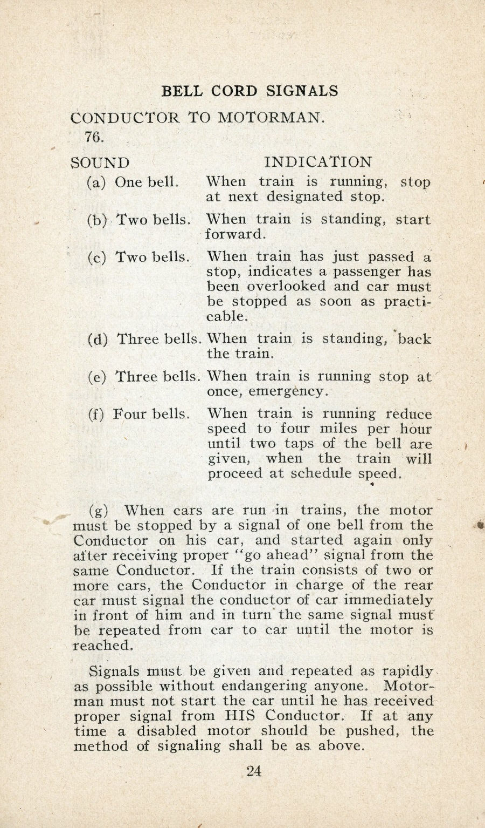
- When a train is running, how many bells does the Conductor ring for an emergency?
______ bell(s)

- How many bells rung by the Conductor indicate a passenger has been overlooked at a stop?
______ bell(s)

- How many bells does a Motorman ring to tell the Conductor to back the train up?
______ bell(s)

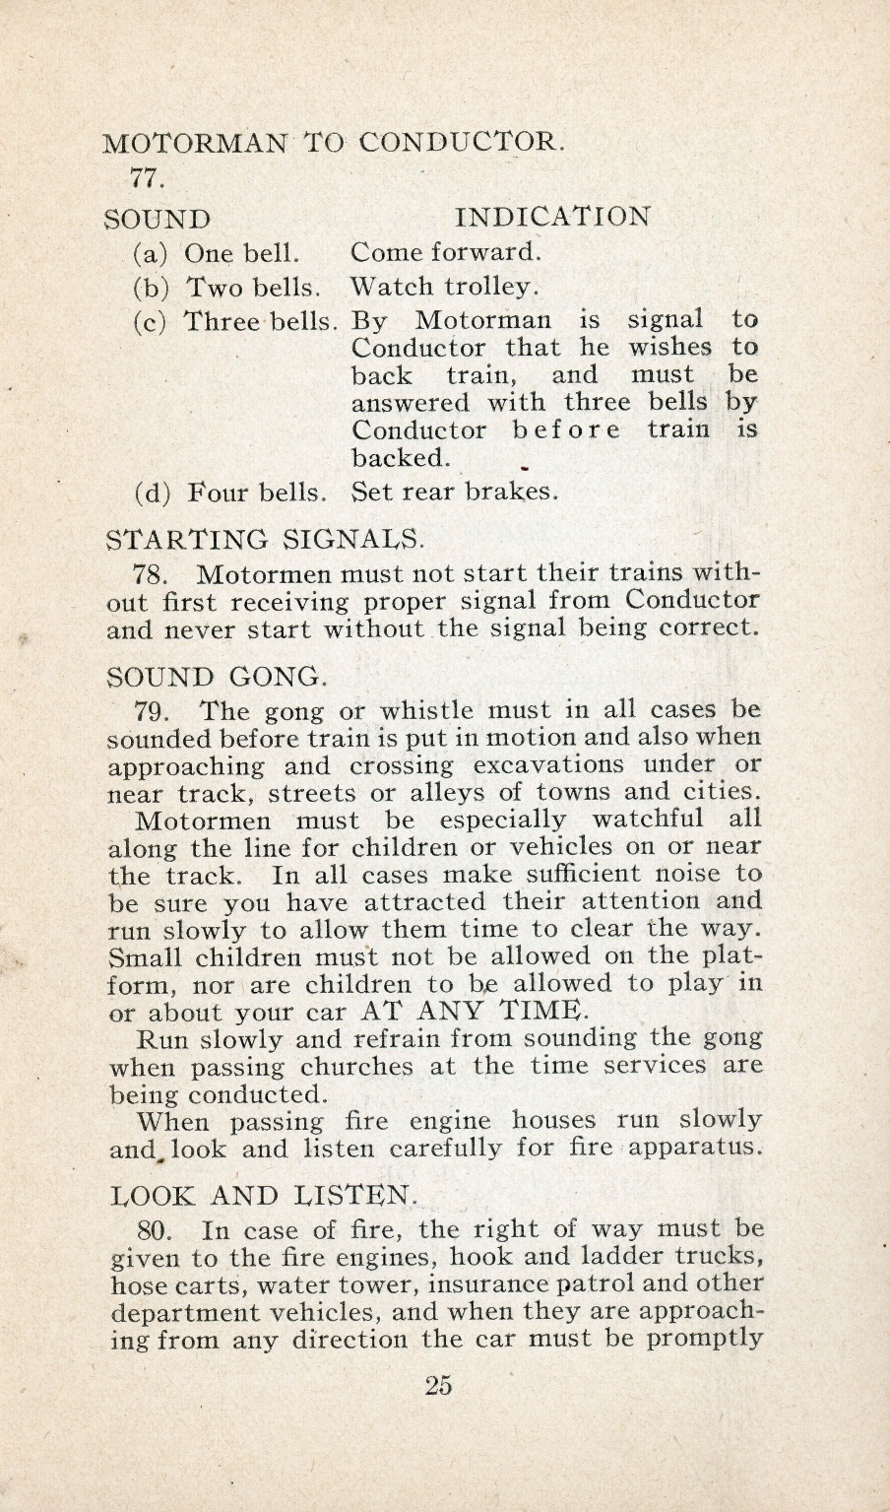

- When a Motorman rings the bells to back a train up, how many bells does the Conductor ring before he actually begins backing up?
______ bell(s)

- How many bells does the Conductor ring to indicate he is reducing the speed of the train to four (4) miles per hour?
______ bell(s)

- When the above signal is followed by two taps of the bell, what happens?

Grade Level: 3rd thru 5th
Answers:
Pages 21-22:
- 2 short, 2 long [re: Sound (l)]
- 4 short, 0 long [re: Sound (i)]
- 1 short, 0 long [re: Sound (a)]
- 1 short, 1 long [re: Sound (n)]
- 1 bell [re: Sound (n)]

Pages 24-25:
- 3 bells [re: Conductor to Motorman – Sound (e)]
- 2 bells [re: Conductor to Motorman – Sound (c)]
- 3 bells [re: Motorman to Conductor - Sound (c)]
- 3 bells [re: Conductor to Motorman – Sound (d) AND
Motorman to Conductor - Sound (c)]
- 3 bells [re: Conductor to Motorman – Sound (f)]
- Train will return to scheduled speed.
[re: Conductor to Motorman – Sound (f)]

