Article Study: Cloud adoption is not an option — it’s a necessity
By: Harold Albo December 8, 2017
Cloud services have changed our world in a profound way. Smartphones depend on cloud-based mobile applications and data to deliver tremendous value to people worldwide. Cloud technology enables new business models with automated self-service, multiplatform deployment, scalable application and data continuity capabilities.
Still, many enterprises have been reluctant to convert their legacy computing capabilities and choose cloud adoption. IT organizations hesitate to rationalize hundreds or even thousands of legacy applications and migrate them to the cloud. However, establishing blueprints can provide a road map of which applications are best-suited for immediate migration.
Businesses must maintain their legacy applications while implementing new public and private cloud capabilities. This dual operational model can be challenging to manage, especially if the organization lacks sufficient cloud expertise and experience.

Cloud adoption: Benefits and challenges
Despite the causes for hesitation, there are some key advantages to the cloud that are making today’s enterprises treat the technology as a necessity rather than an option.
- Emerging opportunities: Cloud adoption equips enterprises to make small investments and increasingly reallocate savings to new business initiatives. For example, ride-share companies are leveraging the cloud and GPS data to enable a new business model, provide enhanced customer experiences and disrupt the industry.
- Accelerated innovation: Technology providers are releasing new cloud and Internet of Things (IoT) offerings at an accelerated pace to gain market share. Cloud services are inherently easier to adapt to these new offerings than fixed legacy environments.
- Rapid demand changes: CIOs burdened with a fixed IT capacity must meet rapid market changes and quick merger and acquisition deals initiated by the business. Cloud services utilize a consumption-based model to rapidly scale capacity up or down as needed to mirror demand.
- Cost reduction: IT organizations can implement a cloud-based IT-as-a-service (ITaaS) model in response to urgent, large-scale cost reduction mandates from the business. Companies often use benchmark comparisons to proactively reduce IT costs. These comparative benchmarks will change with the proliferation of lower cost IoT and cloud services. This will place pressure on CIOs to measure up against IT organizations that have already made these investments.
But in order to realize these benefits, companies still need to overcome the core challenges to cloud adoption, which include:
- Increasing cloud complexity and security concerns.
- Lack of an operating model, processes and skills to support hybrid cloud.
- Integrating public and private cloud with traditional IT.
- Growing shadow IT creates governing issues.

The value of cloud services
Cloud services provide an opportunity for enterprises to reinvent business by identifying new models and revenue streams. This allows businesses to rethink IT by better engaging and connecting with customers, lowering the total cost of ownership (TCO) of IT, scaling services up and down with demand and improving time-to-market innovation.
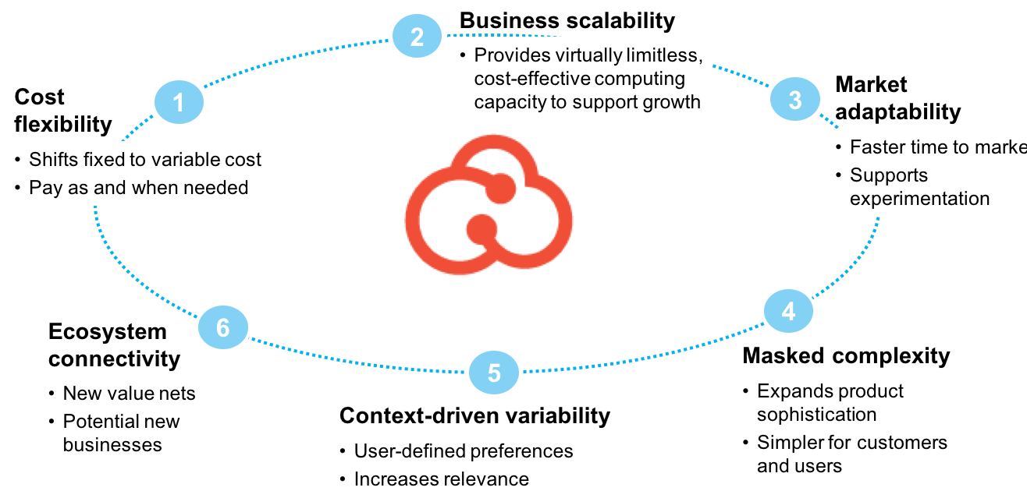
The cloud can also increase business agility and innovation, reduce TCO and cut down on short- and long-term technical debt. Cloud services equip enterprises to take full advantage of emerging capabilities such as block chain, automation, machine learning and IoT.

How to achieve the benefits
To experience the full value of the cloud, businesses must:
- Implement methods and tools to overcome architecture, migration and integration complexities.
- Design organizational changes that address new ways of working with an adoption mandate.
- Create a strategic partnership to design, implement and operate the new cloud ecosystem.
The greatest adoption challenges come from within the enterprise itself. Successfully transitioning to a new technology architecture and operating model requires an entirely new set of capabilities that must be carefully implemented with proven technologies, blueprints and methods.

