TAM Learning:

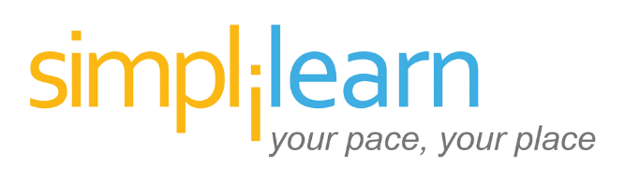

Certified ScrumMaster® (CSM) Certification Training

Summary:
The Certified ScrumMaster (CSM) Certification Training provides a comprehensive overview of the Scrum framework for agile project management and will prepare you to become a certified ScrumMaster. You’ll learn the basics of Scrum and the Scrum lifecycle, how to organize a Scrum team and set up a project, and how to implement a Scrum, from releases and sprints to enterprise transformation.

Date(s): 07/18 – 07/19
Venue: MicroTek - Computer Classrooms
Location:
10604 NE 38th Place, Suite 118
Kirkland, Washington 98033

Contact: tushar.agrawal@simplilearn.net, 844:532:7688 ext. 3004

Cost: $1099 (Paid)

Included:

- CSM In-Person training and online pre-classroom content
- Examination fee for CSM Certification included
- 2 Year Membership to Scrum Alliance.
- Free Exam Retake and Delivered by CST®.
- 20 PDUs and 16 SEUs are offered along with the training.
- CSM Hard Book manual
- JIRA Project Module Training
- Simplilearn Course: Microsoft Agile Scrum Foundation
- Simplilearn Course: Microsoft® Project 2013
- Simplilearn Course: Microsoft PMI-ACP
- Business Analytics Certification Training with Excel

Source: https://www.simplilearn.com/agile-and-scrum/csm-certification-training

Course and Exam scheduled for July 18 – 19.

