TAM Learning:

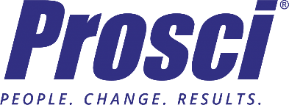

Integrating Agile and Change Management Workshop

Date(s): 09/10
Venue: ADA Convention Center
Location: Chicago, IL

Date(s): 12/10
Venue: Prosci Headquarters
Location: Fort Collins, CO

Cost: $989.
Learning Objectives:
- Understand the foundation and parallels of change management and Agile
- Explore industry-leading research on how to manage change adoption in an Agile initiative
- Identify specific adaptations for your change management approach
- Align the Prosci ADKAR® Model with Agile efforts and sprints/releases
- Align the five organizational change management plans to Agile and identify specific adjustments for each
- Define change management roles in an Agile environment

Source:
https://www.prosci.com/solutions/training-programs/integrating-agile-change-management

It is my desire to complete the above certification course within 90 days of hire.

