TAM Learning:

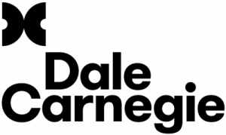

Dale Carnegie Sales Training: Winning with Relationship Selling

Date(s): 08/05, 08/12, 08/19
Venue: Dale Carnegie Training
Location: Bellevue, WA

Cost: $1,995.

What You’ll Learn:
Learn the importance of a confident attitude when interacting with customers. Develop active listening skills to uncover customer needs and head off challenges. Find out how to establish credibility and communicate your value by focusing on customer-centric solutions.
Why you want to learn it:
When customers have completed 70% of the buying process or can complete many online purchases without ever engaging with a single salesperson, traditional sales tactics simply no longer work. Your customers are the personification of the empowered consumer, knowledgeable beyond the need for basic information. You need a relationship-selling approach that leads to a profitable relationship.
How it will help you:
By mastering a relationship-based selling approach, you can offer your customers value they can’t find on the Internet: You! And you position yourself for long-term partnerships that bring positive outcomes for all parties.

