TAM Review:



**Microsoft Corporation Ratings**

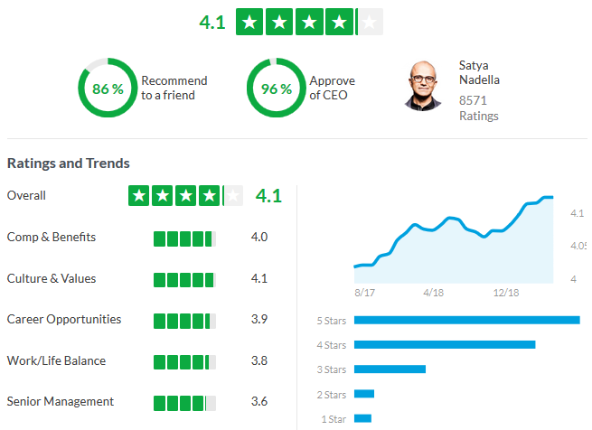

***Assessment:***

-The ratings on Glassdoor indicate Microsoft is a superlative organization to work for!

-The internal ratings of Satya’s leadership show an upward trend. With a rating of 96%, Microsoft is a great place to work indeed.

**Salary Expectation Range**

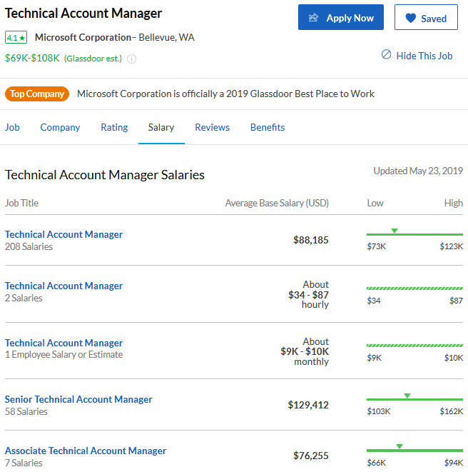

***Assessment:***

-According to Glassdoor and a high-level, informal conversation with Angela Daugherty, the middle of the road salary for this role is around $84,000. Glassdoor says the mode is 88.

-I am pursuing continuous learning opportunities outside of the functions of the role, however, directly impact my ability to execute the responsibilities, therefore I ask for $85,000+

**Excellent Benefits**

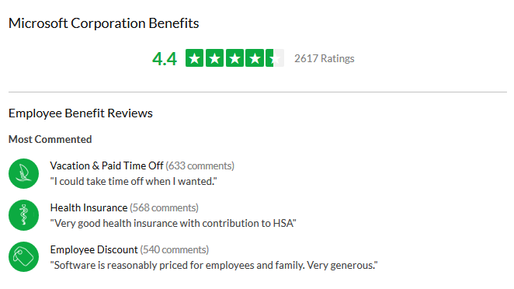

***Assessment:***

-The ratings on Glassdoor indicate Microsoft has excellent benefits.

-Nothing to review here. An employee discount, health insurance, vacation time and PTO.