A little bit from Microsoft:
We've noticed that successful candidates don't stop at understanding the position they're interviewing for. They gain a thorough, high-level understanding of Microsoft as a business and learn how their desired position contributes to working as one to empower billions.

The most valuable candidate will think outside the box and have a vision beyond the role they’re applying for. This vision extends to where they want to grow within Microsoft. Read about different career paths by visiting Microsoft Life.

Be prepared to answer questions related to professional relationships you maintained with former supervisors and colleagues.

We look for a strong desire to learn, intelligence, a passion for technology, a willingness to work hard, rock-solid skills, an entrepreneurial spirit, and a desire to be the best.

Be prepared to speak about how you solved a job-specific issue, design question, or problem-solving puzzle. We're interested in how your mind works, how you find solutions, and how you articulate your thought process.

Great candidates have an idea of what's happening in the tech industry. It's good to know what Microsoft is doing well, and how we can make ourselves stand out from the competition.
Follow us on Twitter at Microsoft Jobs , on Facebook at Microsoft Careers , Instagram at Microsoft Life , and LinkedIn on the Microsoft Corporate page .

“On my profile, I am very specific about what I’m passionate about, what I do, and how I can help people.

1. Who am I? (Or, what kind of experience do I have?)
2. What do I want to be known for (Or, how do I want to be perceived?)
3. What is my biggest selling point?

Make your profile relevant, to ensure that recruiters know what you do and what you can do for the company. Find people who are on the Microsoft teams you’re interested in, and check out how they’ve crafted their profiles. Then, when you write your own, you might have something that’s more likely to resonate with hiring managers. (Helpful hint: If you’re new to LinkedIn, read others’ profile summaries to get a feel for language common to your industry.)

1. Add your skills and request endorsements from current and former colleagues. Not only does this help recruiters more easily discover you in search and understand your strengths, but people with at least five skills listed on their profile receive up to 17x more views.
2. Make sure that you list your current or most recent position, as well as the location. Profiles with a position show up more readily in search, and more than 30% of recruiters use advanced search based on location.
3. Include a personal summary of at least 40 words. Think of your summary as the “elevator pitch” for yourself and where to pique your audience’s interest in reading the rest of your profile.
Looking for things to post? Set up an account with an RSS aggregator like Feedly, and subscribe to blogs relevant to your field, as well as your professional and personal interests. As you come across interesting articles, share them on your social media channels. Twitter also lets you create lists of users—tech industry leaders, for example—so you can better organize accounts you follow. Take your content curation to the next level with Hootsuite, which lets you set up dashboards with columns for each of your Twitter lists for easy reading, retweeting, replying, and posting. You can even set up columns that pull in tweets with certain keywords or hashtags (#interactiondesign, as an example) to easily track tweets related to these topics.
And don’t forget about creating your own content! You have your own unique point of view, so think about the trending topics within your field that you could write about. LinkedIn has a native publishing feature that lets you publish longer-form posts without having to create a blog on another platform. Creating your own articles is a great way to establish yourself as a thought leader, and by writing them on LinkedIn, you’ll be able to share those thoughts with your entire professional network, including any recruiters you may be trying to impress. LinkedIn can show you who’s reading your posts, so you’ll be able to see whether you’re making an impact on the right people.
If you’re interested in a certain position at Microsoft, first apply online through the Microsoft careers site; recruiters can’t find you if you’re not in the system. Then, do some initial preparation and research before you reach out to a recruiter directly. Turn on “Open Candidates” on LinkedIn, which lets recruiters and peers outside your organization know that you’re open to new opportunities but keeps your job search under the radar. Use LinkedIn Salary to make sure that the role you’re interested in would fall within your target salary range. Finally, check out Microsoft’s LinkedIn page to see the latest company news and discover who in your network already works for the company or any connections you may have in common with the recruiter or hiring manager and team.
Recruiters appreciate candidates who respond to their posts. Simply writing “I’m available” or “Can I have the job?” does little to encourage a dialogue with a someone who’s dealing with hundreds of people. They appreciate when you put some thought into starting a conversation. Try responding to recruiters’ posts with humor, or showing excitement about an opportunity. Those types of comments give them material to work with.
Robin McMahon, a senior recruiter who specializes in hiring for artificial intelligence (AI), machine learning, and data science, stresses the importance of networking. “Connect with others in your industry, LinkedIn groups, and recruiters at Microsoft,” she says.

“Keeping your name in front of people who can help your career is really smart,” McMahon says. “Follow #machinelearning and #AI on Twitter and LinkedIn. Know what’s going out in the news—even in the Microsoft blogs.” From a blog article, you can often learn the product, the team name, and usually the hiring manager’s name. Send that person an invitation to connect with you. Ask them “What can I do to get into Microsoft?” As a talent sourcer, she uses LinkedIn “all the time” to contact potential candidates.

“Consistently leverage your social media presence. Network with the right people. Listen to industry speakers, such as company CEOs. Do research to approach the right people on social media.” Ask recruiters how they can help you to get a job at Microsoft; it’s better than sending “heaps of messages or generic salutations without a name.”
“Candidates come to my network more effectively through social than through the career site. It’s a more personable approach. I can see who they are and what they do. I feel more obliged to put them in touch with the right person or right opportunity,” he says.
When people engage with recruiters on social media, they’re starting conversations that can lead somewhere—sometimes right into a new job.
Recruiter Amy Ala keeps an eye out for certain traits beyond the technical skills of the job, such as the abilities to adapt and collaborate. “A sense of partnership and willingness to play nicely with others is golden,” she says.
But for starters, you need to get a foot in the door. A generic résumé isn’t likely going to do it, no matter how polished it looks. So make sure it lines up with the job description, because “any communication to the recruiter or hiring managers should be very clear in how you’re a fit for the role,” Ala says.
And you’ve heard it before, because it’s true: Networking is key. Reach out to family, friends, colleagues and anyone else you know to find people who work in the Microsoft group or team you’re interested in. Use LinkedIn or Twitter. Express your interest and learn what you can.
Such efforts can “give you a better understanding of the organization, and that person may even be able to get your résumé into the direct hands of the hiring manager or recruiter,” advises recruiter Colleen Corbin.
1. The most obvious advice is not always heeded: Be prepared. Do your homework on Microsoft products, the technologies and the team, Swinton says. If there are technical skills you’ll need, know them. Ala, who often recruits software engineers, emphasizes that “fundamental coding skills are one of the most challenging aspects of the interview.”
2. Research your way to confidence. Use LinkedIn and other online resources to learn what you can about the interviewers and their backgrounds. Also make sure you know and can articulate how your skills apply to the job requirements and the needs of the team.
3. Speaking of skills, trust in yours. They’ve already gotten you this far. As Swinton says, “We’re bringing you here for a reason.”
4. Be yourself. Really. “We want to hire the real you, so make sure you shine through,” Corbin says. “It’s OK to be nervous and have the jitters, but allow yourself to enjoy the experience, which will be the best way for us to get to know you.”
5. Along those same lines: Be honest. “Knowledge can be learned, but trust must be earned,” Swinton says. “Don’t be afraid to tell us when you don’t know something.”
6. Ask questions. What questions, you ask? Ala suggests some general possibilities: What makes the hiring team stay at Microsoft? What do they love about their jobs? What excites them about their work? And if you’re coming from out of town, she says, ask some questions of your recruiter. Their insights can not only help you get to your interview on time but also assess local housing, schools, entertainment and other factors if relocation is a possibility.
7. Don’t overthink it, Swinton says. Relax if you can.
8. Work with your recruiter; it benefits both of you. Ala advises: “Let us know about any other conversations you’re having, whether with other Microsoft teams or outside companies, so we can keep things moving and meet any deadlines for setting up interviews or extending offers.”
9. Always follow up with a “thank you” email to your interviewers. Heard this one before? You’d be surprised how few candidates do it, Corbin says, but “it leaves a great impression.”
10. And if it doesn’t work out? Remember, “no” doesn’t mean “never.” “Oftentimes candidates may not be the exact fit for a certain role, but Microsoft is a huge company. Another team might be a better match,” Ala says. “Talk with your recruiter about other options, or at the very least let us know it’s OK to share your résumé internally with colleagues.” The right role could be right around the corner.

(1) Your interest in the technology
(2) Your ability to innovate
(3) How well you think creatively
(4) How you adapt to changing requirements
(5) Your problem-solving approach
(6) Your analytical thinking skills
(7) How you handle feedback

What does a Technical Account Manager (TAM) do?
Understand value creation, capture and realization
- Business acumen – ability to truly understand a customer’s business and how they can leverage IT to enable and enhance that business and move it forward
- Ability to build relationships at many levels and work with people across the organization (not just IT)
- Understanding of Cloud, what it means in terms of business and how it can benefit customers
A role that focuses on business value creation, capture and realization (strategic, business focused), skills and abilities that help me understand business goals and objectives and how IT can be an enabler in helping customers achieve those goals. This is critical going forward as many companies are putting pressure on IT to work with them to deliver solutions that enable and move that business forward.

5 Step Account Management Formula.
You can be successful landing an account and expanding your footprint.

- Success = Relationships X Situation X Process X Embeddedness X Value

Relationships:
-Building relationships with key stakeholders and other influencers.
-Look at who they are and build relationships.
>>Built on trust and “buy in”
>>Must understand the customer’s goals. Must understand their values and share goals with them.
-When you understand the goal, you can make yourself indispensable by establishing an emotional relationship.

Relationship drivers ----- When you are trying to understand a stakeholder, ask yourself if you can figure out what their drivers are:
~Professional goals – What does the stakeholder want to do professionally?
~Personal – What drives the stakeholder personally?
~Goals – What are their short term and long-term goals?
~Concerns/Issues – What types of issues or concerns does the stakeholder have?
~Strategic initiatives – Can you ascertain the stakeholder’s strategic initiatives?
~Personality style – What is the stakeholder’s personality style? How do they like communicating?

For each stakeholder, let’s get an org chart. How is the org structured? How connected to the org are we?
What kind of groups or influencers are they?
What role does the stakeholder play in the decision-making process?
What is their involvement in the overall process?
What type of support do we see them giving us throughout the experience? Are they promoting us?

Put all of this into a stakeholder map.
We want to make sure everyone on the account management team has relationships with the stakeholders.

Creating the stakeholder map allows us to determine where they fit within the quadrant below.

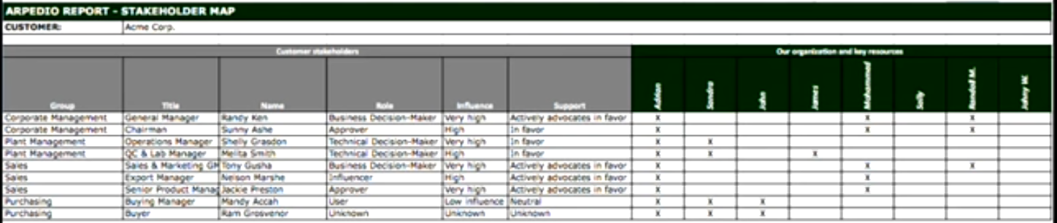

Situation:
-Shift focus from your own products and services to understanding the customer’s environment.
-Uncovering and understanding customer challenges and opportunities.
*Know the Industry*
>>Understand the history
>> What are the objectives of the industry
>>What are the current concerns and problems
>>What is the organizational structure of players in the industry
>>What Government regulations affect the industry
>>What terminology is used in the industry

We want to perform some analysis to understand the forces of profitability.
Industry Rivalry – Head to Head competitors – We need to help our customer’s understand who their competitors are if they have not looked at them yet.
Buyer Power – If there are less buyers, then the buyer has more power and therefore less profit.
Seller Power – If there are a few sellers for an industry, there is less profit.
Potential Entrants – If there is a low barrier to entry, this will reduce profit.
Potential Substitutes – If customers can go outside of the industry and satisfy a need, that reduces profit

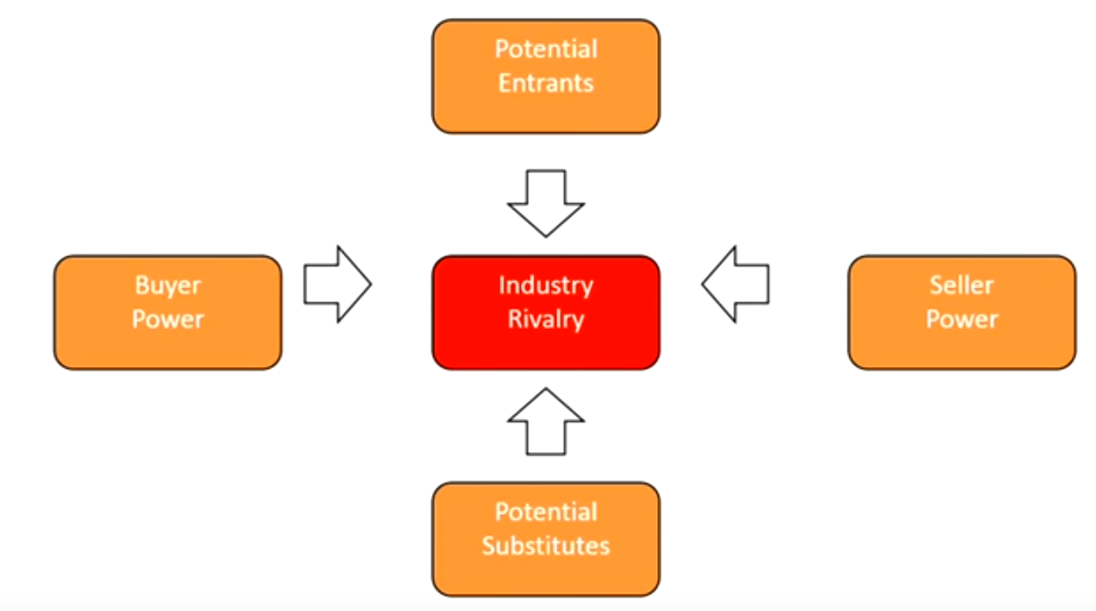
*Know the organization*
>>What is your customer’s strategy and what are they trying to accomplish.
>>What is your customer’s financial situation like? Are they as profitable as they need to be.
>>What are the objectives, needs and priorities of your customer

We want to understand how the mission, values and vision cascade down all the way to the front line employees.
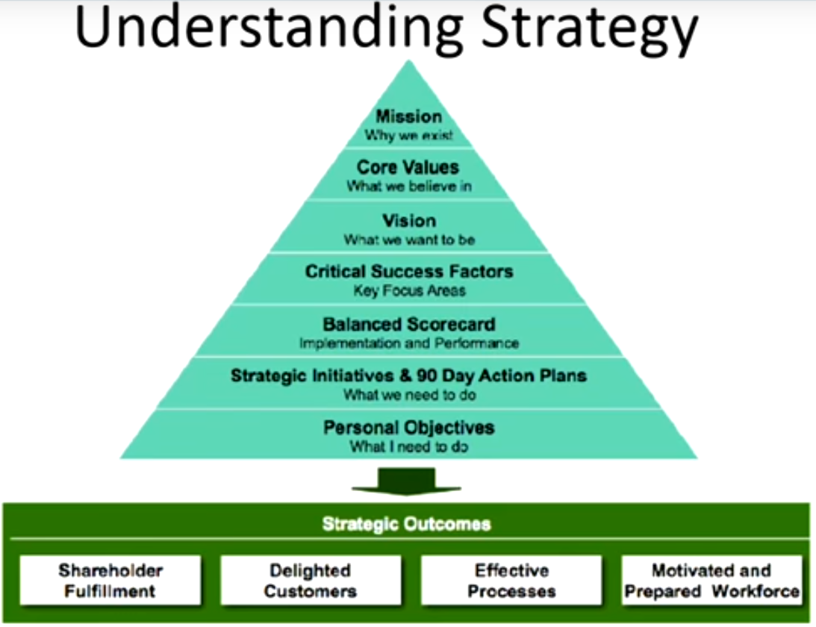

Research Sources – Examples:
>>Secondary Research First: Published Documents
>Primary = Live in person.

-Associations – What associations does your customer have and what value do they bring?
-Trade Shows – Go to trade shows to understand the market players
-Trade Publications – Read trade publications to get a better grasp of what your customer’s industry is doing
-Hoovers / D&B / Standard & Poors
-Library (articles, databases, periodicals) – Read about the industry and the history of your customer
-The Official Board, data.com, Stock-analysis-on-net
-Harvard Business School – Study what the customer does to better understand how you can add value
-Social Media, Personal Contacts, etc.
-Whetstone

~~~~~~~~Become knowledgeable about the customer that the questions themselves add value.
>>What is your value to the organization? How do you impact their balance sheet?
-Do you increase their profitability?

VALUE DISCOVERY – Opportunities for improvement – How do you add value?
-Cost avoidance – Do you help your customer avoid costs through strategic planning?
-Cost displacement – Do you direct your customer to other services, or do you take stuff on to displace costs?
-Revenue increase – Do you help your customer increase their overall revenue stream?

Process:
-Understand how the customer makes decisions.
-Understanding, and influencing the decision-making process with key stakeholders

Change means something in the moment is unpleasant or something in the future is desirable. The transition in the middle is uncomfortable. It feels risky.

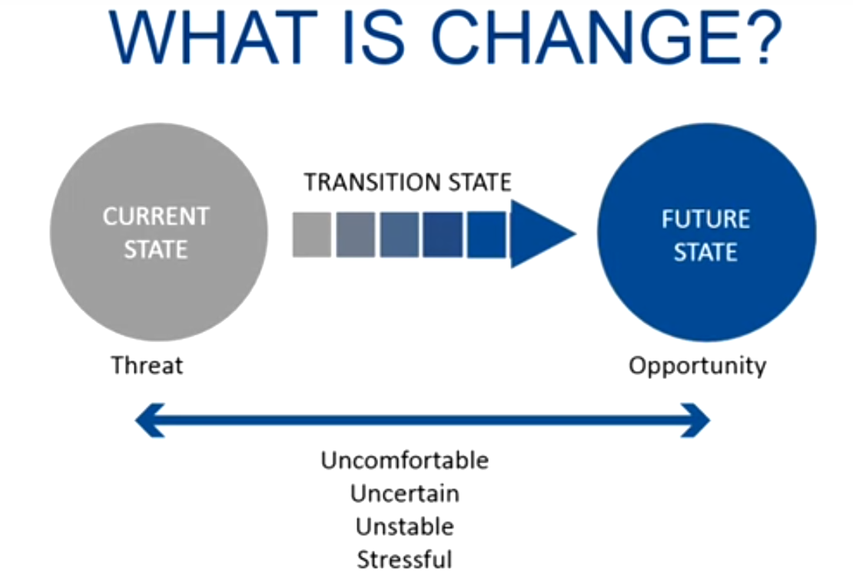

The changes you are proposing is not the only change they have to make.
You need to understand the decision-making process of your customer to better navigate the changes.
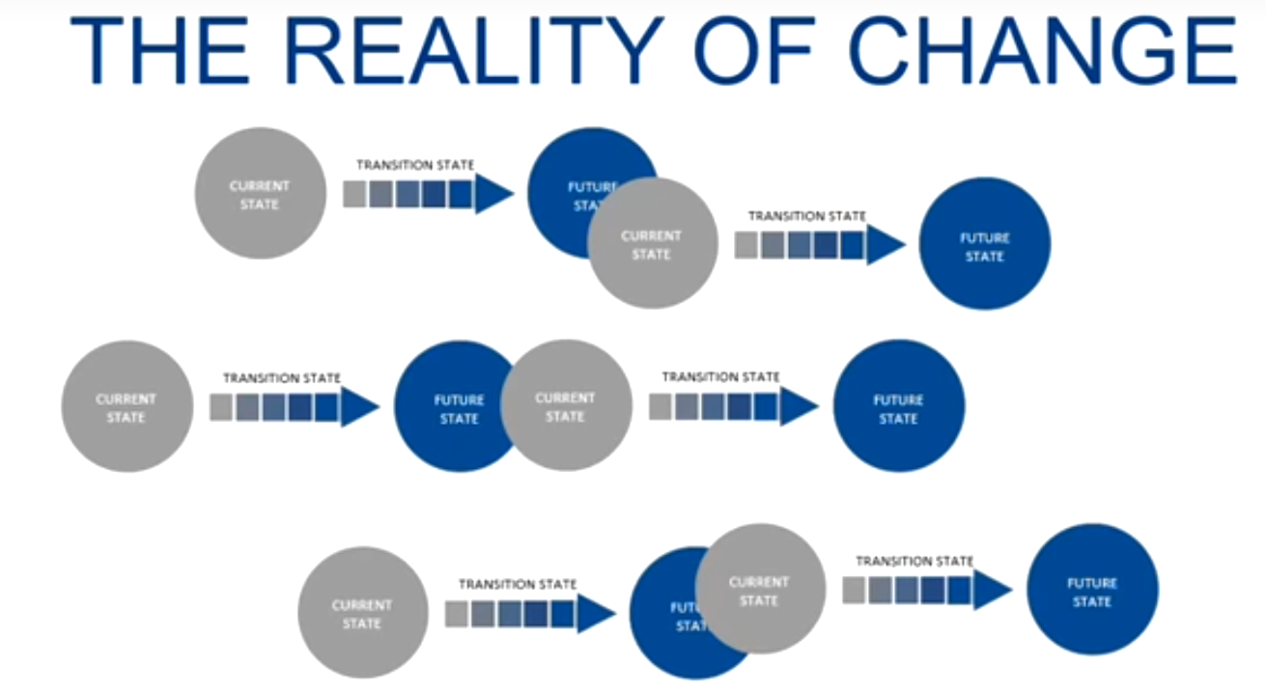

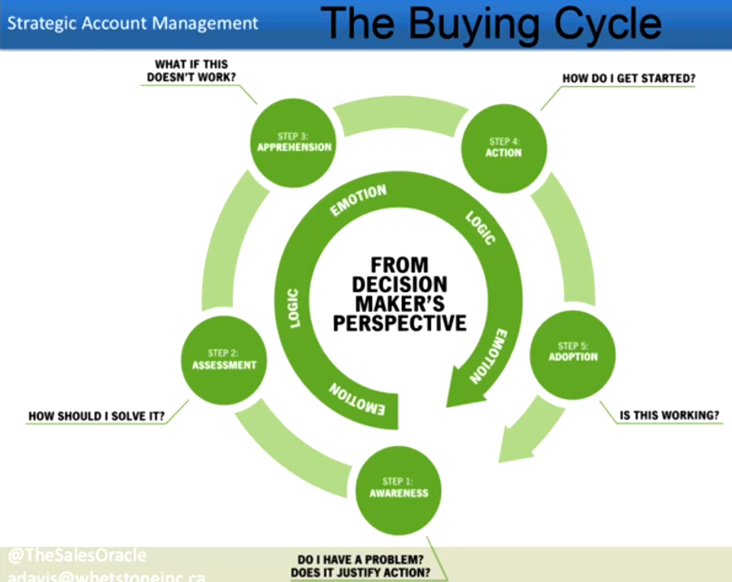
You need to understand the buying cycle of organizations.
Awareness of something good or bad. Most small business owners do not help customer become aware of the need for change (awareness of where they are or where they could be).

*Mutual Action Plan* or a “QBR – Quarterly business review”
-Event
-When
-Who
-Status
-Go / No Go?
-Billable?

Embeddedness:
-Position your company as an indispensable partner to the customer.
-Increase switching cost (to prevent moving to another vendor).
>>Embeddedness is really about solving problems and joint planning.

Key principles:
-Integrated solutions – In order to embed yourself, your solution needs to integrate and embed into their organization to increase the switching cost – aka make yourself unique.
-Embedded – Configure a solution they can only get from you
-Collaborative – Understand what their challenges are – work with them, co-creating.
-Business Impact
-Eliminate – Is there any waste that can be eliminated?
-Raise – Is there anything we can do “more of” because it has a high impact long term
-Reduce – Is there anything the customer can reduce to limit the impact
-Create – Should we create “All-new”

Embeddedness is more of an opportunity pipeline. We want to create value for the customer – for the next 3 years, because we understand the customer so well, we have a hand on all things.

Value:
-Articulating the value and documenting your value to decision makers and stakeholders.
-Understand economic impact to the stakeholders.

Key Skills to a Challenger. The challenger would make sure every meeting is valuable. They form an opinion or perspective after doing their research.
>Teaching – Teach the executive something new
>Tailoring – Articulating your value in a tailored way based on the stakeholder
>Taking Control – They understand how things happen in an org and take control of what happens next.

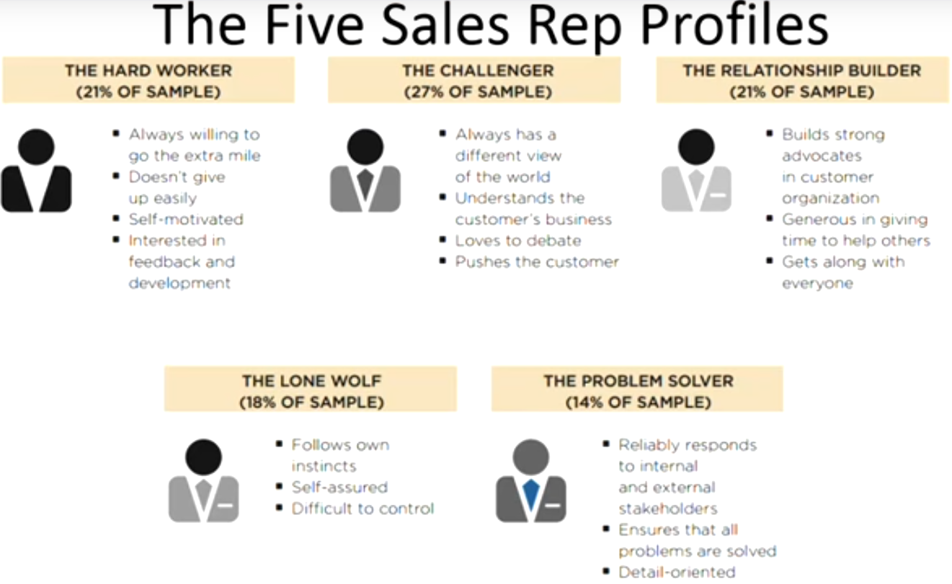
*Articulate your value*
>>Focus on the customer’s business objectives. Move away from your product or service.
>>Look at the external pressures which are affecting the organization. How can you help them withstand those pressures?
>>What is going on inside the organization (tied to their objectives). What risks and challenges are present.
>>Only after you understand these components, can you articulate your value and unique position.

You want to be able to articulate your value through a story and through a business case.
>>annualize both costs and revenues to demonstrate the economic viability of your solution.

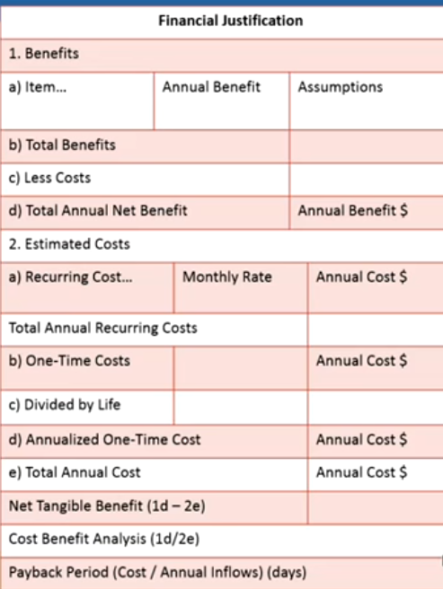

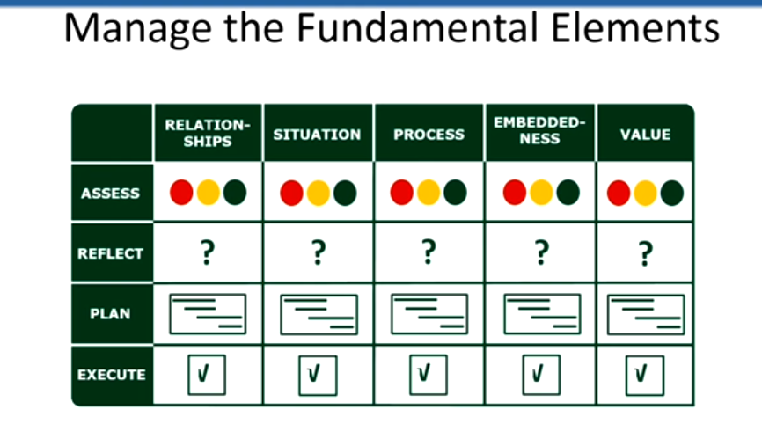

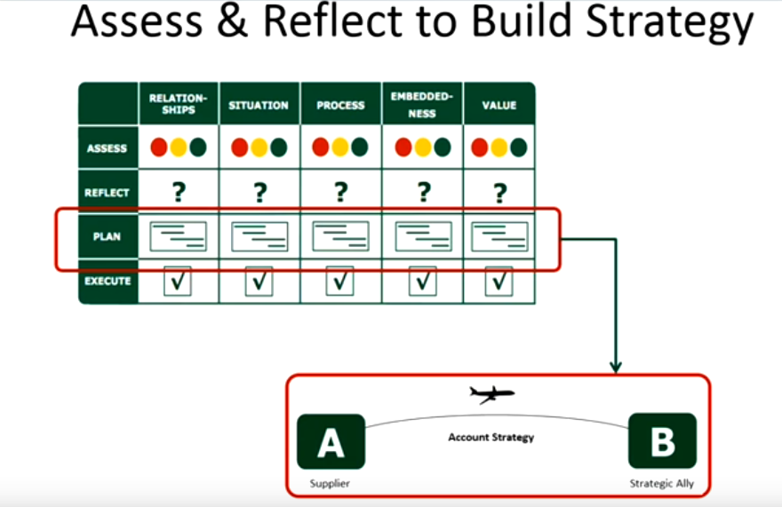

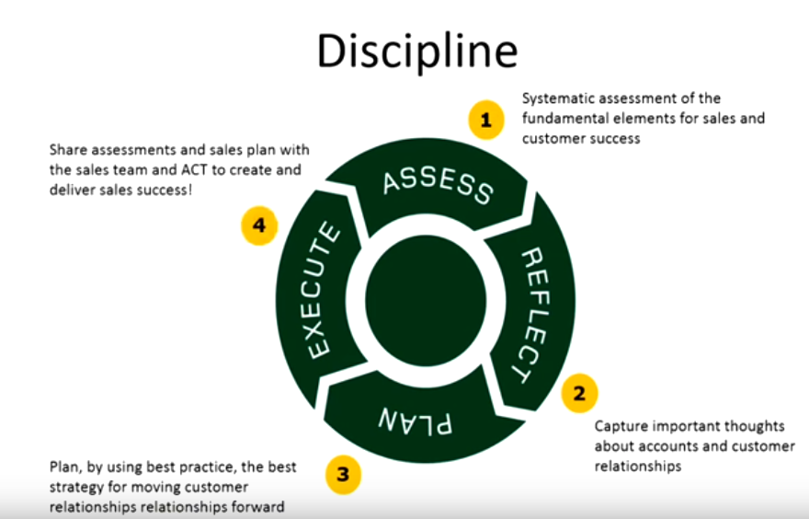

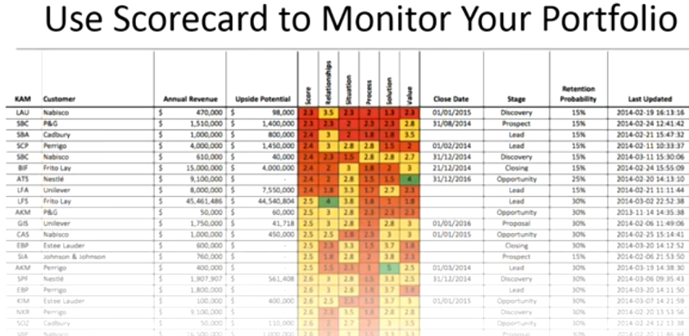

All Expertise is Ultimately a Language
E= (K+S+C)/t
Expertise = (Knowledge + Skills + Context) / over time

