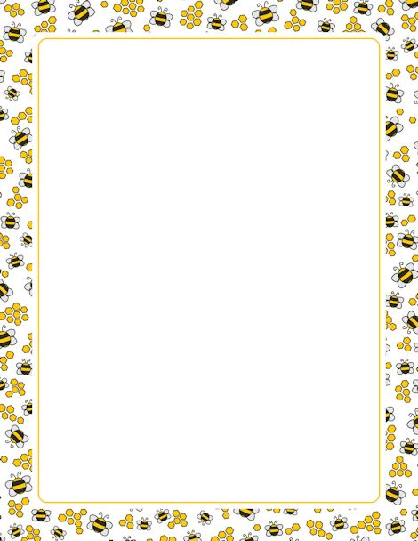
Certificate of Participation
in the 2026 School-Wide Spelling Bee
This certificate is awarded to:

Suzie Que
The Elementary School

______________________
Date
_________________________________________
Signature
