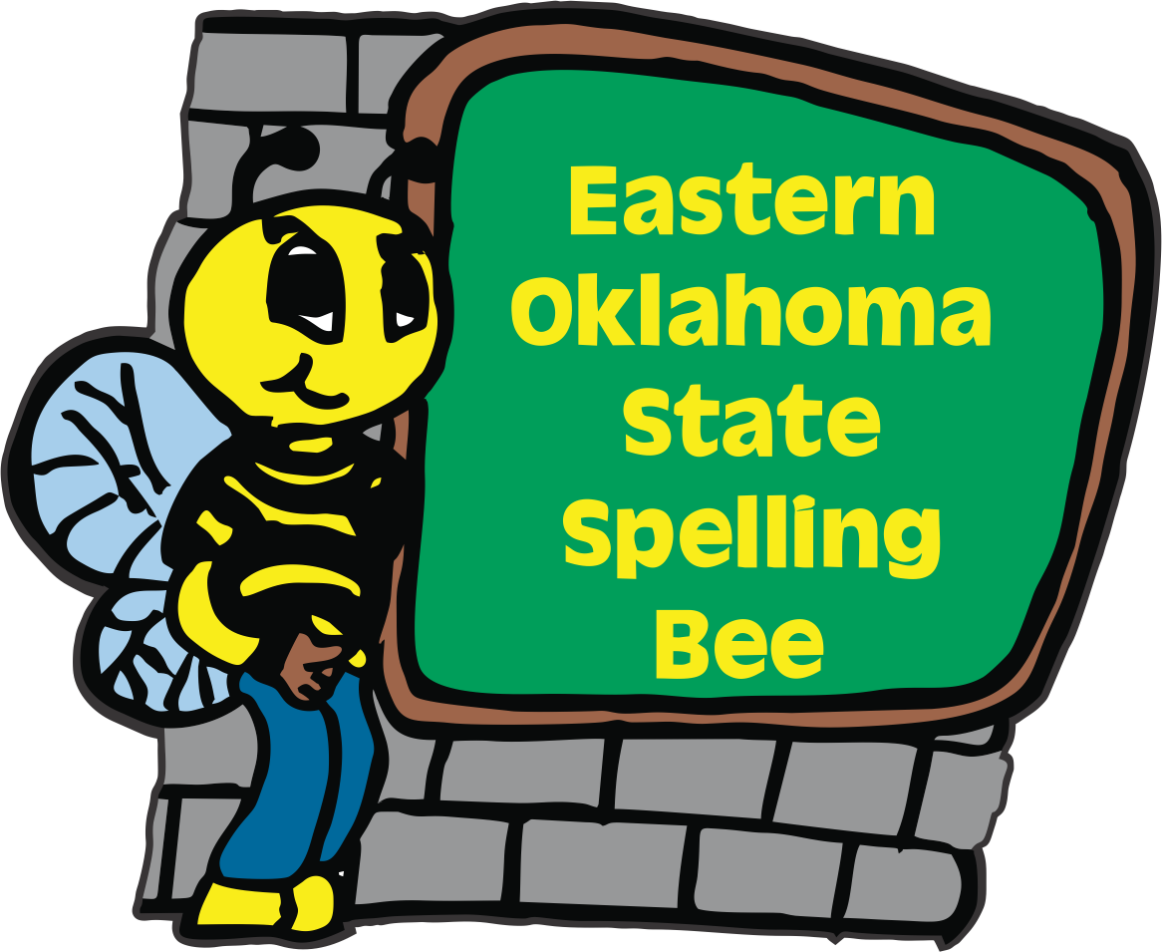
2026
Eastern Oklahoma State Spelling Bee Event
Registration Form

Welcome to the 16th Annual Eastern Oklahoma State Spelling Bee Event. The Bee will be held on a Friday in April 2026 at the Muskogee Civic Center. To participate in the EOSSB competition, please e-mail or send this form in the U.S. mail with your entry fee payable to the Eastern Oklahoma State Spelling Bee. We are excited to announce that our registration fee has remained at $50.00 per school site. The deadline to register is Friday, December 19th.
Purchase Orders will be accepted. We are not able to take credit cards.

_____ I would like to register our school. Check is included.
_____ I would like to register our school. We will be using a Purchase Order.

Name of School __________________________________________________
School Phone ____________________________________________________
School Address __________________________________________________
City ___________________________________ Zip Code _______________
County ________________________________
Spelling Bee Coordinator__________________________________________
Spelling Bee Coordinator Cell Phone Number ______________________________________
Spelling Bee Coordinator’s Email Address_________________________________________
Contact Person for Purchase Order_______________________________________________
Purchase Order Person’s Email Address___________________________________________
You may e-mail this entry form to sehoog@gmail.com or send us in the US mail to:

Eastern Oklahoma State Spelling Bee
Attn: Registration Form
1404 East Broadway Office # (918) 682-1288
Muskogee, OK 74403 Cell # (918) 869-2037

