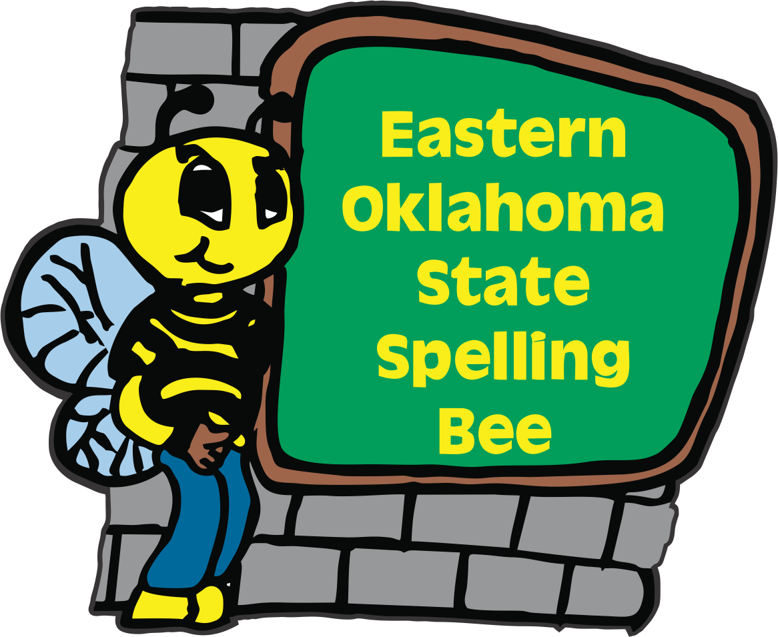
2027
Eastern Oklahoma State Spelling Bee Event
Registration Form

Welcome to the 17th Annual Eastern Oklahoma State Spelling Bee Event. The Bee will take place on a Friday April 30, 2027 at the Muskogee Civic Center. To participate in the state EOSSB competition, please e-mail or send this form in the U.S. mail with your entry fee payable to the Eastern Oklahoma State Spelling Bee. Our registration fee has remained at $50.00 per school site.
Deadline to register is Friday, December 4, 2026.
Purchase Orders will be accepted. We are not able to take credit cards.
_____ I would like to register our school. Check is included.
_____ I would like to register our school. We will be using a PO# ___________

Name of School __________________________________________________
School Phone ____________________________________________________
School Address __________________________________________________
City ___________________________________ Zip Code _______________
County ________________________________
Spelling Bee Coordinator__________________________________________
Spelling Bee Coordinator Cell Phone Number ______________________________________
Spelling Bee Coordinator’s Email Address_________________________________________
Contact Person for Purchase Order_______________________________________________
Purchase Order Person’s Email Address___________________________________________
You may e-mail this entry form to sehoog@gmail.com or send us in the US mail to:

Eastern Oklahoma State Spelling Bee
Attn: Registration Form
1404 East Broadway Office # (918) 682-1288
Muskogee, OK 74403 Cell # (918) 869-2037

