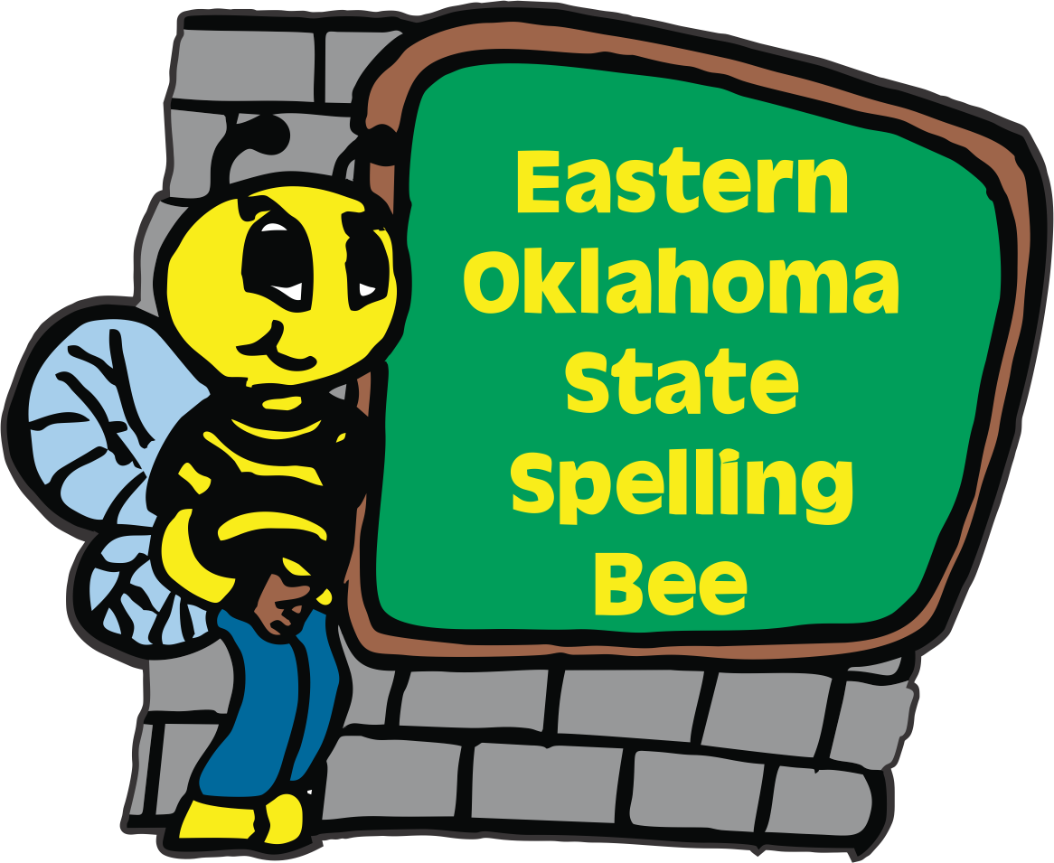 2025

Eastern Oklahoma State Spelling Bee Event

Registration Form

Welcome to the 15th Annual Eastern Oklahoma State Spelling Bee Event. The Bee will be held on a Friday April 25, 2025 at the Muskogee Civic Center. To participate in the EOSSB competition, please e-mail or send this form in the U.S. mail with your entry fee payable to the Eastern Oklahoma State Spelling Bee. We are excited to announce that our registration fee has remained at **$50.00** per school site. The deadline to register is Thursday, December 12th.

***Purchase Orders will be accepted****.* ***We are not able to take credit cards****.*

***_____ I would like to register our school. Check is included.***

***_____ I would like to register our school. We will be using a Purchase Order.***

**Name of School** __________________________________________________

**School Phone** ____________________________________________________

**School Address** __________________________________________________

**City** ___________________________________ **Zip Code** _______________

**County** ________________________________

**Spelling Bee Coordinator_**_________________________________________

**Spelling Bee Coordinator Cell Phone Number ______________________________________**

**Spelling Bee Coordinator’s Email Address**_________________________________________

**Contact Person for Purchase Order_______________________________________________**

**Purchase Order Person’s Email Address___________________________________________**

**You may e-mail this entry form to** [**sehoog@gmail.com**](mailto:sehoog@gmail.com) **or send us in the US mail to:**

**Eastern Oklahoma State Spelling Bee**

**Attn: Registration Form**

**1404 East Broadway Office # (918) 682-1288**

**Muskogee, OK 74403 Cell # (918) 869-2037**