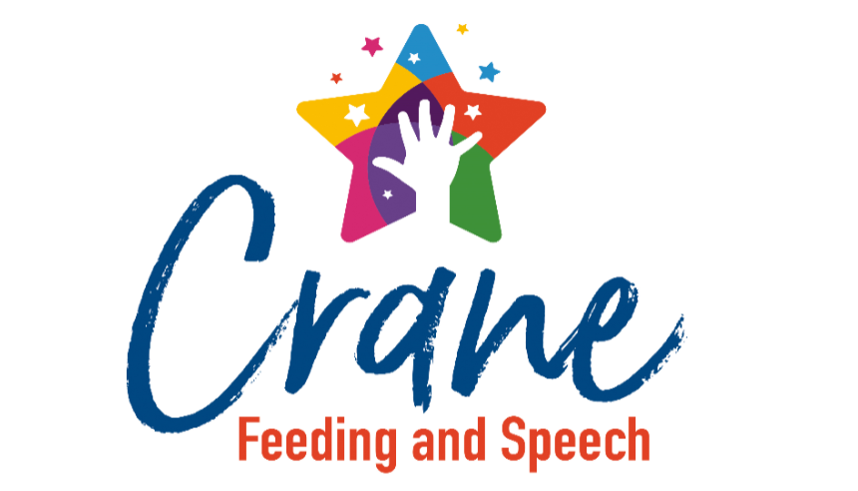
Summer Camp Application
Child Name: DOB:
Parent/Guardian Name: Phone #:
Address:
What school does your child attend?
Which camp do you wish to attend? (Circle one)
Breakfast Club (July 14-18) Lunch Buddies (June 16-20) Speech Camp (June 23-27)
Breakfast Club (August 4-8) Lunch Buddies (July 21-25)
Why would you like your child to attend this camp (3-4 sentences)?

What do you hope to gain from the week (3-4 sentences)?

Does your child currently receive speech services (for speech camp only)? ☐ yes ☐ no
*To qualify your child must have a speech sound diagnosis or receive an evaluation prior to the start date
If yes, where are you receiving services?

Please send completed applications via text to Crane Feeding & Speech at (217) 215-3016.

