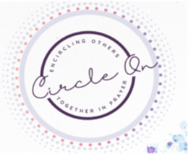
Dear ,

Hello! I am writing this letter to share that I have been praying for you for the last 30 days. You see One month ago, I started a mission through Circle On to pray for someone for 30 consecutive days and I chose to pray for you. I believe if I circle people in prayer and carry out acts of kindness, many people will be blessed as a result.
I began each day by praying The Armor of God prayer over you (Ephesians 6: 10-20). {Or simply insert your favorite verse}. It is a great verse to start the day. I also prayed for you and your family. Specifically, I prayed for {insert your specific intentions for the person(s) you prayed for here}.
Today, as I send you this note, I pray that whatever success and challenges you encountered in the last 30 days you somehow felt blessed and loved. Praying for others is something we can all easily do to help encourage one another. I invite you to join the Circle On 30 days of prayer or acts of kindness and pick someone in your own Circle that is in need. I have enclosed a Circle On bracelet in hopes that it will remind you that, while you may not know it, someone is praying for you.

Circle On in prayer,

You will find more resources and information on the Circle On website, www.circleon.net.

