…THANK YOU for Your Gift of Time
We want our VOLUNTEERS to Know,
We could not do it without YOU

Exhibit Hall Hours:

Sunday, June 21, 2026
2:00pm-4:00pm (Set-up Exhibit Hall for the Week)

1.__________________________________________ 2:00pm-4:00pm
2.__________________________________________ 2:00pm-4:00pm
3.__________________________________________ 2:00pm-4:00pm
4.__________________________________________ 2:00pm-4:00pm
5.__Sandra Blackburn___________________________ 2:00pm-4:00pm

Monday, June 22, 2026
5:00pm-7:00pm (Accept Entries)

1.__________________________________________ 4:45pm-7:15pm Check-in
2.__________________________________________ 4:45pm-7:15pm Check-in
3.__________________________________________ 4:45pm-7:15pm Sort/Display
4.__________________________________________ 4:45pm-7:15pm Sort/Display
5.__Sandra Blackburn____________________________ 4:30pm-7:15pm Chair EH

Tuesday, June 23, 2026
5:00pm-7:00pm (Accept Entries)

1.__________________________________________ 4:45pm-7:15pm Check-in
2.__________________________________________ 4:45pm-7:15pm Check-in
3.__________________________________________ 4:45pm-7:15pm Sort/Display
4.__________________________________________ 4:45pm-7:15pm Sort/Display
5.__Sandra Blackburn____________________________ 4:30pm-7:15pm Chair EH

Wednesday, June 24, 2026
7:00am-9:00am (Accept Entries)

1.__________________________________________ 7:00am-9:00am Check-in
2.__________________________________________ 7:00am-9:00am Check-in
3.__________________________________________ 7:00am-9:00am Sort/Display
4.__________________________________________ 7:00am-9:00am Sort/Display
5.__Sandra Blackburn___________________________ 6:30am-9:00am Chair EH



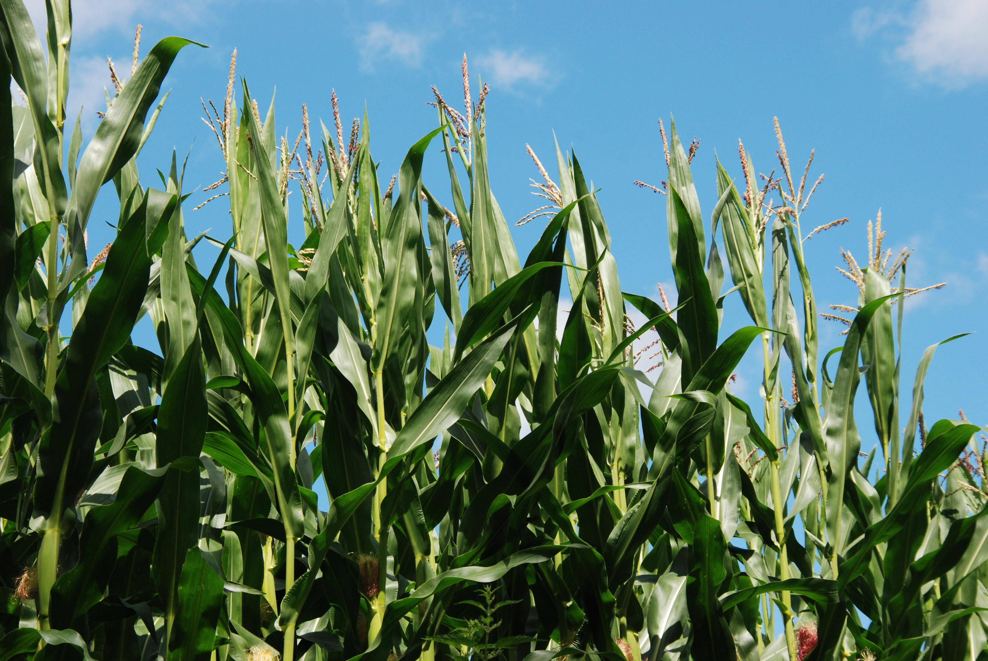
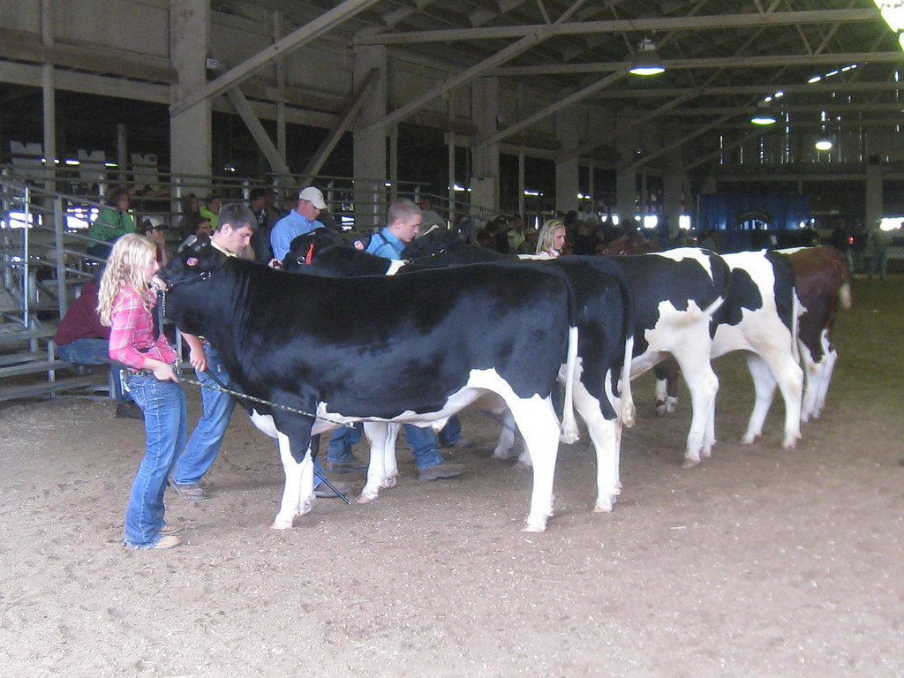
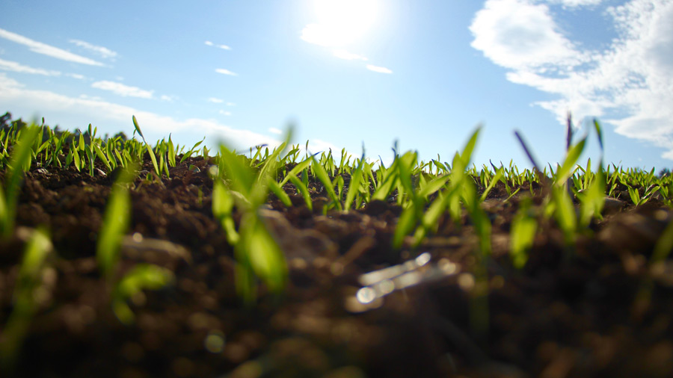
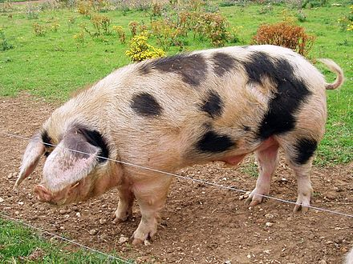

9:00am-3:00pm (Closed-Judging)
Orange County Fair
June 25-28, 2025

Sow It, Grow It, Show It

1._________________________________Agriculture 9:00am-3:00pm Assist Judges
2._________________________________Agriculture 9:00am-3:00pm Assist Judges
3.______________________________Garden Produce 9:00am-3:00pm Assist Judges
4.______________________________Garden Produce 9:00am-3:00pm Assist Judges
5._____________________________Food Preparation 9:00am-3:00pm Assist Judges
6._____________________________Food Preparation 9:00am-3:00pm Assist Judges
7_____________________________Food Preservation 9:00am-3:00pm Assist Judges
8.____________________________Food Preservation 9:00am-3:00pm Assist Judges
9.____________________________________Sewing 9:00am-3:00pm Assist Judges
10.___________________________________Sewing 9:00am-3:00pm Assist Judges
11.____________________________Home Furnishings 9:00am-3:00pm Assist Judges
12.____________________________Home Furnishings 9:00am-3:00pm Assist Judges
13.______________________________________Arts 9:00am-3:00pm Assist Judges
14.______________________________________Arts 9:00am-3:00pm Assist Judges
15._____________________________________Crafts 9:00am-3:00pm Assist Judges
16._____________________________________Crafts 9:00am-3:00pm Assist Judges
17.______________________________Flowers & Plants 9:00am-3:00pm Assist Judges
18.______________________________Flowers & Plants 9:00am-3:00pm Assist Judges
19.________________________________Photography 9:00am-3:00pm Assist Judges
20.________________________________Photography 9:00am-3:00pm Assist Judges
21.________________________________AG Mechanics 9:00am-3:00pm Assist Judges
22.________________________________AG Mechanics 9:00am-3:00pm Assist Judges
21.__Sandra Blackburn_______________Chair Exhibit Hall 9:00am-3:00pm Assist Judges

3:00pm-9:00pm (Open to Public)

1.__________________________________________ 3:00pm-5:00pm Greet & Visit
2.__________________________________________ 5:00pm-7:00pm Greet & Visit
3.__Sandra Blackburn___________________________ 7:00pm-9:00pm Greet & Visit

Thursday, June 25, 2026
2:00pm-9:00pm (Open to Public)

1.__Sandra Blackburn_________________________ 2:00pm-3:00pm Greet & Visit
2.__________________________________________ 3:00pm-5:00pm Greet & Visit
3.__________________________________________ 5:00pm-7:00pm Greet & Visit
4.__Sandra Blackburn___________________________ 7:00pm-9:00pm Greet & Visit

Friday, June 26, 2026
2:00pm-9:00pm (Open to Public)

1.__Sandra Blackburn_________________________ 2:00pm-3:00pm Greet & Visit
2.__________________________________________ 3:00pm-5:00pm Greet & Visit
3.__________________________________________ 5:00pm-7:00pm Greet & Visit
4.__Sandra Blackburn___________________________ 7:00pm-9:00pm Greet & Visit

Saturday, June 27, 2026
9:00am-9:00pm (Open to Public)

1.__Sandra Blackburn___________________________ 9:00pm-11:00pm Chair EH
2.__________________________________________ 11:00pm-1:00pm Greet & Visit
3.__________________________________________ 1:00pm-3:00pm Greet & Visit
1.__________________________________________ 3:00pm-5:00pm Greet & Visit
2.__________________________________________ 5:00pm-7:00pm Greet & Visit
3.__Sandra Blackburn___________________________ 7:00pm-9:00pm Greet & Visit

Saturday, June 27, 2026
8:00pm-9:00pm
(Exhibitor–Pick up Entries)

1.__________________________________________ 8:00pm-9:00pm
2.__Sandra Blackburn___________________________ 8:00pm-9:00pm Chair EH

Sunday, June 28, 2026
9:00am–12:00pm
(Pick up Entries)

1.__________________________________________ 9:00pm-12:00pm
2.__________________________________________ 9:00pm-12:00pm
3.__Sandra Blackburn___________________________ 9:00pm-12:00pm Chair EH

