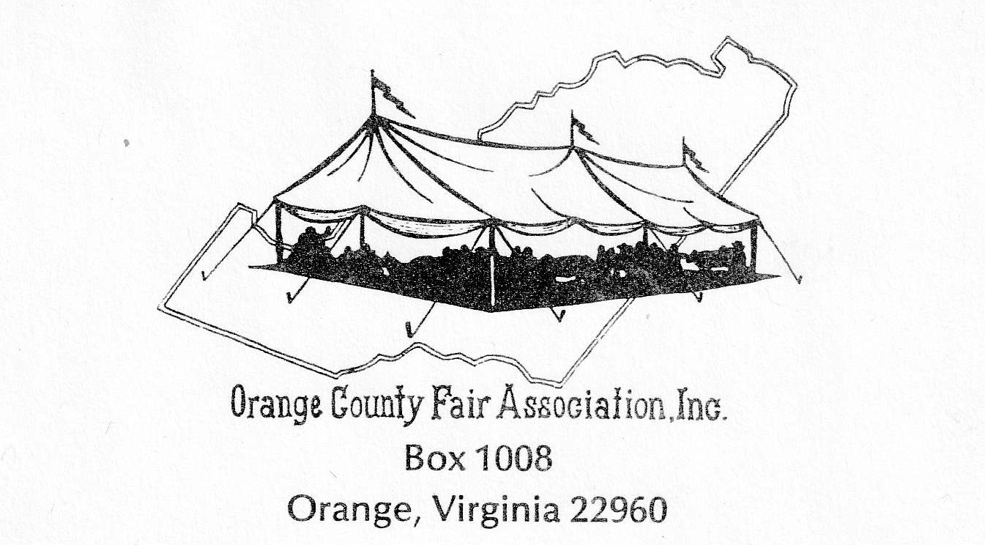

“Farmer Pride, County Wide”
June 24-27, 2026

Dear __________________, April 17, 2026
First, I would like to thank you for helping us in the past. We have had some hot summers lately and it has made it almost unbearable. Well, let’s be honest, it was unbearable. But this year I have good news, we are very proud of our Fair Board. They have contractors installing Insulation, adding Electrical Upgrades, and putting in a HVAC System. It is all going on now and will be finished in May, one month before we arrive for this years Fair in June. We are going to have Air Conditioning in the Exhibit Hall!
With that being done, I need to get started on securing our judges. We cannot have a successful fair without you and your expertise. This year the Orange County Fair runs from June 24-27, 2026. The big day for the Exhibits and the Judging will be held on Wednesday, June 24th. The Last time for entering items will be from 7:00a.m. to 9:00a.m. with the Judging beginning at 10:00 a.m. and usually last until 2:00 p.m. We are located at 14500 Old Gordonsville Road, Orange, VA 22960.
We are hoping that you will be able to join us again this year. Which category do you enjoy judging? Please list your first, second, and third choice below as we want everyone to be able to enjoy and be comfortable with what they judge.
There will be a BBQ lunch provided for all judges and volunteers in appreciation for helping us on that day.
I look forward to hearing back from you, and even more so getting to visit with you again. I am asking that you cut off the bottom portion of this letter and return it to me in the enclosed stamped envelope. Or you can email it back whichever works best for you.
Thank you,

Sandra Blackburn
Orange County Fair Association
Exhibit Hall Chair
979-436-3577 cell
sandrak.blackburn@yahoo.com

Please check your calendars and return this form as soon as you know your availability. We appreciate your time and are looking forward to having you be part of this fun day.

Check one:

_____ Yes, I will be able to help you with the judging this year.

_____ No, I cannot help with judging this year.

Name: _______________________________________________ Preference in Judging:

Address:______________________________________________ 1.___________________________________

Phone Number:________________________________________ 2.___________________________________

Email:_________________________________________________ 3.___________________________________

