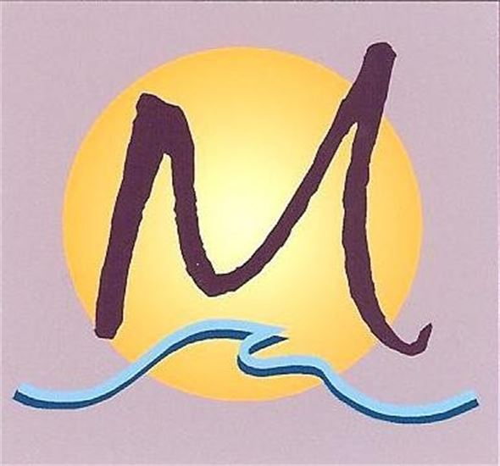
Hands On OC Massage & Bodywork
with Michael Roberson, CMT, BCTMB
1601 Dove Street, Suite 278, Newport Beach, CA 92660
949.292.9207 michael@handsonoc.com
www.HandsOnOC.com

Prenatal Massage Release Form

Massage therapy during pregnancy has been shown to be beneficial to mother and child for a number of common complaints such as fatigue, musculoskeletal pain sciatica, edema, and many others. However, there are also risks associated with specific conditions that may occur during pregnancy.

You must inform your massage therapist if you have or have had in the past, any of the following conditions or symptoms which may make massage therapy contraindicated or may require alterations in the approach to your sessions. The priority is to keep you and your baby safe and healthy.

History of miscarriage Preeclampsia
Gestational diabetes History of any high-risk pregnancy
Cardiac, pulmonary, liver or renal disorders Drug exposure
Mother’s age, under 20 over 35 Severe nausea or vomiting
Pitting edema or sudden swelling Multiples
Epilepsy or convulsive disorders Hypertension
Placental or cervical dysfunction Genetic abnormalities
Abdominal pain Fetal growth retardation
Leaking of amniotic fluid Bloody discharge
Fever Sudden weight gain
IVF Treatment Diarrhea
Severe headaches Decrease in fetal movement over 24-hour period

Client’s Release

Client’s name______________________________________________________________________________

OBGYN name ____________________________________________ Phone ___________________________

Due date: ____________ Term__________ Weeks _____________

Is this your first pregnancy? ____________ How many successful births? ____________

Have you ever miscarried? _____________ If yes, how many times? ________________

Have you made use of IVF for this or any pregnancy? ___________

Are you making use of a midwife or doula? _________ If so, name and contact information, please.

Name ____________________________________________ Phone __________________________________

Hands On OC Massage & Bodywork
with Michael Roberson, CMT, BCTMB
1601 Dove Street, Suite 278, Newport Beach, CA 92660
949.292.9207 michael@handsonoc.com
www.HandsOnOC.com

I, _______________________________________, have read the aforementioned conditions and symptoms which make massage therapy during pregnancy contraindicated. The massage therapist has discussed this information with me and provided an opportunity for any questions. I have disclosed all high-risk factors of my pregnancy. I have completed and/or updated my client intake form.

I have discussed with my prenatal healthcare provider/physician any health concerns that I have about receiving massage therapy. I agree that my healthcare provider/physician has given me clearance to receive massage therapy.

I understand the information contained on this form and confirm that 1) I am receiving medical care including regular check-ups with a licensed healthcare provider, 2) I have not experienced any of the listed symptoms, conditions or complications, 3) I am not currently experiencing any of the listed symptoms, conditions or complications, 4) I am experiencing a low-risk pregnancy.

I understand that I will be receiving massage therapy as an adjunct form of healthcare only and that this therapy is not meant to replace appropriate medical care. I release the massage therapist of all liability of any harm that may unintentionally occur during my treatments.

Signature ________________________________________________ Date ____________________________

California Massage Therapy Council (CAMTC 4487) National Certification Board for Therapeutic Massage and Bodywork (NCBTMB 397447) American Massage Therapy Association (AMTA 158318), Association of Bodyworkers and Massage Professionals (ABMP 861487)
Newport Beach Business License BT30062610

