Patient Information
____________________________________________________________
Last Name: ______________________________________First Name: ______________________________MI: ___
Address: __________________________________ Apt No.: ______________ City: _________________________
State: ______ Zip: _____________
Home Phone: ___________________________________ Cell Phone: ____________________________________
Email: ________________________________________________________________________________________
Date of Birth: _______/__________/___________
Employer/Name of School___________________________________ Full Time Part Time
Sex: Male Female Marital Status: married single divorced widowed
Patient Referral Information:

_____________________________________________________________________________________________
Referred By: _____________________________________ How did you hear about us? ______________________
Have you been to Chiropractor before: Yes No
If Yes, who did you go see and when was last time you have been adjusted? ________________________________
Emergency Contact:

_____________________________________________________________________________________________
Name: __________________________________________________ Relationship: __________________________
Home Phone: __________________________________ Cell Phone: _____________________________________

Patient’s Present Complaints

Patient Name:__________________________________________________________________________________ Present Complaints:
_____________________________________________________________________________________________
Who is your primary care physician (PCP)? __________________________________________________________
Please list your symptoms in order severity: __________________________________________________________
_____________________________________________________________________________________________
How did your problem begin:______________________________________________________________________ Date problem began:________/________/__________
What treatments have you undergone for this condition in the past? (surgery, medications, injections, therapy, chiropractic)___________________________________________________________________________________
Have you had X-rays, MRIS or other tests for this condition? Yes No
If yes, what tests and when? _____________________________________________________________________
Is this condition the result of an auto or work accident? Yes No
If yes, please explain: ___________________________________________________________________________
How bad is your pain? (circle a number) 0 1 2 3 4 5 6 7 8 9 10
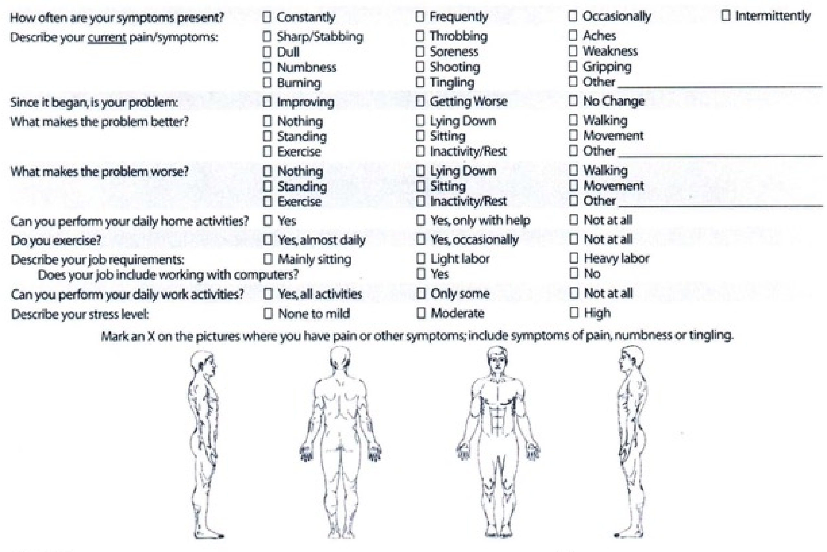
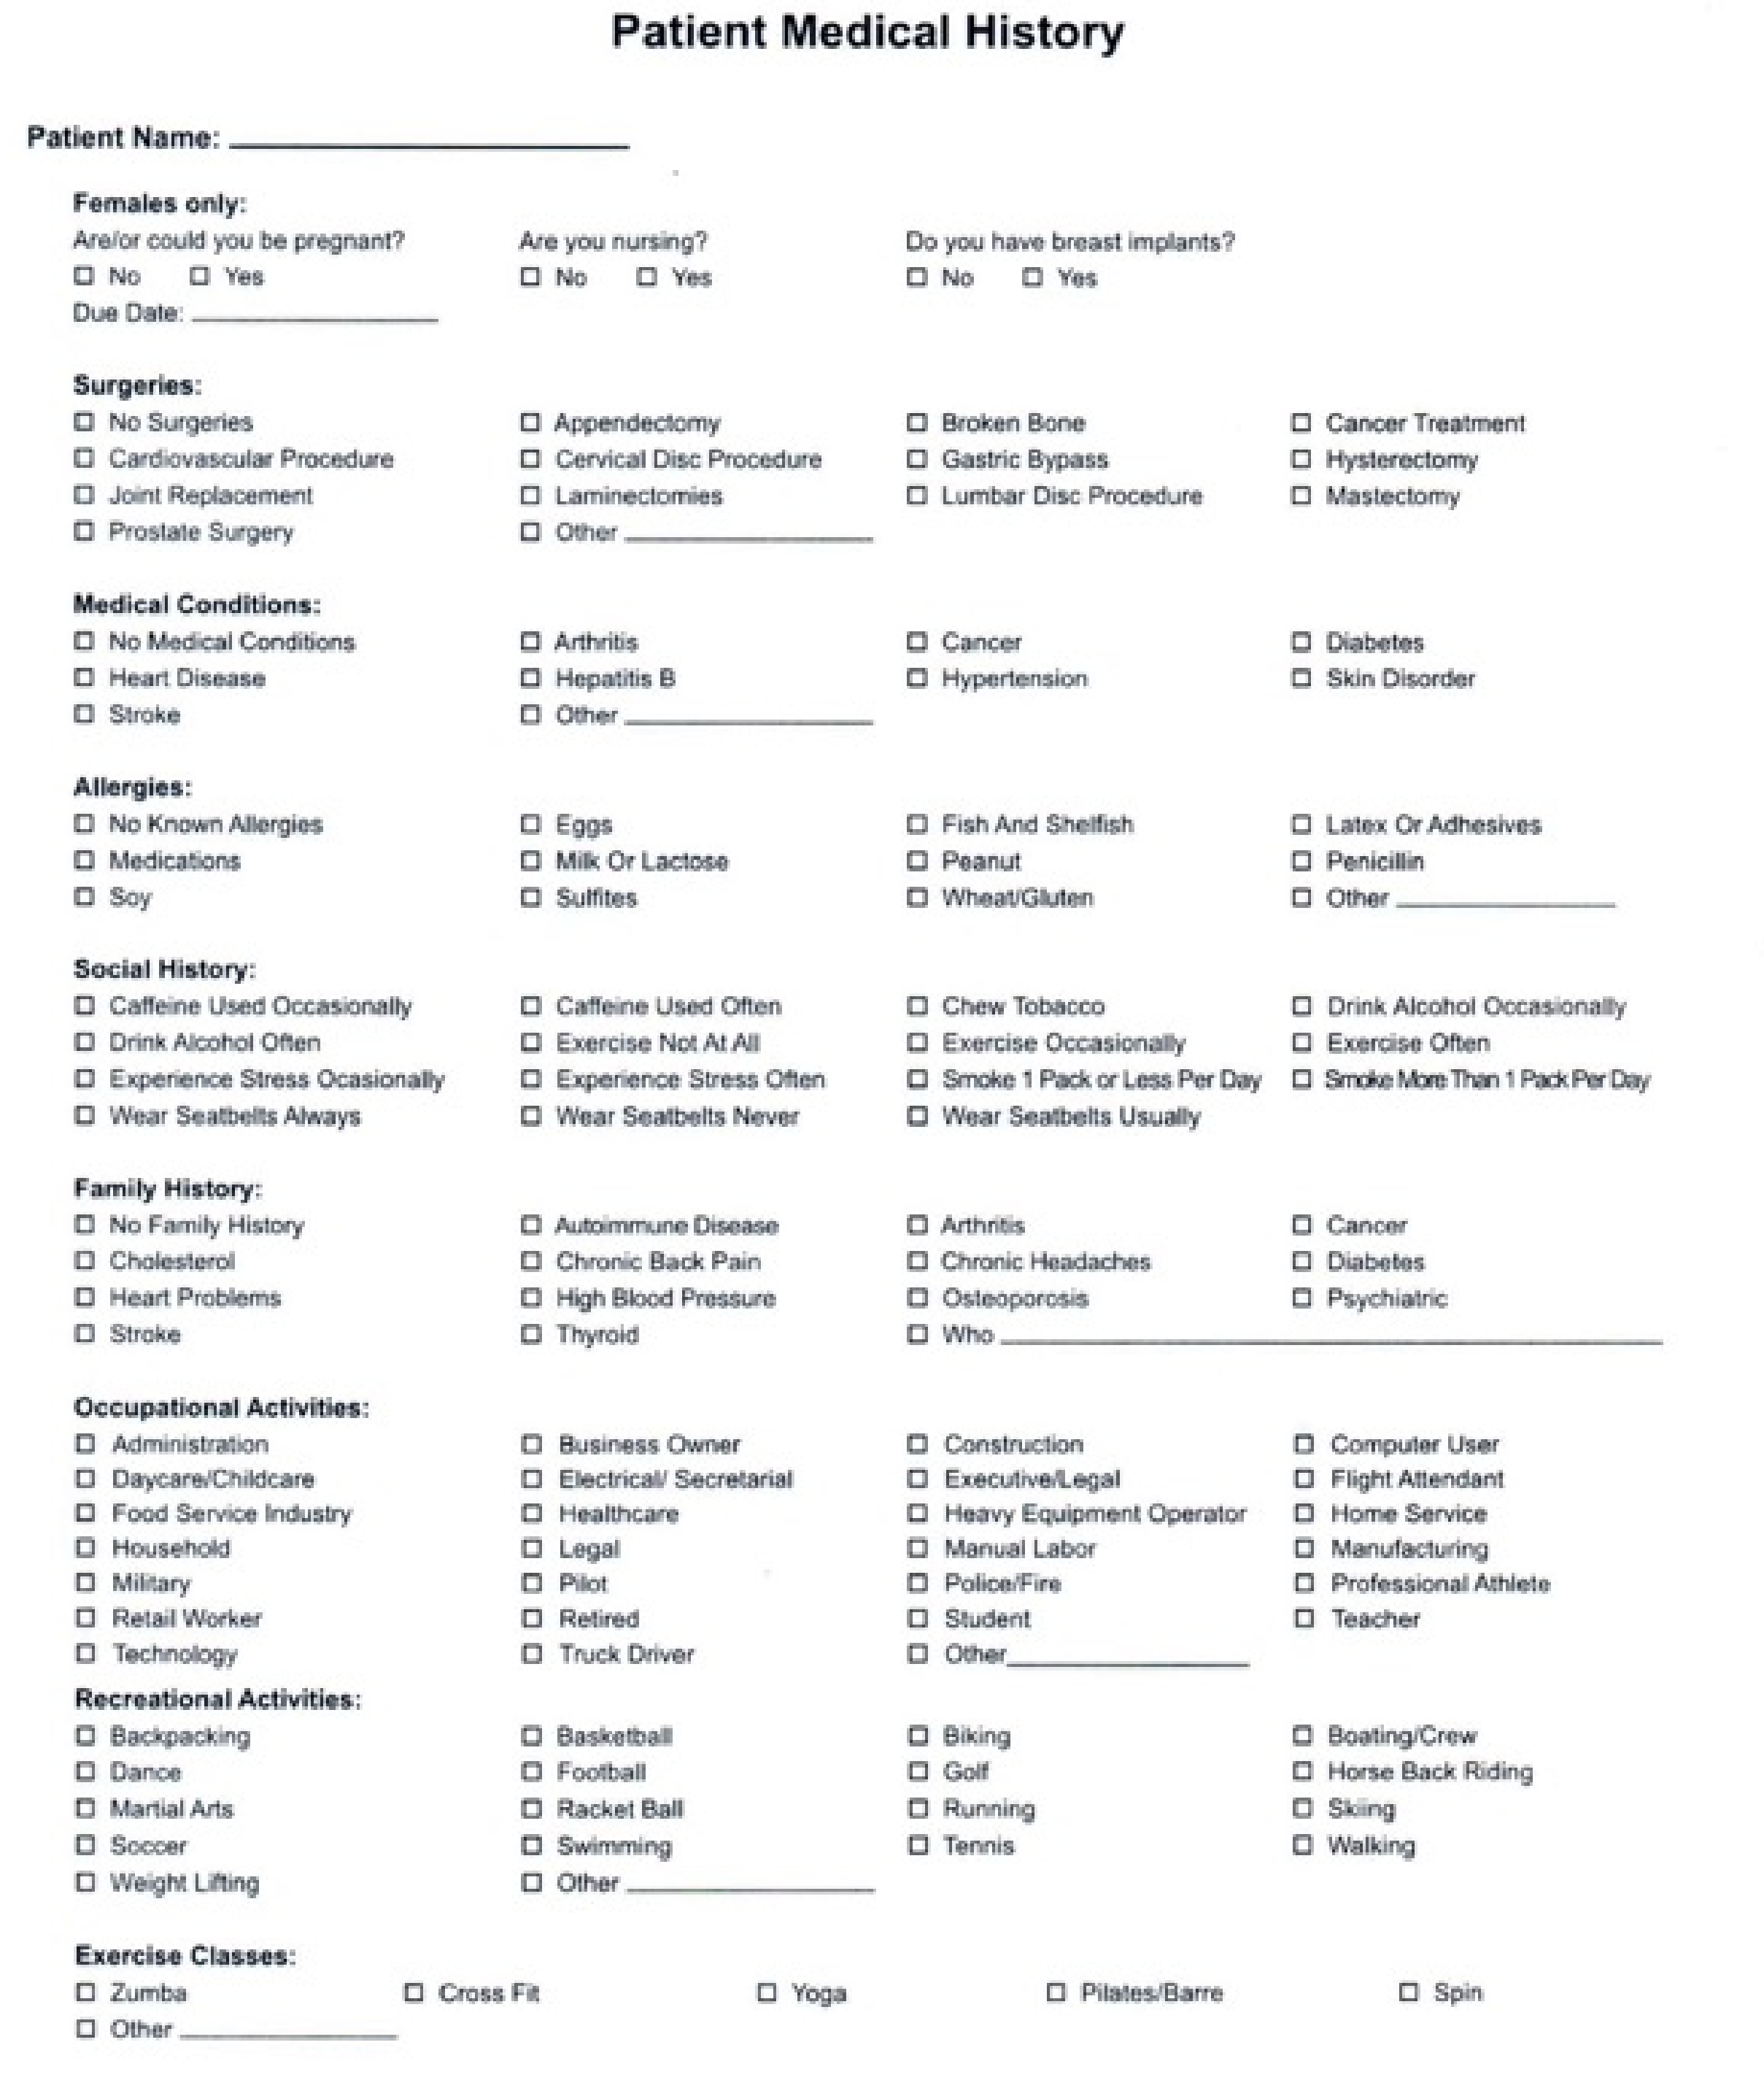
No pain Unbearable Pain
Please list any medications/supplements that you are currently taking: ____________________
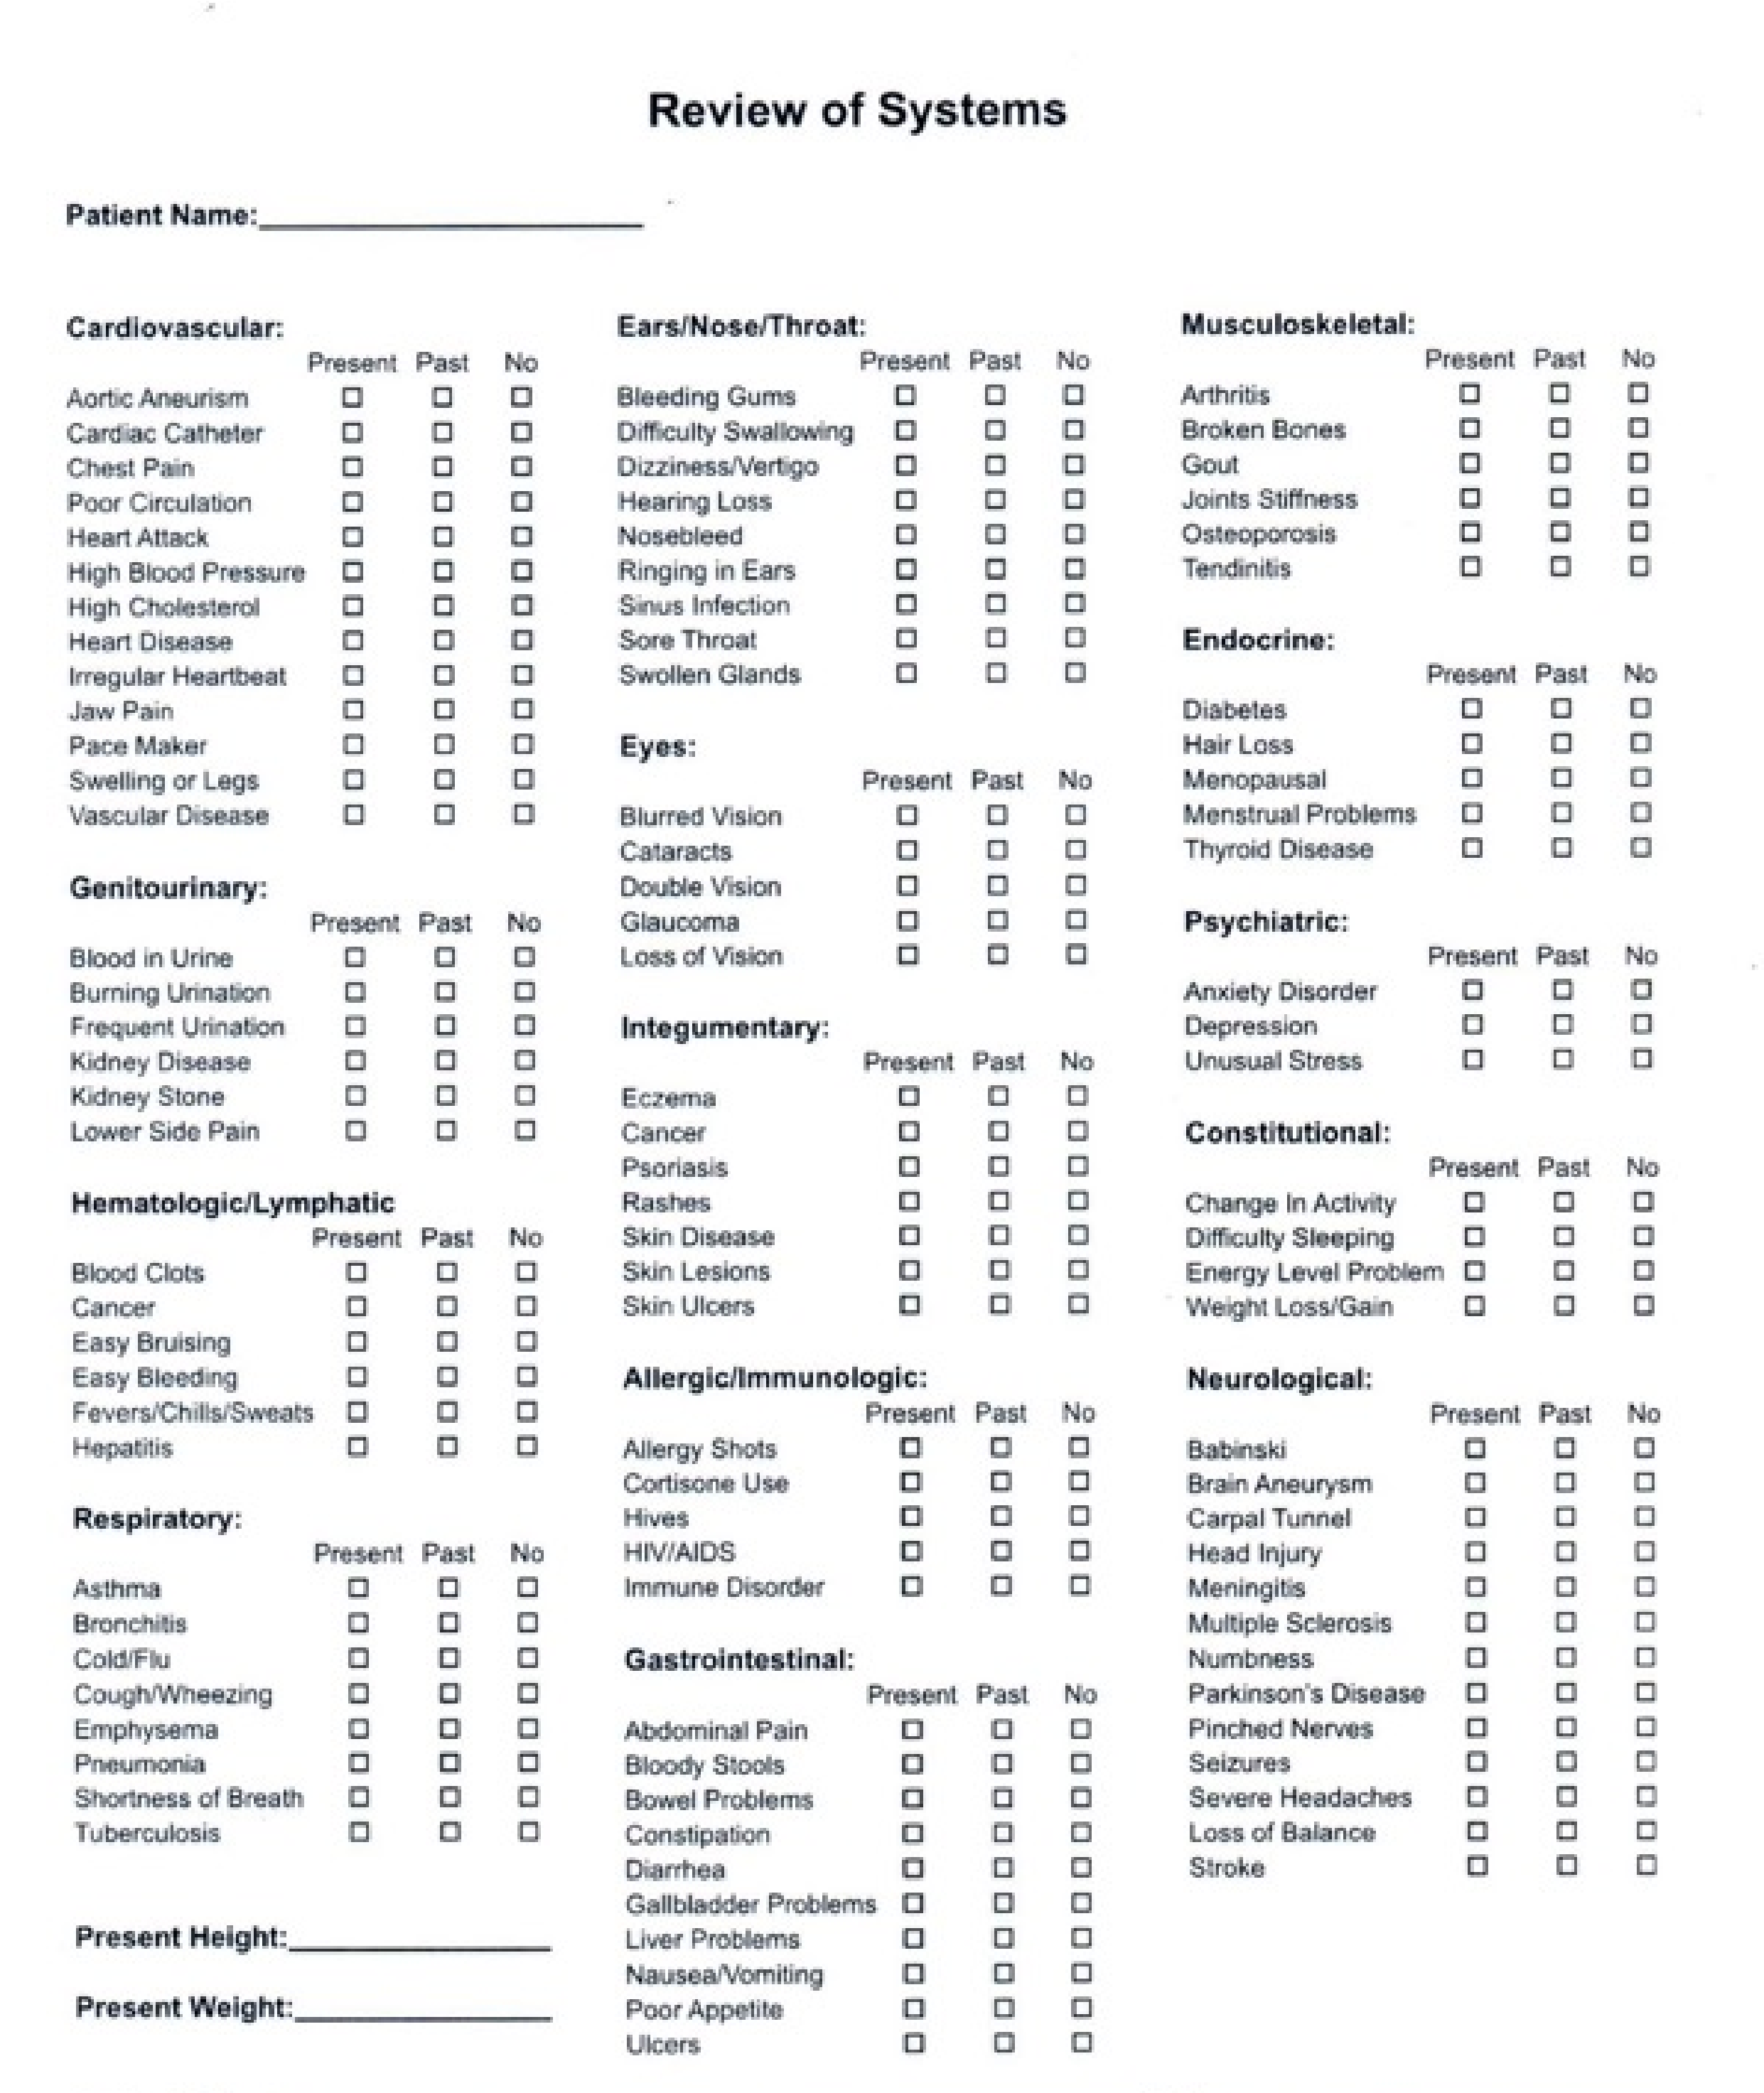
Dr Cody Marlow Dr Hannah Goforth
211 Welsh Pool Road Suite 106
Exton, Pa 19341
I hereby volunteer to receiving the following treatments for my present and future health conditions. I understand the treatment will be administered by Kinisi LLC.
Treatments that may be administered.
Electrical Stimulation: is a treatment that involves the use of electric devices such as TENS (Transcutaneous Electrical Nerve), or MENS (Micro current Electrical Nerve) units. Mild electrical impulses are transmitted through the skin to stimulate nerve fibers. Contraindications are, Pacemaker, Pregnancy, Epilepsy/Seizures (no treatment above the neck) Cancer. The electrodes are on self-adhesive pads that have a gel and there is the rare possibility that your skin may be agitated.
Cupping: is a treatment of creating a vacuum in a glass or plastic cup, which is applied to the surface of the skin. After the cups are removed there may be a slight discoloration of the skin (like a type of bruising) this usually will resolve in a 3-7 days.
Blood-Flow Restriction Training (BFRt): is a technique utilized during the rehabilitation stages. It is typical and normal for a patient to experience numbness/tingling during the initial phase of this technique. Post BFRt, it is typical to feel fatigued in areas that were worked.
Taping: Our taping treatments usually consist of utilizing kinesiotape, in order to provide relief to an area of injury. There can be irritation to the area applied if one is allergic to the glue used on the tape and the tape should be removed immediately and the area washed if this happens.
IASTM: is scraping on the skin in a small area using a smooth-edged instrument. This often results in bruising at the treatment area, it is not usually painful and resolves in 3-7 days.
Therapeutic Ultrasound: is a treatment that is used to provide deep heating and healing to soft tissues in the body. Every precaution is taken to prevent over-warming, but the rare possibility of mild burns does exist.
Myofascial Release: is a safe and very effective hands-on technique that involves applying sustained pressure into the myofascial connective tissue restrictions to eliminate pain and restore motion. This can often result in bruising at the treatment area, it is not usually painful and resolves in 3-7 days.
I understand that no promise has been made regarding the outcome of treatment and that reasonable efforts will be made to give information to me so that I might make an educated decision regarding the duration and appropriateness of continued care. I do not expect the doctor to be able to anticipate and explain all the risks and complications. I wish to rely on the doctor to exercise judgement during treatment, which he/she feels at the time, based upon the facts then known, and is in my best interest.
By signing below, I acknowledge that:
I have read or have had read to me the information on this consent form. I understand the possible risks and complications involved. I have had the opportunity to discuss the consent with the doctor. I understand I can request more information at any time if desired. I consent to receiving treatment that involves the above procedures. I understand that I have the rights to refuse or discontinue any treatment at any time. I understand that this refusal may affect the expected results.
Patient Name (PRINTED): _____________________________________________________________
Patient/Guardian Signature if not 18: _____________________________________________________
As with any healthcare procedure there are certain complications which may arise during chiropractic manipulation and therapy. Doctors of Chiropractic are required to advise patients that there are risks associated with such treatment. In particular, you should note:
Informed Consent to Chiropractic Treatment
- Some patients may experience some stiffness or soreness following the first few days of treatment.
- Some types of manipulation have been associated with injuries to the arteries of the neck leading or contributing to serious complications including stroke. This occurrence is exceptionally rare and remote. However, you are being informed of the possibility regardless of the extreme remote chance.
- The Doctor(s) will make every effort to screen for any contraindications to care; however, if you have a condition that would otherwise not come to our attention, it is your responsibility to inform the Doctor(s).
- Other complications may include fractures, disc injuries, dislocations, muscle strain, cervical myelopathy, costovertebral strains and separation, and burns.
The probabilities of these complications are rare and generally result from some underlying weakness of the bone or tissue which is checked for during the history, examination, and x-ray (when warranted).
I acknowledge I have had the opportunity to discuss the associated risks as well as the nature and purpose of treatment with my Chiropractor.
I consent to the chiropractic treatments offered or recommended to me by my chiropractor, including spinal manipulation. I intend this consent to apply to all my present and future chiropractic care.

Patient Name (PRINTED): _____________________________________________________
Date: _______________________
Patient/Guardian Signature if not 18: ____________________________________________
Date: _______________________

