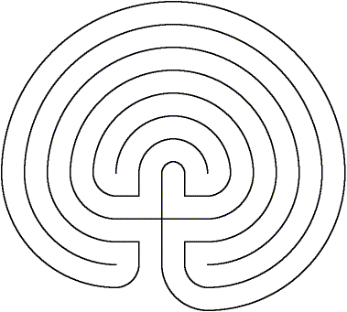

_{www.aridspirit.org}




The Centering Labyrinth
for connecting to your center
Before beginning take 3 belly breaths with your eyes closed
Ask your Divine Source to assist you in your walk
Begin by placing your finger at the entrance
As you begin, take another belly breath
As you walk the path, with each breath, become aware of obstacles
It may be responsibility, financial concern, loss or physical ailments
When you encounter these obstacles, say hello to them
Take a deep belly breath and release them with the out breath
At each corner, pause and take a moment to thank your Divine Source
For giving you everything you need
When you reach the center take another belly breath
Feel how at peace you are – with yourself – with the world
Begin to walk the path again, with each step feel how you are fully supported
At each corner, pause and take a moment to thank your Divine Source
You are now ready to come back into the world
Namaste

