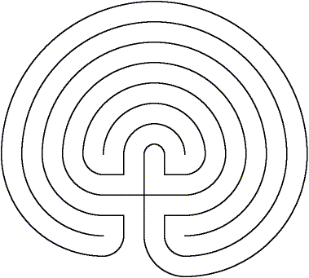

_{www.aridspirit.org}




The Clearing Labyrinth
for clearing emotions
Before beginning take 3 belly breaths with your eyes closed
Ask your Divine Source to assist you in your walk
Begin by placing your finger at the entrance
As you begin, take another belly breath
With each corner, become more aware of your emotions
Be aware of them, but do not engage with them
At each turn, check in with yourself, breathe in
Release any emotions that are ready to go with the out breath
When you reach the center take another belly breath
Thank your Divine Source
Ask what you need to know
With each corner become more and more open to hear
With each turn pause for reflection and breathe in your Divine Source
You are now ready to come back into the world
Namaste

