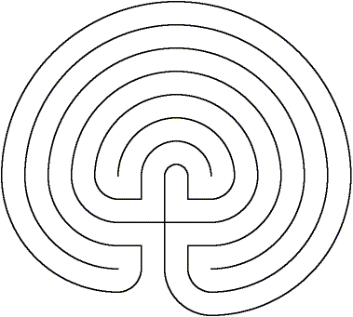

_{www.aridspirit.org}




The Grounding Labyrinth
for connecting to Earth
Before beginning take 3 belly breaths with your eyes closed
Ask your Divine Source to assist you in your walk
Begin by placing your finger at the entrance
Take another belly breath
Feel the breath filling and emptying your lungs
With each step, feel yourself going further and further into the rich earth
Feel the love and support of the Divine in each layer
With each step, feel strength, support and deep love flowing into you
When you reach the center, you are at the heart of Earth
You are fully grounded to Earth and completely supported by the Divine
As you begin to go from the center, feel your worries fall from you
Like leaves from an autumn tree, they all drop away
Worry . . . Pain . . . Fatigue. . .
Anger . . . Distrust . . . Fear. . .
As you exit the labyrinth, thank the Divine and Earth for always supporting you fully
Namaste

