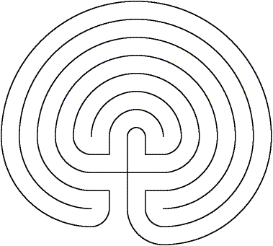

_{www.aridspirit.org}




Healing Earth Labyrinth
for restoring Earth
Before beginning take 3 belly breaths with your eyes closed
Ask your Divine Source to assist you in your walk
Begin by placing your finger at the entrance, bring to your mind a landfill
See how Earth struggles to support the load
Feel its pain as toxic chemicals and rotten waste penetrate its layers
As you walk the path, with each step, gather as much from the landfill as you can
Do not be concerned about how it got to the landfill, simply focus on the gathering
At each corner, pause and thank the items for their service - release them with the out breath
Observe them as they dissolve into nothingness
As you enter the center , look again at the earth that was under the landfill
Ask the Divine to bless this earth and help you nourish and love it
As you go from the center, through each curve, send Earth love and thanks
At each corner, plant something for its enrichment – some flowers, perhaps a tree
See Earth now breathing with health and love
Exit the labyrinth knowing that this is possible
Namaste

