**PROJECT NOTES**

1. Property is 0.3 miles (7 minutes walking) from the entrance of the Lynnwood Transit Center. See map below.
2. Under Washington State's HB 1110, Lynnwood may waive the parking requirements if the property is within a half-mile of a Major Transit Stop. See below.
3. Opportunity Zone tax incentive (my Lynnwood property is in the Opportunity Zone):
   1. Deferral of Capital Gains Tax: Investors can defer paying taxes on capital gains if they reinvest those gains into an Opportunity Fund, which is a private investment vehicle that invests in eligible properties located in Opportunity Zones. The deferral is until 12/31/2026 or until the property is sold, whichever is sooner.
   2. Reduction of Capital Gains Tax: If the investment in the Opportunity Fund is held for at least five years, investors can reduce the amount of capital gains subject to tax by 10%. If held for seven years, this reduction increases to 15%.
   3. Exclusion of Gains from Qualified Investments: If the investor holds the Opportunity Fund investment for at least ten years, they can exclude any additional gains from the Opportunity Fund investment from taxes.
   4. See the link. <https://www.irs.gov/credits-deductions/businesses/opportunity-zones>
4. Community Development Loan Fund. This is a program that Heritage Bank offers in conjunction with the government to promote the development in economically stressed areas. My property is included in the area.
   1. Offers a below-market interest rate
   2. 7-year loans of interest-only payments
   3. Etc.
   4. See attached.

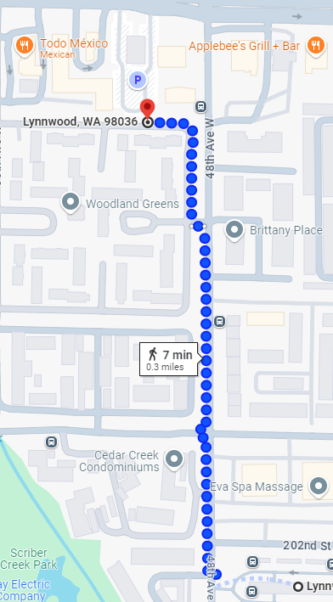

The **Planned Commercial Development (PCD) zone** is an existing zone that will be reformatted.  The PCD zone is focused on commercial and mixed-use residential development and makes up the remaining portions of the Regional Growth Center (RGC). The PCD zone is intended to allow and encourage commercial development of contiguous parcels under multiple ownership, while allowing for potential residential development. Click Link: <https://arcg.is/1qDuGP2>

