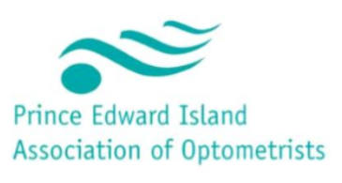**Maritime Continuing Education (MCE) Symposium**

**Venue: Rodd Charlottetown Hotel**

**April 27-30, 2023**

Sponsorship Opportunities

**Platinum – Welcome Reception Sponsor:**

* **Two (2) hours of CE presented by your own approved speaker.** Opportunity to introduce your speaker and 10 minutes to market your company**.** Lecture & speaker will be in mutual agreement with CE Chair. Speaker expenses are covered by sponsor.
* **One (1) Booth (10x6)** at Luncheon, Refreshment Break & Evening Reception. Electrical Included (must be ordered with registration).
* **Company logo** included in the final conference program provided to all participants
* **Company name and logo** displayed on PEIAO conference web site with hypertext link to company’s site
* **Company logo** included on all conference signage & PowerPoint Signage
* **Full Page Ad** to be included in the event program & conference website
* **Exclusive networking opportunity** with the Maritime OD’s

**$5000 +hst**

**General Sponsor:**

* **One (1) hour of CE** in a mutual agreement with CE Chair with the opportunity to introduce a speaker. A list of all speaker arrangements and fees are the responsibility of PEIAO.
* **One (1) Booth (10x6)** at Luncheon, Refreshment Break & Evening Reception. Electrical Included (must be ordered with registration).
* **Company logo** included in the final conference program provided to all participants
* **Company name and logo** displayed on PEIAO conference web site with hypertext link to company’s site
* **Company logo** included on all conference signage & PowerPoint Signage
* **1/2 Page Ad** to be included in the event program & conference website
* **Exclusive networking opportunity** with the Maritime OD’s

**$2500 +hst**