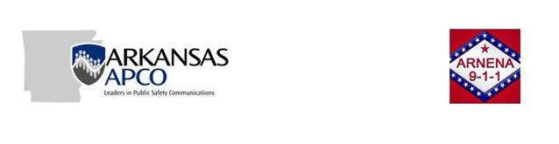

**Location: Virtual Meeting**

**Date: Tuesday, December 1, 2020**

**Time: 2 p.m. (Meeting was recorded)**

1. **Arkansas APCO Business Meeting**
2. **Call to order**

President, Michael McCammon will call the meeting to order at 1400.

1. **Prayer and Pledge of Allegiance**

1st Vice President, Scott Ballard (Prayer)

All attending (Pledge of Allegiance)

1. **Roll call**

Secretary, Carla Holcroft will call the roll.

* Michael McCammon, President
* Scott Ballard, 1st Vice President
* Ronya Marveggio, 2nd Vice President
* Carla Holcroft, Secretary
* Shannon McCuin, Treasurer
* Kristi Key, Executive Council
* Stuart Peters, Commercial Advisory Member
* Open, Immediate Past President

Documentation of who attended the business meeting.

Kim Erickson (In Michael’s Office)? (Unreadable on audio)

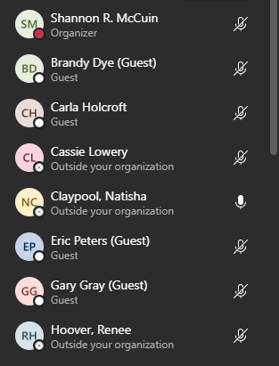 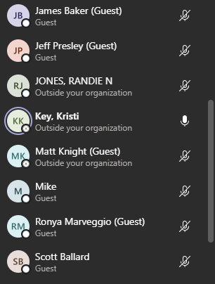 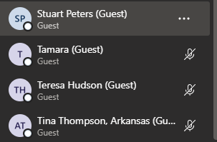

1. **Approval of minutes from last meeting (See attached meeting minutes)**

President, Michael McCammon

Kristi Key-made a motion

Ronya Marveggio 2nd

1. **President’s Welcome and report**

President, Michael McCammon

Michael McCammon- Apologized for moving the meeting out and we were made it happen this time. It has been a trying time this year for everyone in public safety. Especially I those line of work and not everyone is the same. Added work load with the things we have to do for COVID, it is a struggle. I appreciated everyone staying and being supportive to APCO. We would have like to have made it happen this year with NENA.

1. **Treasurer’s Report**

Treasurer, Shannon McCuin

|  |  |  |  |  |
| --- | --- | --- | --- | --- |
| ***AR APCO Balance 2020*** | | | | |
|  |  |  |  |  |
| **2020 Beg balance** |  | **$24,561.24** |  |  |
|  |  |  |  |  |
| **Dues from International** |  | $1,190.83 |  |  |
| **Electronic Withdrawal - Merc Svc** |  | -$209.14 |  |  |
| **Electronic Deposit - Merc Svc** |  | $1,450.00 |  |  |
| **Check Printing Charge** |  | -$29.05 |  |  |
| **Storage Charges** |  | -$363.67 |  |  |
| 2020 Conference registration |  | -$100.00 |  |  |
|  |  |  |  |  |
| **Total Account Balance** |  | **$26,500.21** |  |  |

1. **Executive Council Report**

Executive Council, Kristi Key

2020’s Executive Council meeting was held two days virtually. Long range strategic plan, language changes and recommendations of proposed amendments where some of the things discussed. Anyone wanting information regarding the Executive Council Meeting or the Executive Council Joint Chapter work group get with Kristi Key and she will get you that information.

1. **Elections Update**

2nd Vice President, Ronya Marveggio

Arkansas Board Member Nominations were accepted and votes have been collected for the positions of 2nd Vice President, Executive Council, and Commercial Advisor. Voting ended on 11/7/20. All positions were uncontested.

Jeff Turner, 2nd Vice

Kristy Key, Executive Council

Stuart Peters, Commercial Advisor

1. **Conference Update**

President, Michael McCammon

Cancelled the 2020 conference, working on what will be proposed for next year. Unknown what obstacles we will encounter.

1. **Conference Guide**

Vice President, Scott Ballard

Scott looked at a few different states regarding conference guides. It is 90% complete and will send it out before the end of the year. No questions were asked about the Conference Guide.

1. **Conference Chair appointment**

President, Michael McCammon

Michael felt we should wait to appoint a conference chair, but he was going to leave it up to the board. Ronya asked if we wanted to nominate CJ, but Shannon suggested that since CJ is new in his new job it might be hard. Shannon asked if there was someone else on the board that would be willing and Scott said he would be willing. Shannon nominated Scott and Stuart 2nd it. Scott is the new Conference Chair for 2021.

1. **Joint Chapter APCO/NENA discussion**

President, Michael McCammon

There were bylaws brought forward by Randi Jones to have a Joint Chapter APCO/NENA. Michael is for this and would like for us to work together as one to make this happen and sees it as a benefit for Arkansas and opened it up for discussion.

Shannon-was concerned about the draft of NENA/APCO Secretary/Treasurer there was no need to have two for each Chapters. She likes the regional representatives. We would have to look into the draft more.

Kristi- Brought up a list of concerns they would both have to be both APCO and NENA members to serve on the board for 3-4 years. Would have to look at voting rights. There are no requirements listed on the draft as far as requirements. It would cost an individual or and agency at least$250.00 to be a part of both organizations. How many times a year would we be meeting? APCO requires all of the board members to be full voting members.

Michael- This is just a draft, or final as to what it is going to be like, these are just recommendations. A lot of these can be changed to fit one board. As far as being a membership on both, I don’t see that.

Scott- How would it benefit our members and why are we looking to combine the organizations?

Michael- What has Arkansas APCO as a Chapter accomplished in the last 15 years? We all have the same object and goal. How is this going to better us?

Shannon- Last 15 years we have held lots of conferences with NENA, lots of good guest speakers, training, were incorporated, updated our bylaws to meet national standards, we have standardized training. I don’t think we are pointing out negative things, they are just pointing out things that are standing out. Yes, it’s a draft, we are trying to make it a better document.

Michael- To address what Scott brought up, I see the same people working on things. Get more people involved, the more people we get involved the better we are. All of us on the board have great ideas but other people have great ideas. It is going to take a lot of work and come together as team. If you look at the same organization (NENA) it is the same thing. It is not about money, it is how to can provide the best service and training for the State of Arkansas. We can vote to move forward.

Kristi- It just needs to be a good working document before we present it to the board. I feel like doing something like this in the middle of the pandemic is not a good idea. Kristi felt like there were less than 10% of the membership on this call. Kristi wanted Shannon to check to see how many people were on the phone call and there were twenty (20) and we have over two (2) hundred members.

This is big huge change, I am not opposed to it, working together is a good thing, I just don’t think that the timing it right. I appreciate the work that went into it. There is more work to be done before it is voted on.

Scott- I am not saying that I am against it, I agree with Kristi there is a lot that has to be ironed out.

Shannon- I would like to go through what was presented and either make changes or add notes where we need to look at it closer to present it to our members to vote on. There are a few red flags, and how it is presented right now, as the way of the treasurer position I have a few concerns that needs to be worked out. It may need to say we set a date and meet weekly to get it done, with a teams meeting. Once we get a good working document we can present it.

Ronya- I do believe we should move forward by joining the two chapters, and work together. We are a bigger voice together. It is hard for me to work the floor and be a part of these meetings. There are somethings on this document that needs to be worked out. Who put this document together?

Randie- At conference last year, I presented this. We have been waiting for this for over a year. NENA has already voted to put these two together.

Kristi- I don’t have any issues doing this, before we vote on changes to the bylaws it needs to be a good working document.

Randie- We have had this document for over a year, there are members who are a part of both organizations. We have been talking about this for at least 6-7 years let their voices be heard.

Scott- What you have built is a great foundation, we just need to build a sub-committee, there is a lot of stuff we are going to have to consider.

Randie- You guys have had the time to post this on your website.

Michael- I accept part of the responsibility for not acting on it sooner.

Shannon- I suggest creating a sub-committee meet on a weekly basis needed. Give a deadline of all these concerns, find the answers to those questions, work on that document to correct those issues and bring it back to the membership. This is a big decision we are representing our members.

Michael- I am good with that, we need to get someone on the NENA side to work on this.

Shannon- That’s a great idea.

Randie- Mike I make a motion, that we poll our chapters and then we work on the bylaws.

Kristi- Randie you are a not a member of APCO allowed to be a voting member because you work for commercial.

Randie- Lets move forward.

Michael- We will get a committee put together to move forward. Jeff are you on this call? I will get with Jeff to see who he wants to be on this committee.

Shannon- Made a motion to make a sub-committee. Kristi 2nd that motion to make a sub-committee.

1. **Old Business**

President, Michael McCammon

Storage unit was cleaned out that was reserved in NW Arkansas. Need to get a storage unit in the central part of the state, Michael has stuff to add to the unit as well.

Arkansas APCO logo was approved and is already on our website and approved by APCO International.

1. **New Business**

President, Michael McCammon

Ronya- Who is keeping track of who is on this meeting?

Carla- is recording this meeting.

Shannon-Could set up a team’s meeting.

Michael- Will send out an email of who will want to be on this committee and Shannon if you could set up in teams, will send out an email on PS Connect. We just need a sharable document to make notes.

Scott- Do we want to set a date for a recommendation from that sub-committee?

Kristi- Good idea we do need to have a document set by the mid-year meeting.

Scott- We can set-up a date from two (2) weeks from now.

1. **Swear in new board members**

President, Michael McCammon

Jeff Turner is not on call. Scott will get with him on a later date.

Michael-Officer’s elect please raise their right hand.

**Oath of Office**

The Oath of Office is administered by the outgoing President at the installation of new officers.

The following is the suggested format:

President: “We will now have the installation of Officers.”

(Takes his/her seat, if not the installing officer)

Installing Officer: “Will the Officers-Elect please raise their right hand”

“You have been duly elected to the office in which you are about to enter by vote of the Arkansas Chapter Quorum here assembled.

By this vote the Quorum would invest in you the power of the Arkansas Chapter of APCO.

It bestows upon you its confidence, trust, and places in your hands the duties of your office as written in the Constitution of this Chapter.

Do you, under God, under country, and before these witnesses here assembled, each and every one of you, hereby accept this power, this responsibility, this confidence, this trust, this establishment of duties, and solemnly swear to uphold, protect, and execute to the best of your abilities the aims and objectives of the Association of Public-Safety Communications Officials - International, Inc.?” *(from president on down, who respond with "I do").*

“So be it. I now pronounce each and every one of you duly established in your new office.”

* Scott Ballard- “I do”
* Ronya Marveggio- “I do”
* Carla Holcroft- “I do”
* Shannon McCuin- “I do”
* Kristi Key- “I do”
* Stuart Peters- “I do”

1. **Adjourn**

Michael- Will accept a motion to adjourn to turn this meeting over to NENA.

Kristi- Made a motion

Scott- 2nd that motion